

数据库课程设计文档——设计与实现文档

Temperature 博客系统

指导老师*:* **袁时金**

|  |  |
| --- | --- |
| **1850477** | **邓欣凌** |
| **1750226** | **陆昱珉** |
| **1850170** | **印昱炜** |
| **1850952** | **梁荣嘉** |
| **1851336** | **王心童** |
| **1852577** | **汪毕强** |
| **1852641** | **章逸飞** |
| **1853562** | **梁正扬** |
| **1854036** | **吴 越** |
| **1854039** | **胡 冲** |

September , 2020

Tongji University

School of Software Engineering

**目录**

1. 系统设计 4

1.1 总体架构 4

1.1.1前端架构设计 4

1.1.2后端架构描述 5

1.2 用例设计 7

1.2.1账户信息管理系统用例包设计 7

1） 注册登录 7

2） 个人账户信息管理 8

3） 查看他人账户信息 10

1.2.2文章信息管理系统用例包设计 12

1） 个人文章信息管理 12

2） 查看、点赞、评论他人文章 14

1.2.3收藏夹管理系统用例包设计 15

1）收藏夹管理 15

2）收藏夹文章管理 17

1.2.4相册管理系统用例包设计 20

1）相册管理 20

2）相册内照片管理 22

3）照片信息管理 24

1.2.5话题管理系统用例包设计 27

1）查看话题及回答 27

2）回答话题 30

3）用户话题管理 32

4）话题搜索 34

2. 系统实现 37

2.1软硬件环境 37

2.1.1前端硬件环境 37

2.1.2前端软件环境 37

2.1.3后端软件环境 37

2.1.4后端（服务器）的硬件环境 37

2.2账户信息管理系统用例包设计 37

2.2.1注册用例实现 37

2.2.2登录用例实现 43

2.2.3个人账户信息管理用例实现 46

2.2.4查看他人账户信息用例实现 55

2.3文章信息管理系统用例包设计 65

2.3.1个人文章信息管理用例实现 65

2.3.2查看他人文章用例实现 76

2.3.3点赞他人文章用例实现 78

2.3.4评论他人文章用例实现 81

2.4收藏夹管理系统用例包设计 95

2.4.1收藏夹管理用例实现 37

2.4.2收藏夹文章管理用例实现 95

2.5相册管理系统用例包设计 101

2.5.1相册管理用例实现 101

2.5.2相册内照片管理用例实现 104

2.5.3相册信息管理用例实现 107

2.6话题管理系统用例包设计 112

2.6.1查看话题及回答 112

2.6.2回答话题 116

2.6.3用户话题管理用例实现 117

2.6.4话题管理用例实现 120

附录A. 图表索引 123

# 系统设计

## 总体架构

### 1.1.1前端架构设计

为了便于项目的并行推进，该项目采用了前后端分离的设计模式。前后端分离的模式在近年来重新成为了网页开发项目的主流设计模式，在约定好接口之后，前后端可以在一定程度上解耦，使得前后端同学进行并行开发，提高开发效率，同时，前后端分离的开发模式一定程度上减小了服务器负载，提升了用户使用体验感。

不同于简单的信息维护系统，我们的博客系统面向的用户主要是非专业的计算机使用者，主要的目的也是服务于社交。网络上众多的服务模板因为风格的单一简洁，不适用于我们的目的，所以本次项目中并没有采用模板的方式。

针对上述特点，我们将本次项目分为了几个步骤进行开发：

**1. 前端页面设计**

因为博客系统需要有一定的美观性以及风格的统一，所以本次项目前端负责美工的同学进行了本次前端页面的设计。利用Figma这一敏捷快速的设计平台，我们采用了组件方式设计了本次项目的前端界面，设计完毕后，将前端设计页面发布后，可供前端代码组同学进行排版，在项目过程中，随着界面的不断完善，我们的前端设计进行了多次迭代，例如背景图像的选择，排版的设计等等都进行了逐步的推进。

**2. 前端开发**

**2.1 接口约定**

本次项目采用了前后端分离的开发方式，在项目开发的前期，我们进行了接口的设计约定并撰写了详细的接口设计文档，利用Swagger这一个接口可视化平台，我们将接口发布到网络上便于查看。

**2.2 组件开发**

本次开发采用了快速便捷的vue.js作为前端的框架，项目中我们采用了单页面文件的形式。为了方便项目的并行开发，我们采用了vue所含的特色的组件式开发，在对前端的页面进行了详细的划分之后，我们将不同的组件分配给了各位同学进行独立开发，在开发的过程中，为了美观以及用户操作体验感，我们采用了element-ui这一前端设计框架，该框架封装了大量美观而方便实用的前端组件，用户可以通过引入的方式，直接在html代码中添加标签即可引入组件。

在前端的开发过程中，我们还引入了token等机制，充分的利用cookie等，期望能够尽可能地符合现实生活中的系统。

**2.3 路由导航**

完成了组件开发之后，小组进行了组件融合以及路由设置，通过 vue router这一内置的工具，通过引入router-link标签等方式，我们可以方便的进行页面之间的跳转以及数据传递。从而将各位同学写的组件串联到了一起。

**2.4 部署**

Vue的发布需要借助容器，将最终的vue项目进行build之后，我们利用nginx进行了项目的发布，配置了相关的设置之后，我们利用小组租用的一台windows服务器完成了项目的部署。

### 1.1.2后端架构描述

后端程序作为整个项目的数据来源，是本项目中不可或缺的一点，其架构模式的重要性也不言而喻。我们从项目开始就考虑后端架构，并做了POC（概念实证）。为了保证系统的可靠性和可扩展性，我们给出了以下的服务架构。

* **物理基础：**首先我们选择将项目部署在云服务器上。云端部署能够保证我们的项目不局限于本地网络，并且能够保证我们项目的硬件稳定性以及数据安全性。这次项目我们将使用两个个服务器。

➢IP：<http://139.224.255.43/>

功能服务: .NET WebAPI伺服

➢ IP：cdb-fmybdjyc.cd.tencentcdb.com/10118

功能服务: 数据伺服

➢

如此设计的原因在于，我们发现将每个服务部署在同一台服务器上会出现单个服务器负载过大的情况，并且每个服务模块服务质量都很差，将服务分布在不同的服务器上能够有效的提升各个服务的响应速度从而达到更好的用户体验。

* **可靠性：**如上所述，使用云服务器不经省去了自行配置服务器的麻烦并且增加了整个系 统的稳定性，在并发请求数高时可以有效的降低服务器奔溃的情况，进一步加强了服务的可靠性。
* **开发便利性：**为了便于后端部署和调试，我们在项目启动阶段便决定将数据库上云，并在调试好数据库设计之后，建立了依托腾讯云服务器建立了本项目的云数据库。并以此作为后端开发调试的基础，前端的接口调试同样基于该云端数据库。
* **后端技术栈：**

**.Net Core：**

.NET Core是适用于 Windows、Linux 和 macOS 的免费、开源托管的计算机软件框架，是微软开发的第一个官方版本，具有跨平台能力的应用程序开发框架 (Application Framework)。性能和可扩展性是.NET Core被开发出来时注重的两个区域。.NET Core每个版本之间的兼容性很好。你可以同时很容易的运行不同版本的应用在同一个机器上面。

**EF框架：**

本项目是基于.NET框架、用C#语言开发的，因此我们选用了微软的EF框架进行数据库访问的相关代码开发。

Entity Framework是微软官方提供的ORM工具，ORM让开发人员节省数据库访问的代码时间，将更多的时间放到业务逻辑层代码上。EF提供变更跟踪、唯一性约束、惰性加载、查询事物等。开发人员使用Linq语言，对数据库操作如同操作Object对象一样省事。

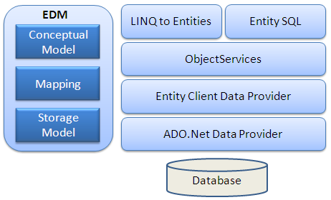

**Swagger：**

本项目采用前后端分离的开发模式，因此后端接口变得尤为重要。因为考虑到接口可能在开发的过程中反复进行修改，所以我们选择了Swagger作为接口文档生成工具，以更大程度提高开发效率。

Swagger 是一个规范和完整的框架，用于生成、描述、调用和可视化 RESTful 风格的 Web 服务。能够自动根据代码和后端开发人员所写注释生成接口文档，并且支持不断更新迭代接口版本。

## 用例设计

### 1.2.1账户信息管理系统用例包设计

1. 注册登录

**注册登录--活动图**

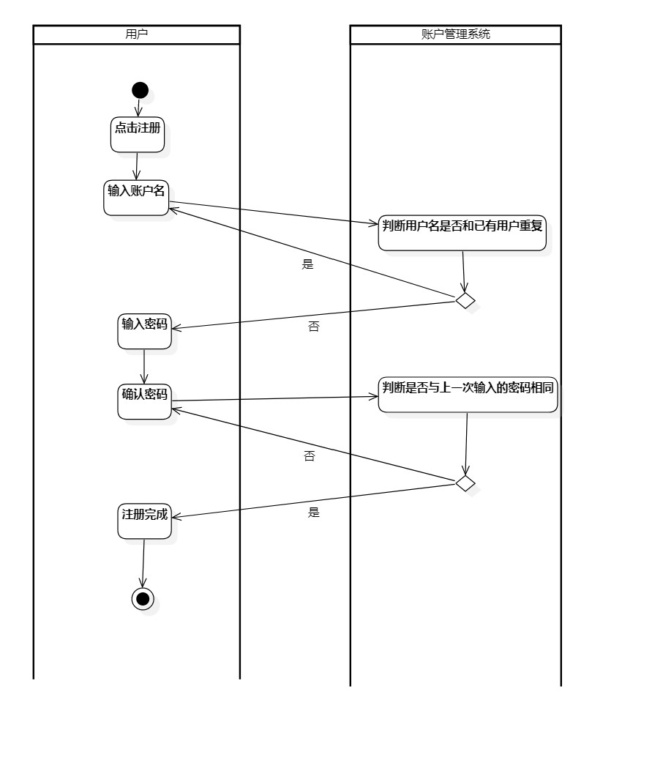

图1.2- 1 注册登录--活动图

**注册登录--类图**

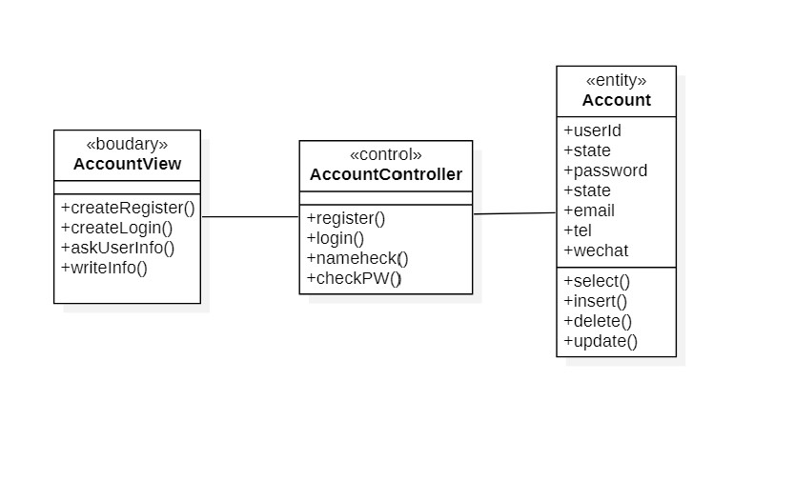

图1.2- 2 注册登录--类图

**注册登录--时序图**

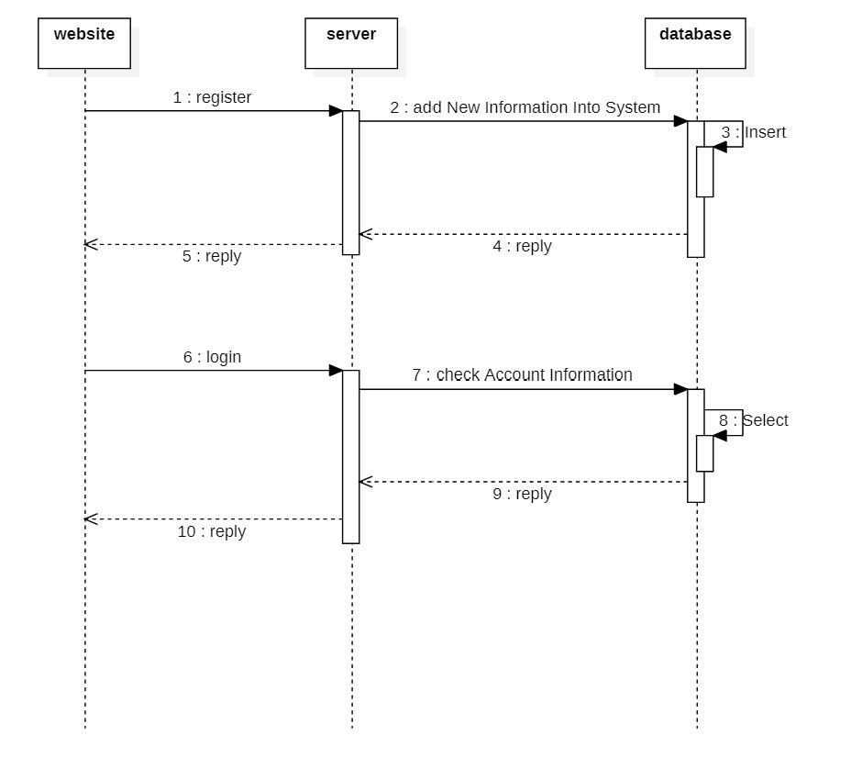

图1.2- 3 注册登录--时序图

1. 个人账户信息管理

**个人账户信息管理--活动图**

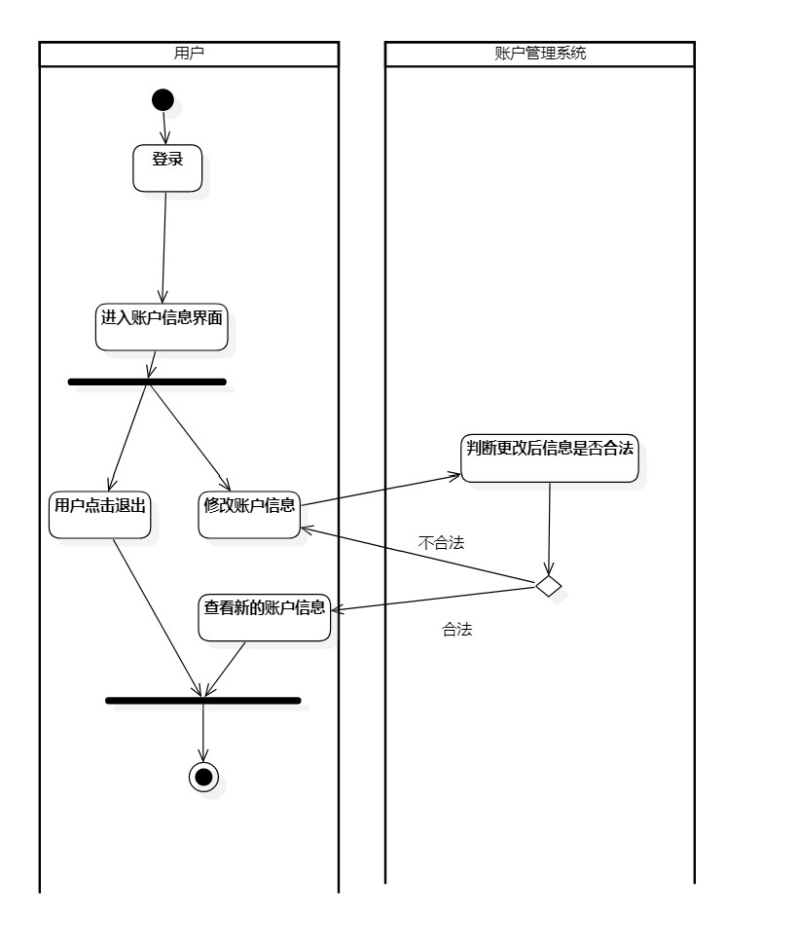

图1.2- 4 个人账户信息管理--活动图

**个人账户信息管理--类图**

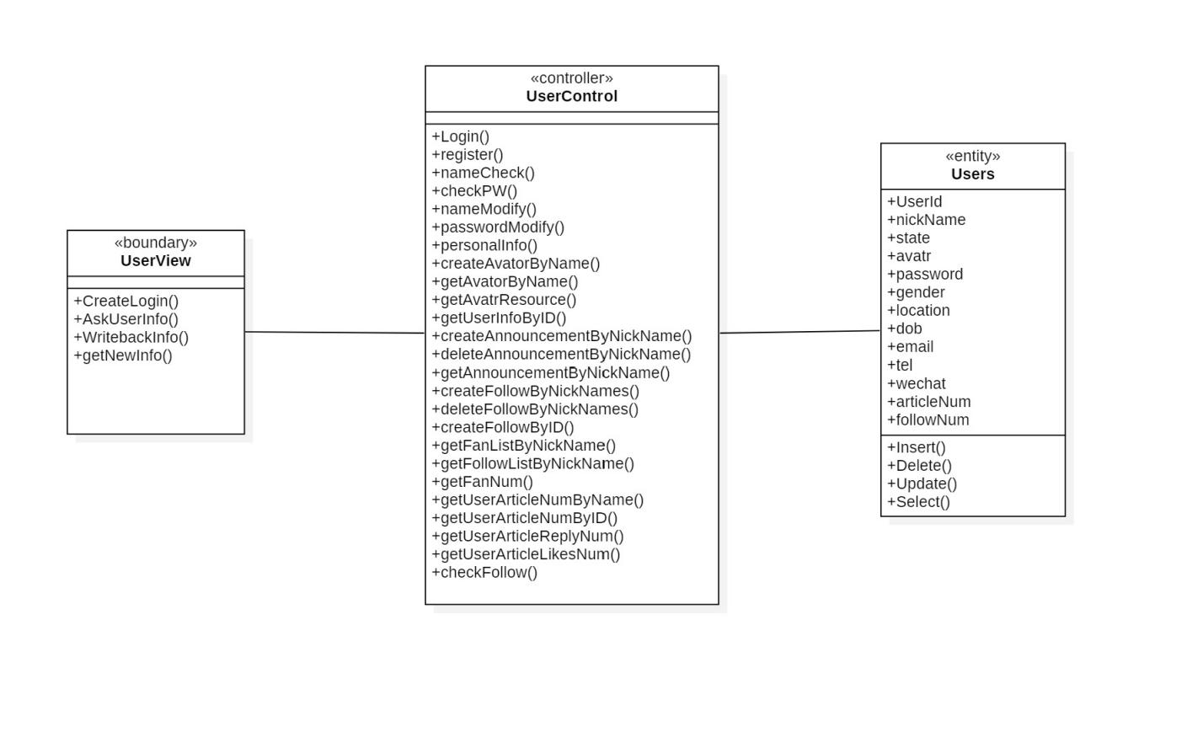

图1.2- 5 个人账户信息管理--类图

**个人账户信息管理--时序图**

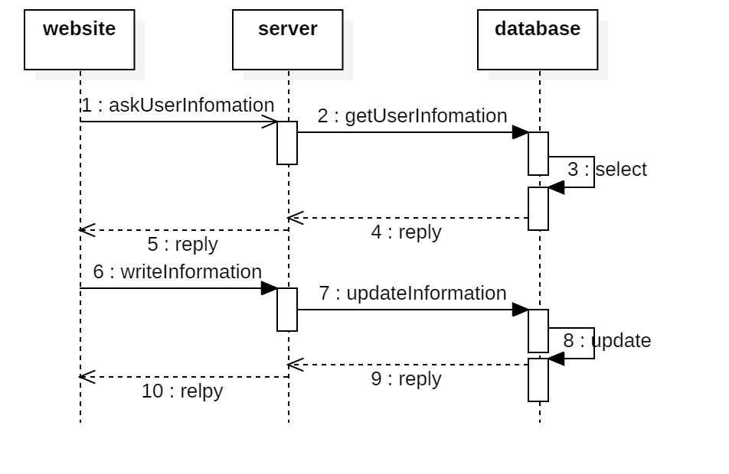

图1.2- 6 个人账户信息管理--时序图

1. 查看他人账户信息

**查看他人账户信息--活动图**

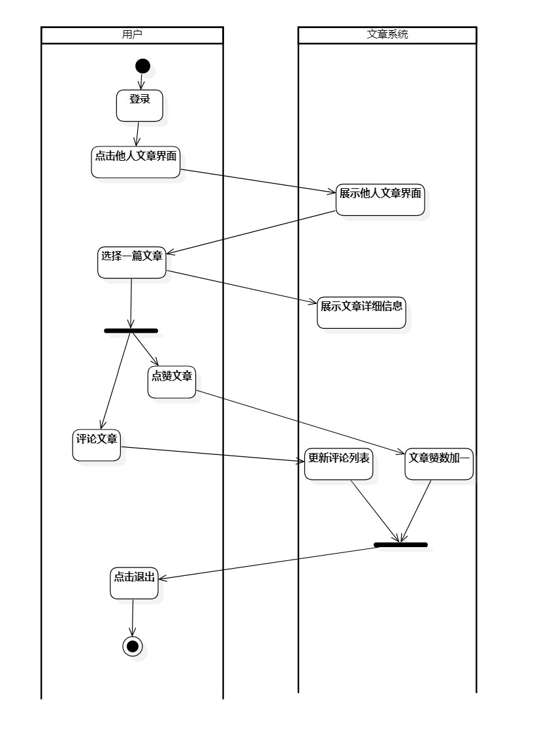

图1.2- 7 查看他人账户信息--活动图

**查看他人账户信息--类图**

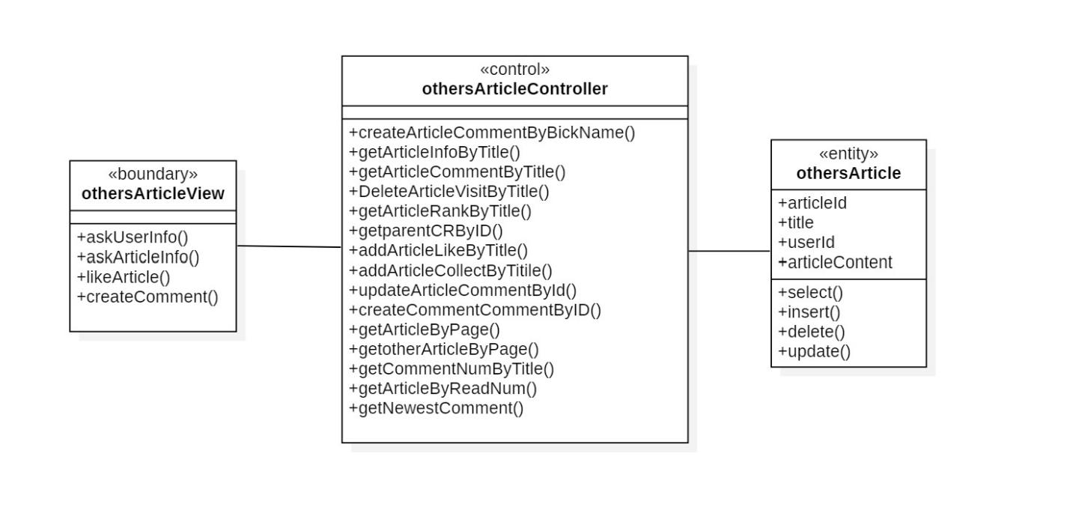

图1.2- 8 查看他人账户信息--类图

**查看他人账户信息--时序图**

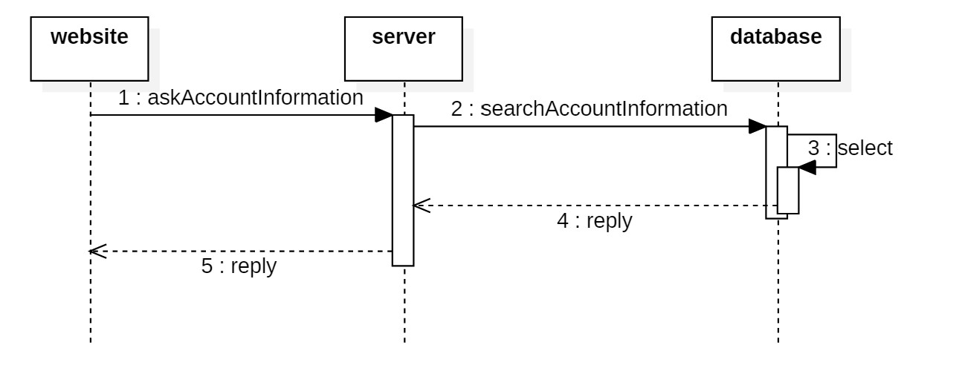

图1.2- 9 查看他人账户信息--时序图

### 1.2.2文章信息管理系统用例包设计

1. 个人文章信息管理

**个人文章信息管理--活动图**

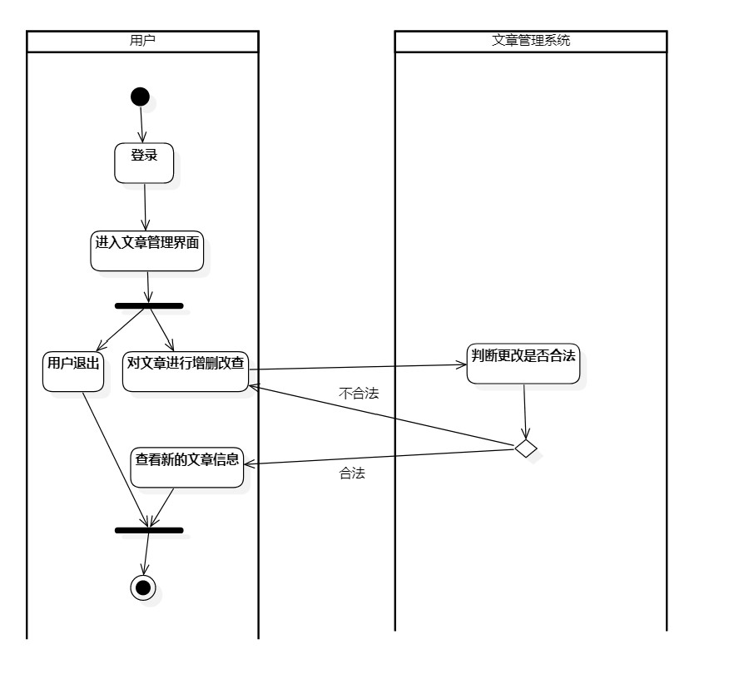

图1.2- 10 个人文章信息管理--活动图

**个人文章信息管理--类图**

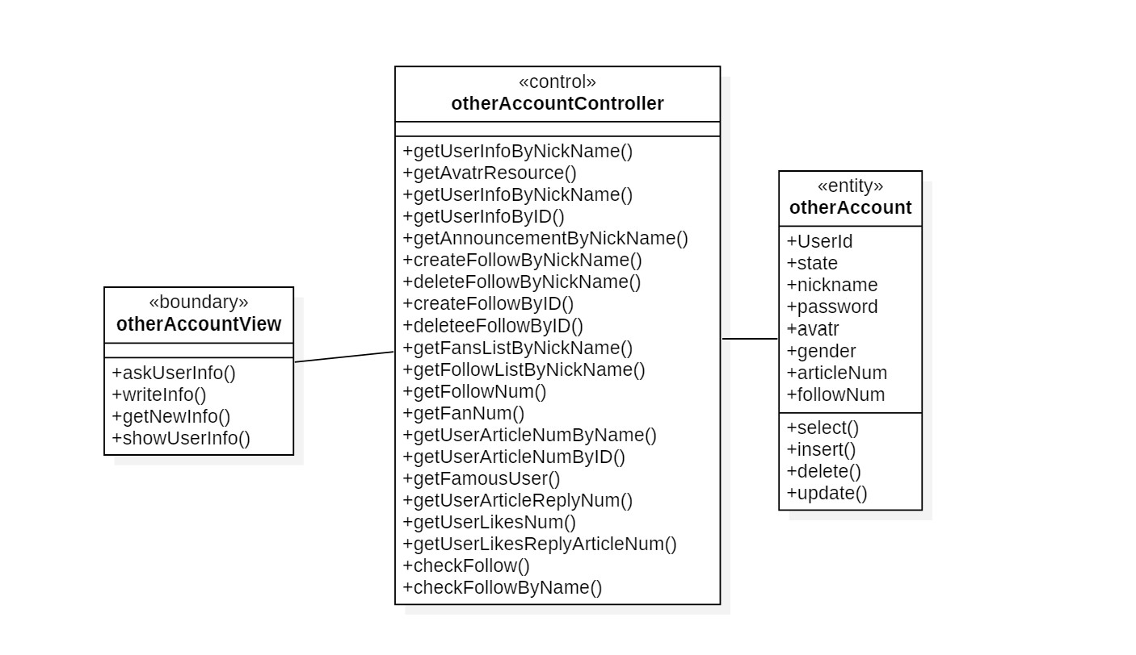

图1.2- 11 个人文章信息管理--类图

**个人文章信息管理--时序图**

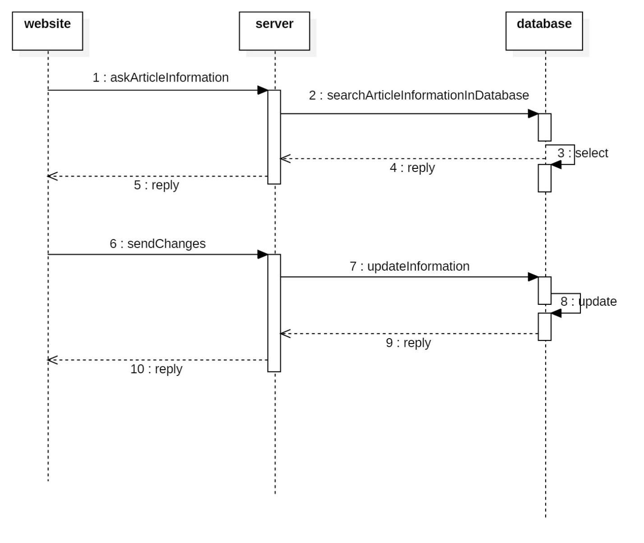

图1.2- 12 个人文章信息管理--时序图

1. 查看、点赞、评论他人文章

**查看、点赞、评论他人文章--活动图**

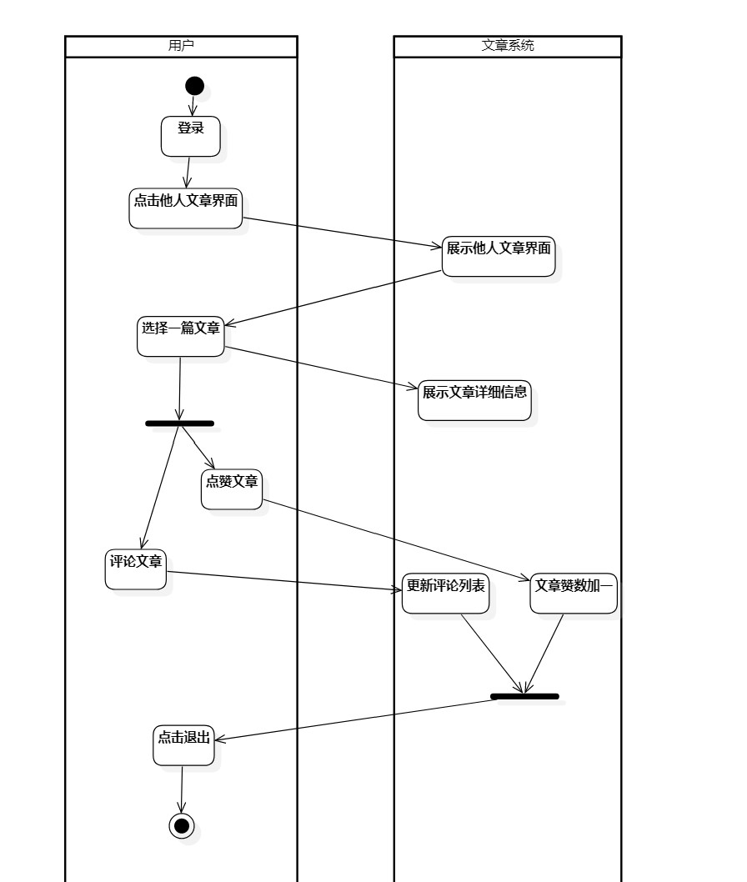

图1.2- 13 查看、点赞、评论他人文章--活动图

**查看、点赞、评论他人文章--类图**

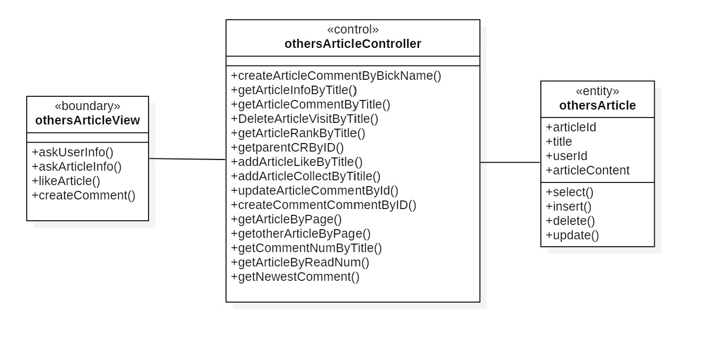

图1.2- 14 查看、点赞、评论他人文章--类图

**查看、点赞、评论他人文章--时序图**

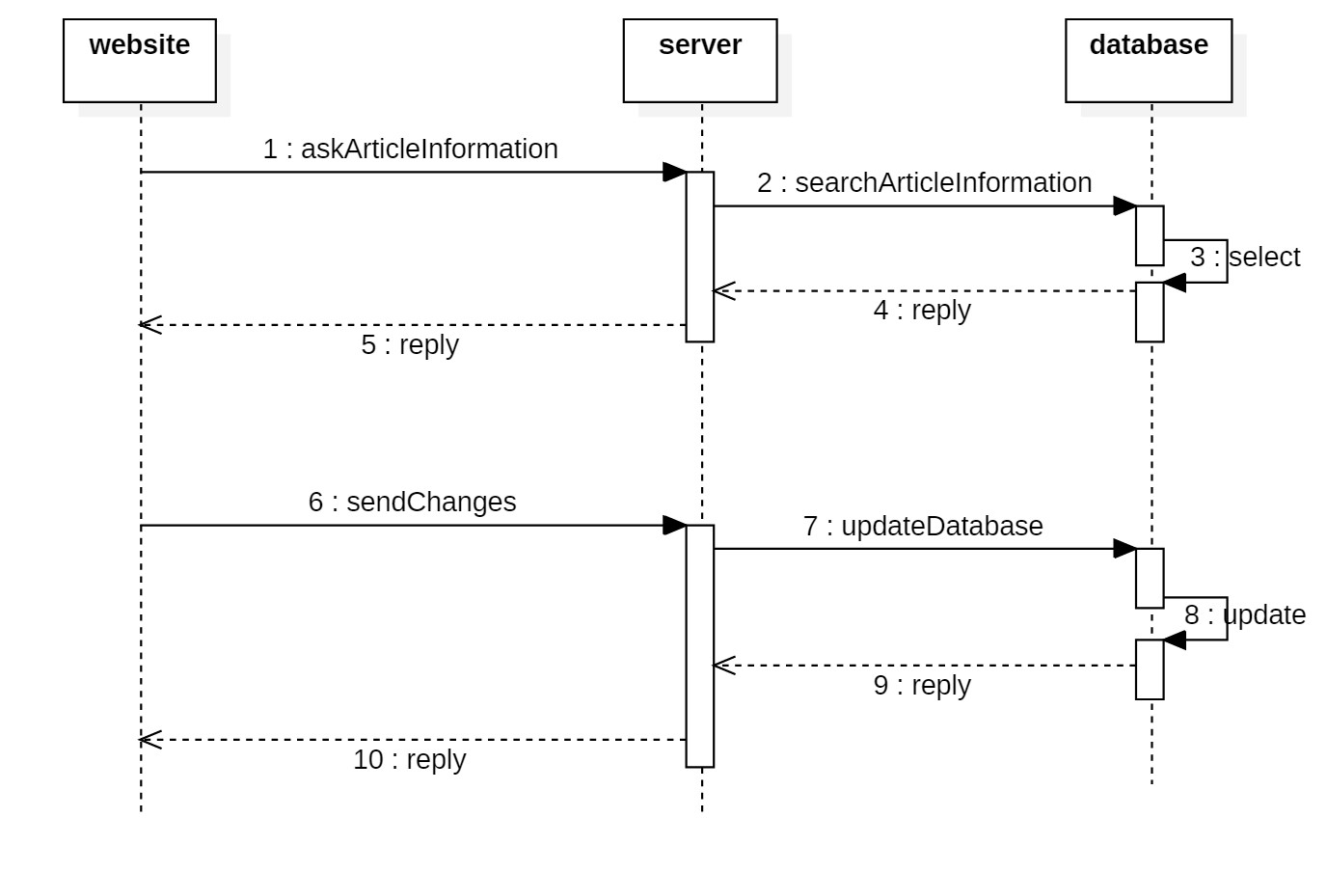

图1.2- 15 查看、点赞、评论他人文章--时序图

### 1.2.3收藏夹管理系统用例包设计

1）收藏夹管理

**收藏夹管理用例--活动图**

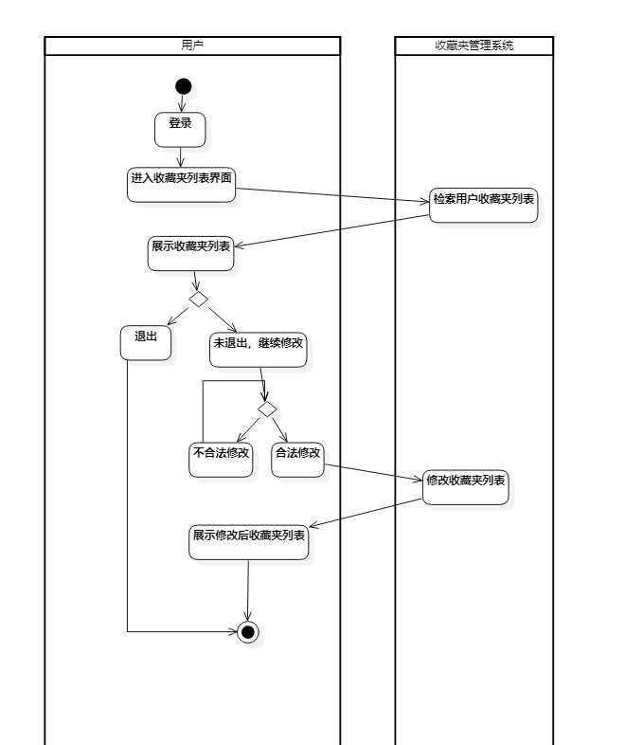

图1.2- 16 收藏夹管理用例--活动图

**收藏夹管理用例--类图**

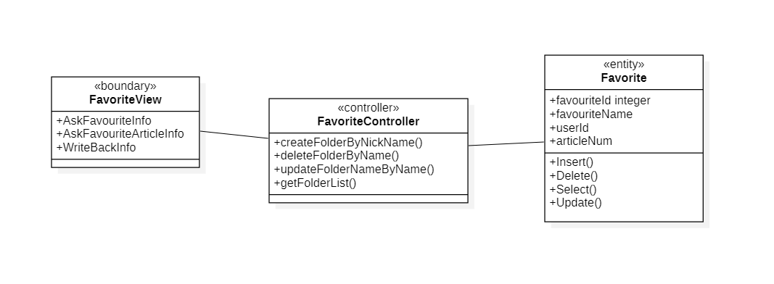

图1.2- 17 收藏夹管理用例--类图

**收藏夹管理用例--时序图**

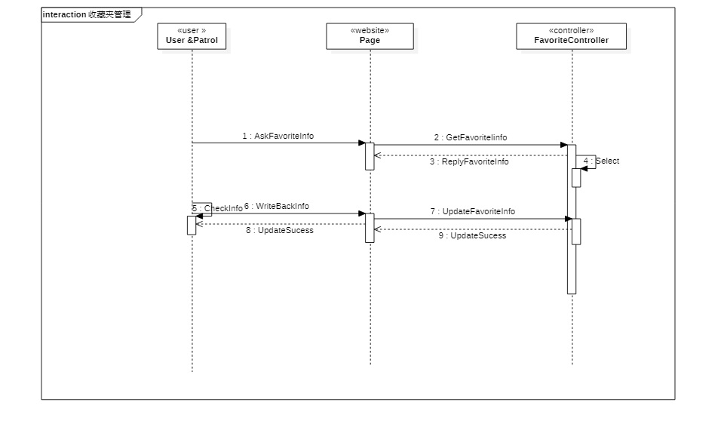

图1.2- 18 收藏夹管理用例--时序图

2）收藏夹文章管理

**收藏夹文章管理用例--活动图**

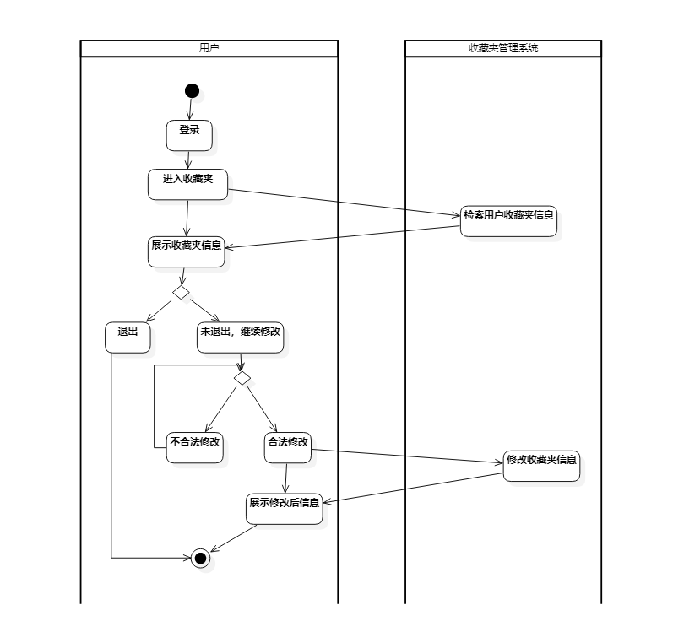

图1.2- 19 收藏夹文章管理用例--活动图

**收藏夹文章管理用例--类图**

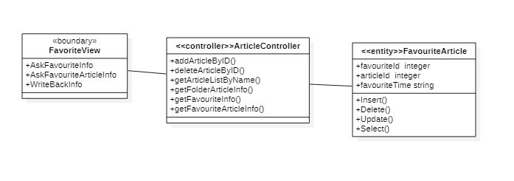

图1.2- 20 收藏夹文章管理用例--类图

**收藏夹文章管理用例--时序图**

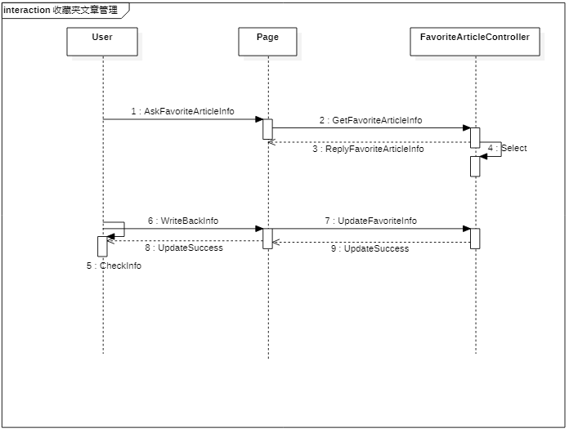

图1.2- 21 收藏夹文章管理用例--时序图

### 1.2.4相册管理系统用例包设计

1）相册管理

**相册管理用例--活动图**

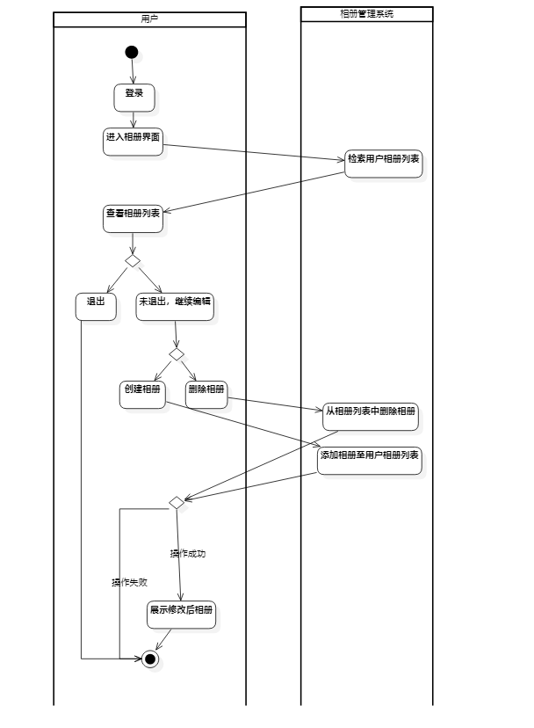

图1.2- 22 相册管理用例--活动图

**相册管理用例--类图**

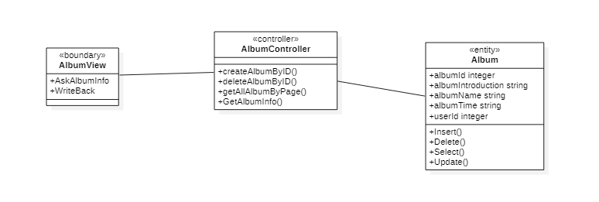

图1.2- 23 相册管理用例--类图

**相册管理用例--时序图**

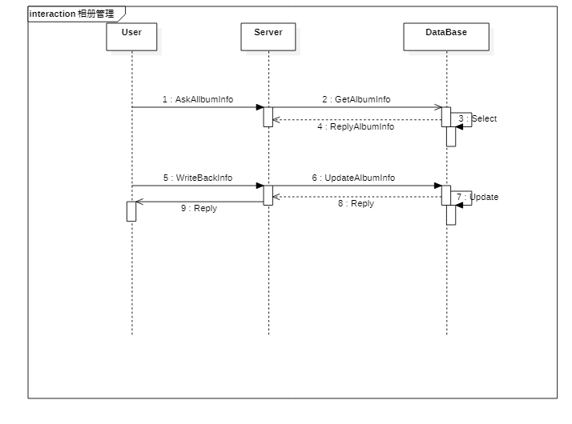

图1.2- 24 相册管理用例--时序图

2）相册内照片管理

**相册内照片管理用例--活动图**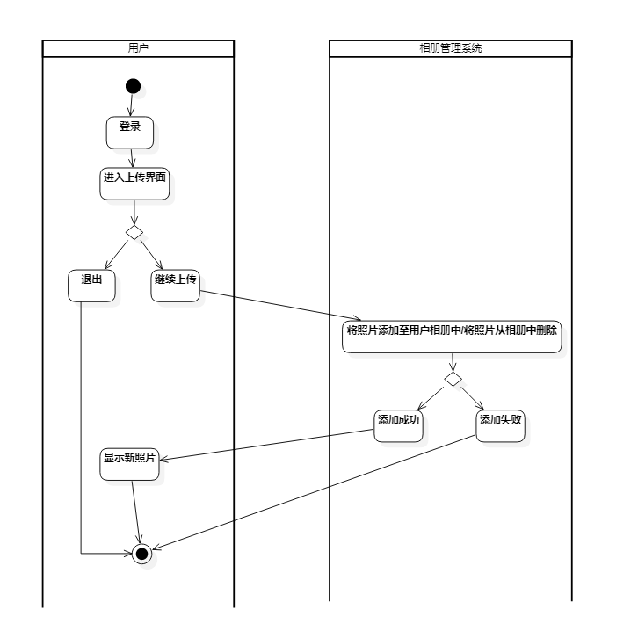

图1.2- 25 相册内照片管理用例--活动图

**相册内照片管理用例--类图**

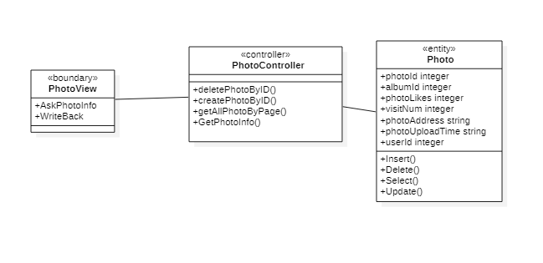

图1.2- 26 相册内照片管理用例--类图

**相册内照片管理用例--时序图**

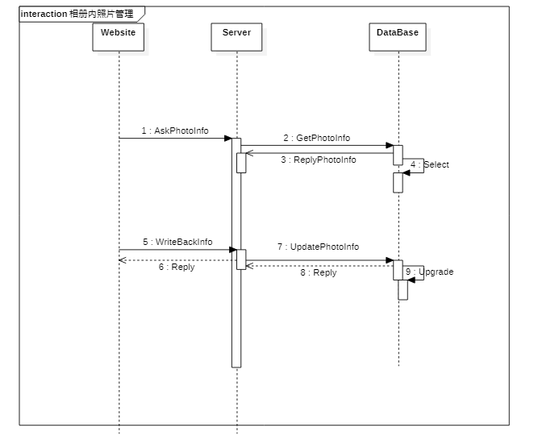

图1.2- 27 相册内照片管理用例--时序图

3）照片信息管理

**照片信息管理用例--活动图**

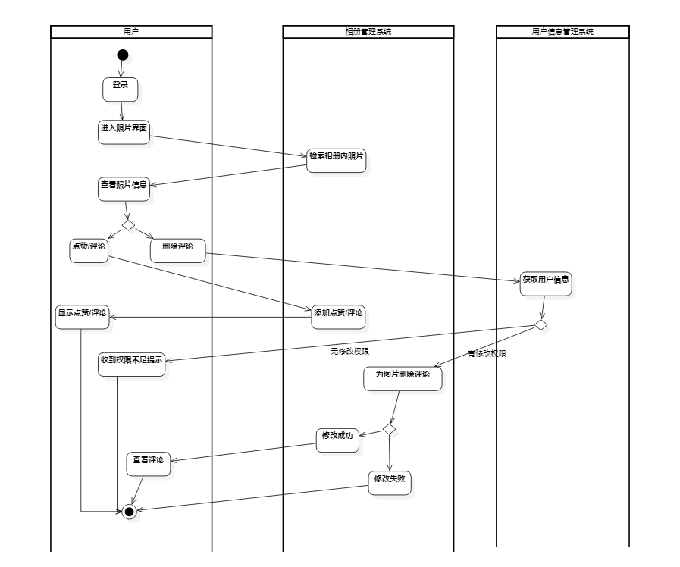

图1.2- 28 照片信息管理用例--活动图

**照片信息管理用例--类图**

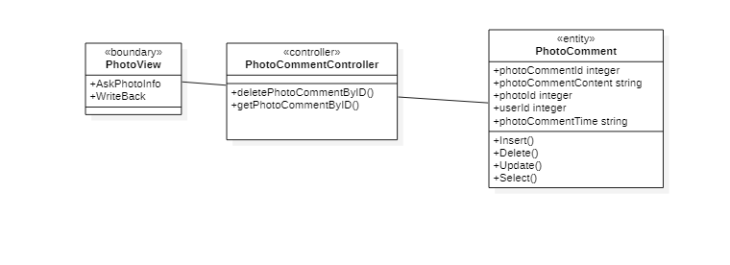

图1.2- 29 照片信息管理用例--类图

**照片信息管理用例--时序图**

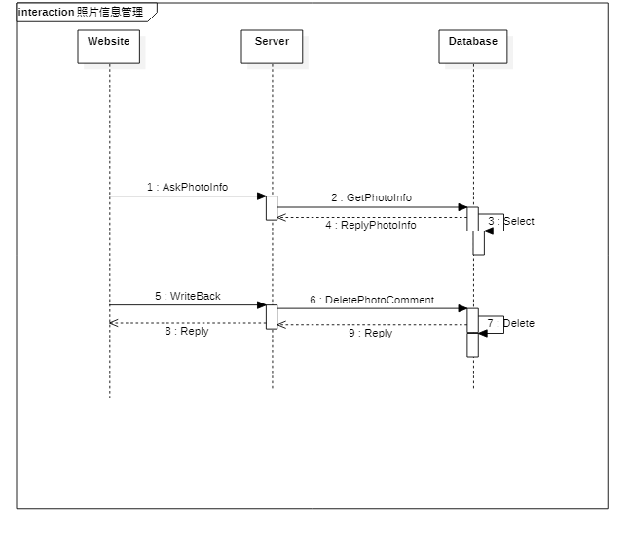

图1.2- 30 照片信息管理用例--时序图

### 1.2.5话题管理系统用例包设计

1）查看话题及回答

**查看话题及回答用例--活动图**

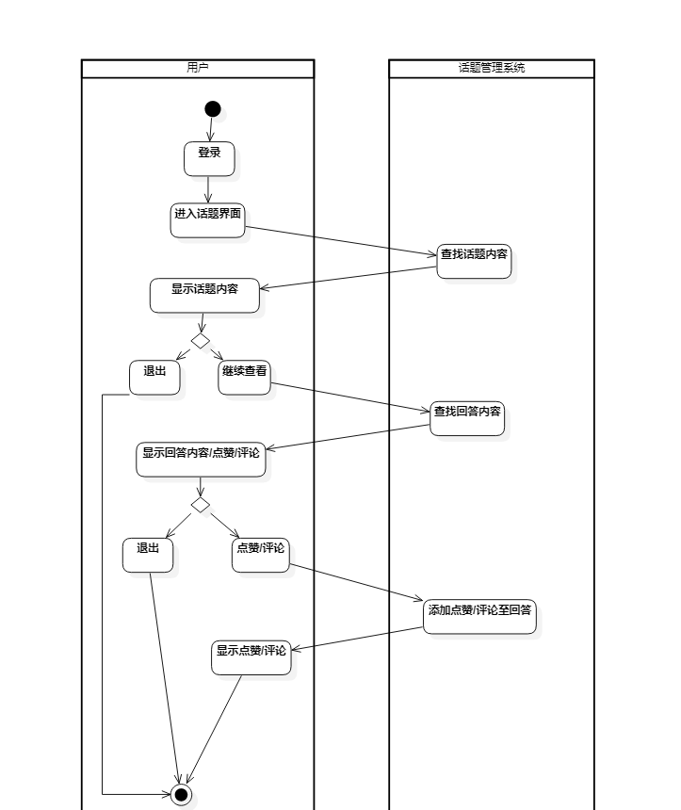

图1.2- 31 查看话题及回答用例--活动图

**查看话题及回答用例--类图**

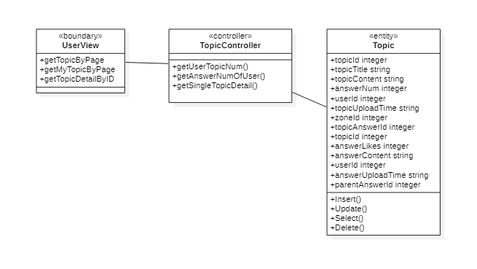

图1.2- 32查看话题及回答用例--类图

**查看话题及回答用例--时序图**

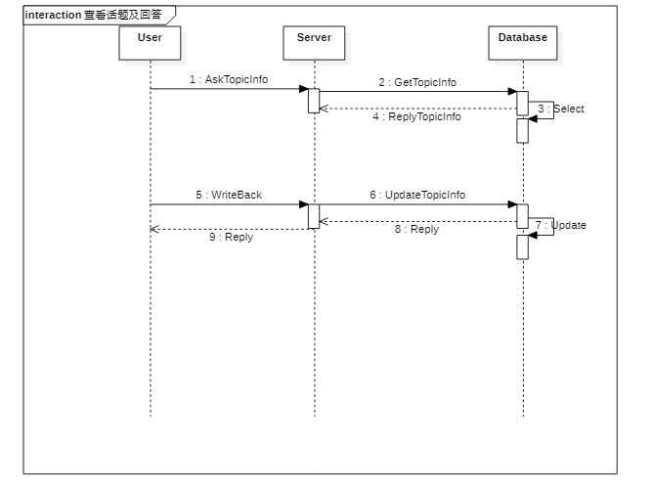

图1.2- 33 查看话题及回答用例--时序图

2）回答话题

**回答话题用例--活动图**

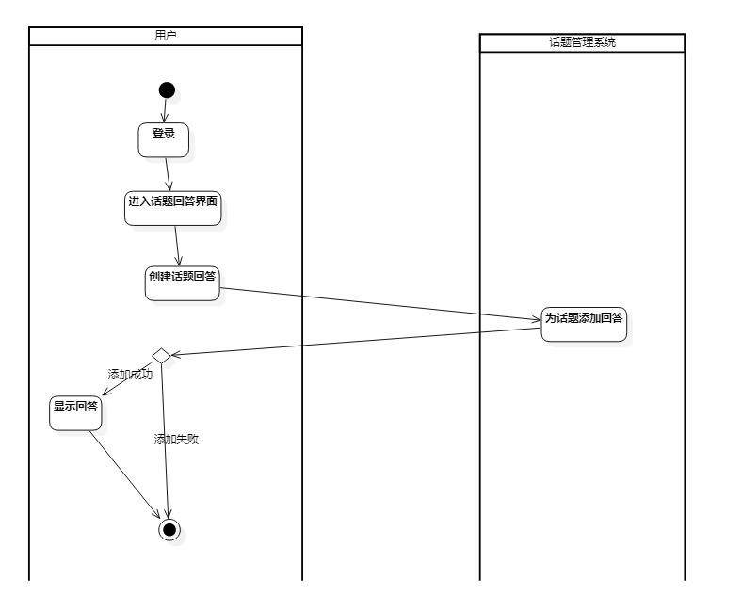

图1.2- 34 回答话题用例--活动图

**回答话题用例--类图**

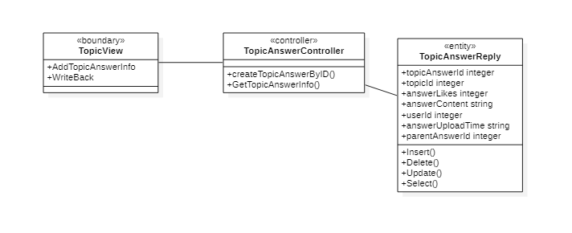

图1.2- 35 回答话题用例--类图

**回答话题用例--时序图**

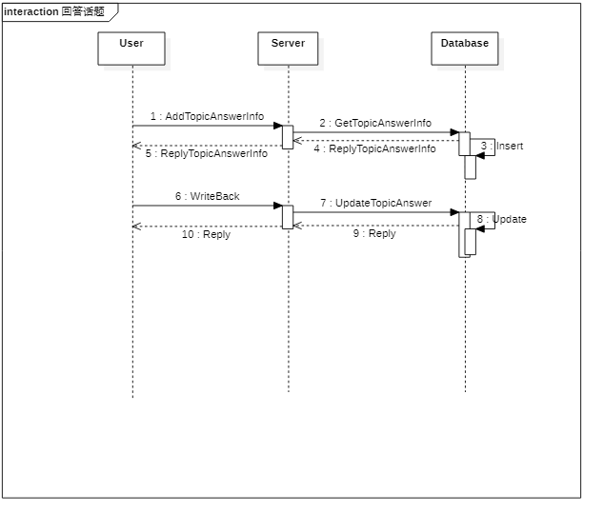

图1.2- 36 回答话题用例--时序图

3）用户话题管理

**用户话题管理用例--活动图**

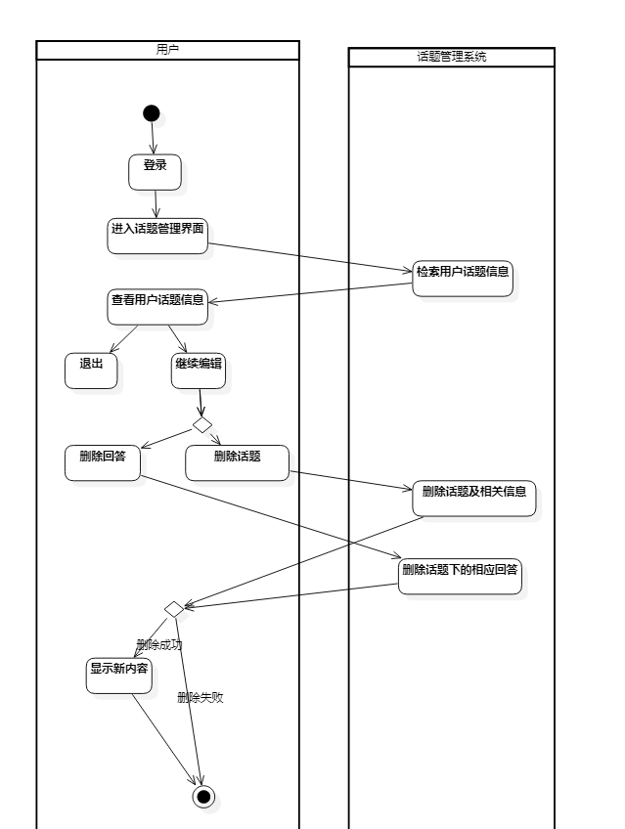

图1.2- 37 用户话题管理用例--活动图

**用户话题管理用例--类图**

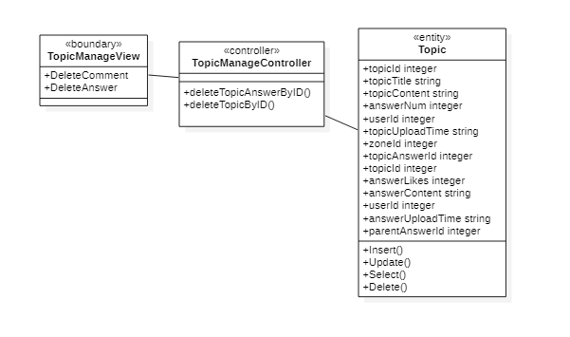

图1.2- 38 用户话题管理用例--类图

**用户话题管理用例--时序图**

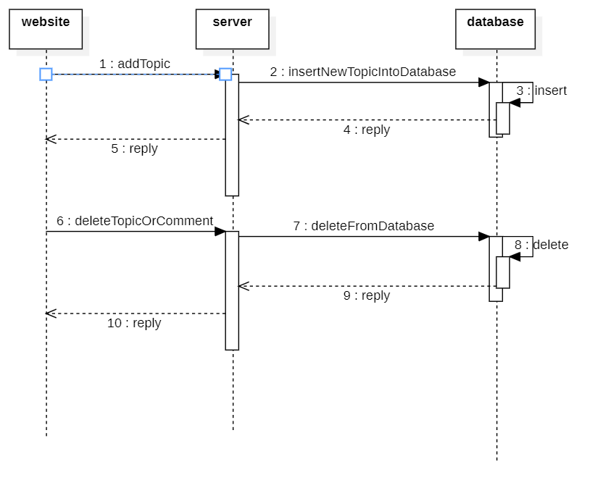

图1.2- 39 用户话题管理用例--时序图

4）话题搜索

**话题搜索用例--活动图**

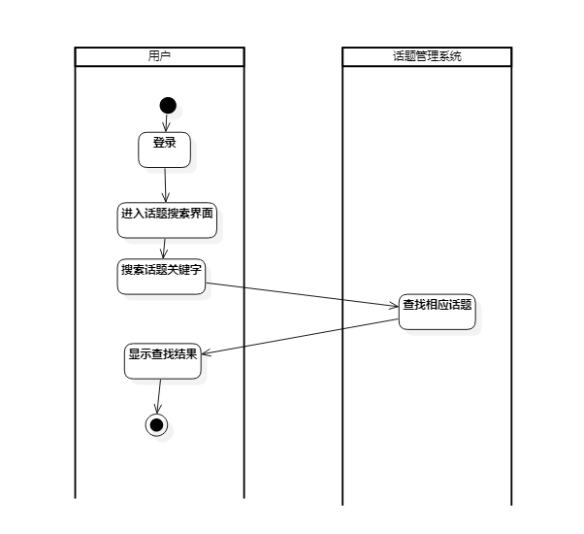

图1.2- 40 话题搜索用例--活动图

**话题搜索用例--类图**

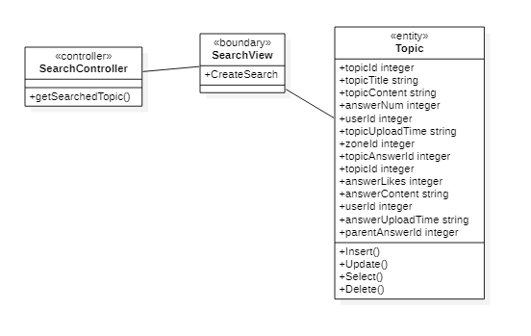

图1.2- 41 话题搜索用例--类图

**话题搜索用例--—时序图**

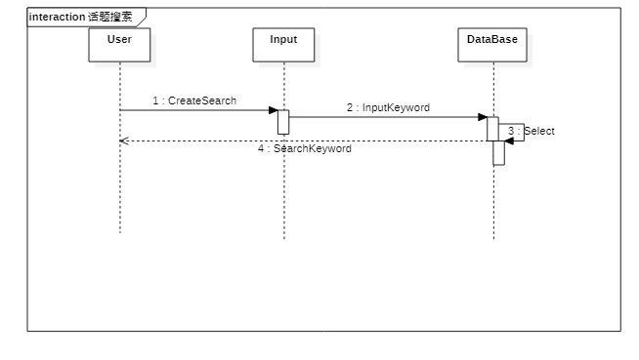

图1.2- 42 话题搜索用例--时序图

# 系统实现

## 2.1软硬件环境

项目部署地址：<http://139.224.255.43:9990/>

项目后端接口文档地址：<http://139.224.255.43:7779/swagger/index.html>

### 2.1.1前端硬件环境

前端利用vue-cli手脚架进行了项目的初始化，利用vue-router进行路由导航管理，引入了element-ui外部库便于我们进行快速的组件开发。

### 2.1.2前端软件环境

我们租用了一台服务器Windows Server 2012 R2 利用nginx 进行项目的部署。

### 2.1.3后端软件环境

.Net Web API服务采用了Entity Framework来实现ORM(Object Relation Mapping)，并且增加了Swagger服务来自动生成后端代码接口。

### 2.1.4后端（服务器）的硬件环境

租用了两个弹性服务器，其中一台腾讯云服务器部署有MySql数据库，另一台部署.Net Web API的服务器为Windows Server 2012 R2。

## 2.2账户信息管理系统用例包设计

### 2.4.1收藏夹管理用例实现

界面截图：

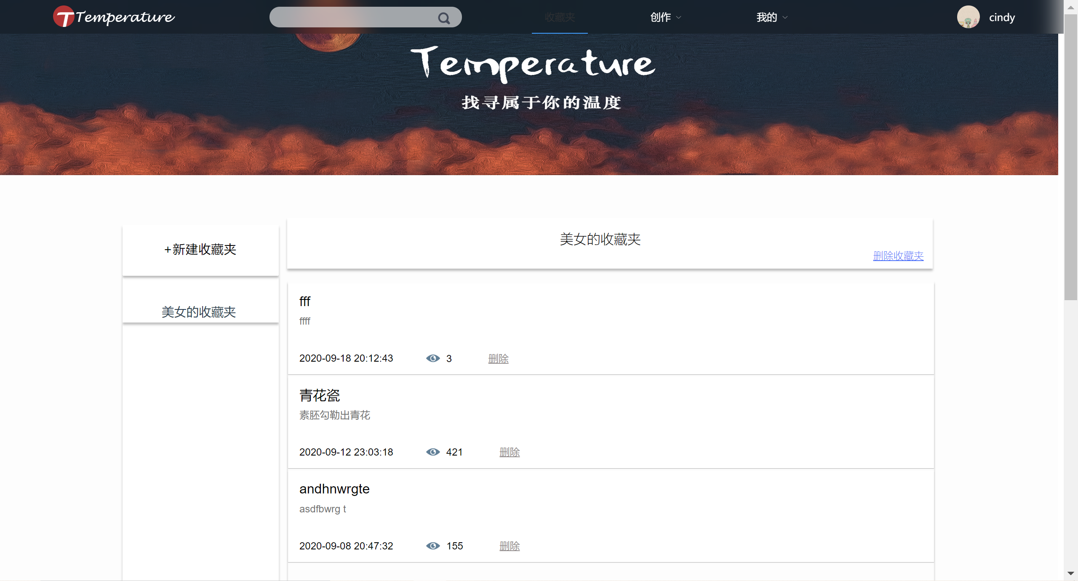

核心代码：

//查看收藏夹

[HttpPost]

public JsonResult getFolderList(int userID)

{

int flag = 0;

string msg = "";

try

{

var user = entity.User.Find(userID);

if(user == default)

{

flag = 2;//该用户不存在

return Json(new { Flag = flag, errorMsg = "User Not Found" });

}

else

{

var result =

(from u in entity.Favourite

where u.UserId == userID

select new { u.FavouriteId, u.FavouriteName, u.ArticleNum }).Distinct();

flag = 1;//成功

return Json(new { Flag = flag, List = result });

}

}

catch(Exception e)

{

msg = e.Message;

flag = 0;

}

return Json(new { Flag = flag, errorMsg = msg });

}

//新建收藏夹

[HttpPost]

public JsonResult createFolderByNickName(string nick_name,string folderName)

{

var flag = 0;

var userid =

(from c in entity.User

where c.NickName == nick_name

select c.UserId).Distinct();

var id = userid.FirstOrDefault();

//检查之前是否已经有过同名收藏夹

var checkFolder =

(from c in entity.Favourite

where (c.FavouriteName == folderName && c.UserId == id)

select c.FavouriteId).Distinct();

var check = checkFolder.FirstOrDefault();

if(check != default )

{

flag = 2;

return Json(new {ReturnFlag = flag, UserName = nick_name, Folder_Name = folderName, result = "Already Exists!" });

}

var folder = new Favourite();

folder.FavouriteName = folderName;

folder.ArticleNum = 0;

folder.UserId = id;

entity.Favourite.Add(folder);

entity.SaveChanges();

//Response.StatusCode = 200;

flag = 1;

return Json(new { ReturnFlag = flag, user = nick_name, folder = folderName });

}

//删除收藏夹

[HttpPost]

public JsonResult deleteFolderByName(string nick_name, string folderName)

{

var flag = 0;

//根据用户名找到用户ID

var userid =

(from c in entity.User

where c.NickName == nick_name

select c.UserId).Distinct();

var id = userid.FirstOrDefault();

if (id == default)

{

flag = 2;

return Json(new { ReturnFlag = flag, UserName = nick_name, result = "NOT FOUND" });

}

//根据用户ID和收藏夹名找到对应收藏夹项

var folderid =

(from c in entity.Favourite

where (c.FavouriteName == folderName && c.UserId == id)

select c.FavouriteId).Distinct();

var F_id = folderid.FirstOrDefault();

if (F_id == default)

{

flag = 3;

return Json(new { ReturnFlag = flag, FolderName = folderName, result = "NOT FOUND" });

}

//ARTICLE表中找到对应记录,并更新记录

var articles =

(from c in entity.FavouriteArticle

from u in entity.Article

where c.FavouriteId == F_id && c.ArticleId==u.ArticleId

select u).ToList(); //这里需要把查询的内容转化为list，不然后面的foreach会报重复连接数据库的错误

foreach(var article in articles)

{

article.CollectNum--;

entity.Entry(article).State = EntityState.Modified;

entity.SaveChanges();

}

//获得FAVORITE_ARTICLE表中记录

var F_A_record =

(from c in entity.FavouriteArticle

where c.FavouriteId == F_id

select c).ToList();

foreach (var record in F_A_record)

{

var articleID = record.ArticleId;

//FAVORITE_ARTICLE表中删除项

entity.Entry(record).State = EntityState.Deleted;

entity.SaveChanges();

}

//FAVOURITE表中删除整个文件夹

var info = entity.Favourite.Find(F_id);

entity.Entry(info).State = EntityState.Deleted;

entity.SaveChanges();

flag = 1;

return Json(new { ReturnFlag = flag, UserName = nick_name,FolderName = folderName,result ="success!" });

}

### 2.2.1注册用例实现

界面截图：

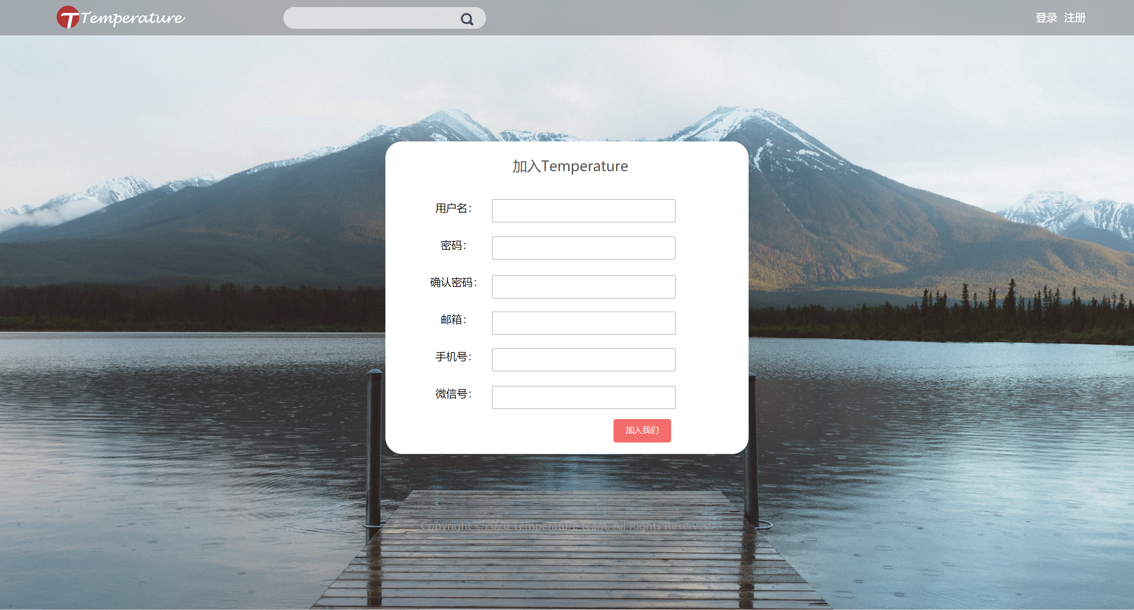

核心代码：

//判断用户名是否被占用

[HttpPost]

[AllowAnonymous]

public JsonResult nameCheck(string username)

{

User user = new User();

int flag = 0;

var userid =

(from c in entity.User

where c.NickName == username

select c.UserId).Distinct();

if (userid.FirstOrDefault() != default)

{

flag = 2; //用户名已经被占用

return Json(new { result = "False" });

}

else

{

flag = 1;//用户名可以使用。

return Json(new { result = "True" });

}

}

//注册

[AllowAnonymous]

[HttpPost]

public ActionResult register(string nick_name, string password,string email,string tel,string wechat)

{

User user = new User();

//JsonData jsondata = new JsonData(); //json格式的数据

int flag = 0;

var userid =

(from c in entity.User

where c.NickName == nick_name

select c.UserId).Distinct();

if (userid.FirstOrDefault() != default)

{

flag = 2; //用户名名已经被占用

}

else

{

//user.UserId = (++idNum).ToString();

//这里id是自增类型

user.NickName = nick_name;

user.Password = password;

user.Email = email;

user.Tel = tel;

user.Wechat = wechat;

user.Avatr = "BlogPics\\Avator\\defaultAvator.png";

entity.User.Add(user); //把user这个实体加入数据库

entity.SaveChanges();

flag = 1; //注册成功

}

var data = new

{

RegisterFlag = flag

};

return Json(data);

}

### 2.2.2登录用例实现

界面截图：

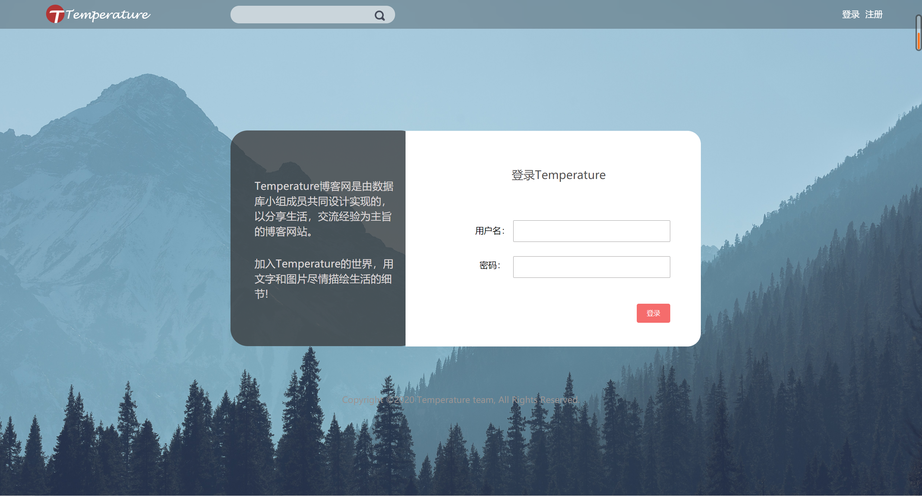

核心代码：

//检验密码正确

[HttpPost]

public JsonResult checkPW(string nick_name, string password)

{

int flag = 0;

var userid =

(from c in entity.User

where c.NickName == nick_name

select c.UserId).Distinct();

var id = userid.FirstOrDefault();

var user = entity.User.Find(id); //在数据库中根据key找到相应记录

if (id == default)

{

flag = 2; //没有找到该用户

return Json(new { Flag = flag });

}

else

{

if(user.Password != password)

{

flag = 3;//密码不正确

return Json(new { Result = "false", Flag = flag });

}

else

{

flag = 1;//正确

return Json(new { Result = "true", Flag = flag });

}

}

}

//登录

[AllowAnonymous]

[HttpPost]

//[SwaggerResponse(0, "文档注释", typeof(User))]

//[SwaggerResponse(0, "文档注释",typeof(User))]

public ActionResult Login(string nick_name, string password) {

User user = new User();

string token = "";

string msg = "";

int flag = 0;

int id = -1;

//JsonData jsondata = new JsonData(); //json格式的数据

try {

var userid = //EF中的Linq语法

(from u in entity.User

where u.NickName == nick_name

select u.UserId).Distinct(); //与sql中的select distinct类同

id = userid.FirstOrDefault();

if (userid.FirstOrDefault() != default) {

//var id = userid.FirstOrDefault();

user = entity.User.Find(id); //根据主键id找

if (user.Password != password) {

flag = 2;//密码错误

}

else {

//jsondata["userID"] = id;

token = getToken(nick_name);

flag = 1;//成功

}

}

else {

flag = 3;//用户名不存在

}

}

catch (Exception e) {

flag = 0;

msg = e.Message;

}

var data = new {

userid = id,

loginFlag = flag,

token = token,

Msg = msg

};

//jsondata["LoginFlag"] = flag.ToString();

//var data = Json(jsondata.ToJson());

//return Ok(data);

//return Ok(Json(jsondata.ToJson()));

//return Ok(data);

return Json(data);

}

### 2.2.3个人账户信息管理用例实现

界面截图：

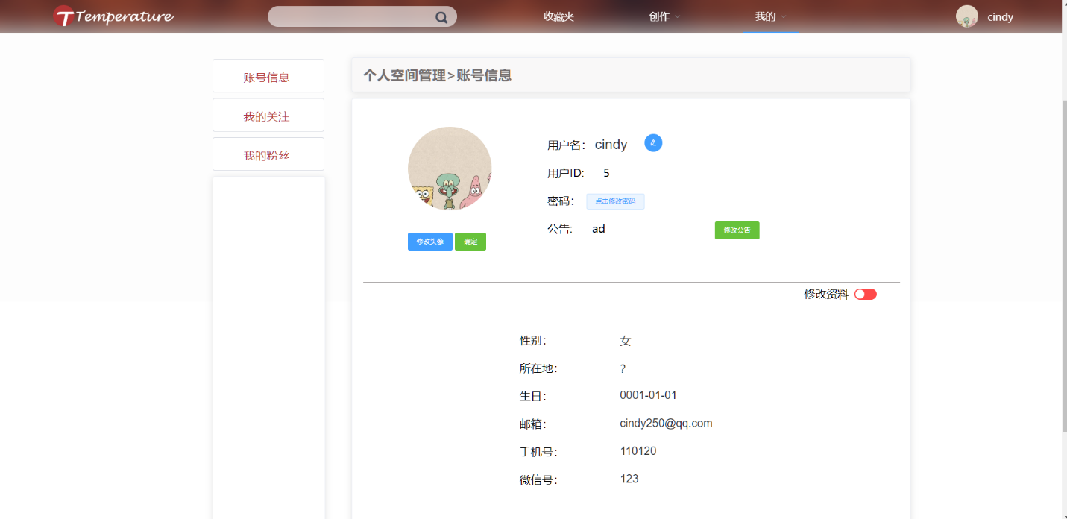

核心代码：

//修改用户名

[HttpPost]

public JsonResult nameModify(string oldName,string newName)

{

int flag = 0;

var userid =

(from c in entity.User

where c.NickName == oldName

select c.UserId).Distinct();

var id = userid.FirstOrDefault();

var user = entity.User.Find(id); //在数据库中根据key找到相应记录

if (id == default)

{

flag = 2; //没有找到该用户

}

else

{

user.NickName = newName;

entity.Entry(user).State = EntityState.Modified;

entity.SaveChanges();

flag = 1; //修改完成

}

return Json(new { ModifyFlag = flag });

}

//修改密码

[HttpPost]

public JsonResult passwordModify(string nick_name,string oldPW,string newPW)

{

int flag = 0;

var userid =

(from c in entity.User

where c.NickName == nick_name

select c.UserId).Distinct();

var id = userid.FirstOrDefault();

var user = entity.User.Find(id); //在数据库中根据key找到相应记录

if (id == default)

{

flag = 2; //没有找到该用户

}

else

{

if(user.Password != oldPW)

{

flag = 3;//旧密码输入不正确

}

else

{

user.Password = newPW;

entity.Entry(user).State = EntityState.Modified;

entity.SaveChanges();

flag = 1;

}

}

return Json(new { ModifyFlag = flag });

}

//维护个人信息

[Authorize]

[HttpPost]

public JsonResult personalInfo(string nick_name, string gender, string location, string year, string month, string day, string email, string tel, string wechat)

{

//User user = new User();

int flag = 0;

var userid =

(from c in entity.User

where c.NickName == nick_name

select c.UserId).Distinct();

var id = userid.FirstOrDefault();

var user = entity.User.Find(id); //在数据库中根据key找到相应记录

if (id == default)

{

flag = 2; //没有找到该用户

}

else

{

user.Gender = gender;

user.Location = location;

var yyyy = year;

var mm = month;

var dd = day;

DateTime dateTime = new DateTime();

DateTime.TryParse(yyyy + "-" + mm + "-" + dd, out dateTime);

user.Dob = dateTime;

user.Email = email;

user.Tel = tel;

user.Wechat = wechat;

entity.Entry(user).State = EntityState.Modified;

entity.SaveChanges();

flag = 1; //信息存储完成

}

var data = new

{

Infoflag = flag

};

return Json(data);

}

//查询用户基本信息

[HttpPost]

public JsonResult getUserInfoByNickName(string nick_name)

{

int flag = 0;

var userid =

(from c in entity.User

where c.NickName == nick_name

select c.UserId).Distinct();

var id = userid.FirstOrDefault();

if (id == default)

{

flag = 2; //没有找到该用户

//Response.StatusCode = 404;//没有该用户

return Json(new { UploadFlag = flag });

}

var user = entity.User.Find(id); //在数据库中根据key找到相应记录

var annoucement =

(from u in entity.Announcement

where u.UserId == id

select u.AnnouncementContent).Distinct().FirstOrDefault();

flag = 1;//找到该用户

// Response.StatusCode = 200;//成功

return Json(new { uploadFlag = flag, userAnnouncement = annoucement, userInfo = user });

}

//添加/更新公告内容

[HttpPost]

public JsonResult createAnnouncementByNickName(string nick_name,string content)

{

int flag = 0;

var userid =

(from c in entity.User

where c.NickName == nick_name

select c.UserId).Distinct();

var id = userid.FirstOrDefault();

if (id == default)

{

flag = 2; //没有找到该用户

}

else

{

var announcementRecordID =

(from c in entity.Announcement

where c.UserId == id

select c.AnnouncementId).Distinct(); //根据userid找到记录(userid不是主码，不能直接find)

var announcement=

entity.Announcement.Find(announcementRecordID.FirstOrDefault());

//在数据库中根据key找到相应记录

if (announcement == null)

{

flag = 1; //该用户没有添加过公告，新建公告

var announcement2 = new Announcement();

announcement2.UserId = id；

//这里id也会自增

announcement2.AnnouncementContent = content;

announcement2.AnnouncementUploadTime = DateTime.Now;

entity.Announcement.Add(announcement2); //把announcement这个实例加入数据库

entity.SaveChanges();

}

else

{

//该用户已经创建过公告，需要rewrite

flag = 1;

announcement.AnnouncementContent = content;

announcement.AnnouncementUploadTime = DateTime.Now;

entity.Entry(announcement).State = EntityState.Modified;

entity.SaveChanges();

}

}

return Json(new { Userid = id,CreateFlag = flag });

}

[HttpPost]

public JsonResult deleteAnnouncementByNickName(string nick_name)

{

int flag = 0;

var userid =

(from c in entity.User

where c.NickName == nick_name

select c.UserId).Distinct();

var id = userid.FirstOrDefault();

if (id == default)

{

flag = 2; //没有找到该用户

return Json(new { DeleteFlag = flag });

}

var announcementRecordID =

(from c in entity.Announcement

where c.UserId == id

select c.AnnouncementId).Distinct(); //根据userid找到记录(userid不是主码，不能直接find)

var announcement = entity.Announcement.Find(announcementRecordID.FirstOrDefault()); //在数据库中根据key找到相应记录

if (announcement == null)

{

flag = 3;//该用户没有创建过公告

return Json(new { DeleteFlag = flag });

}

entity.Entry(announcement).State = EntityState.Deleted;//删除该项

entity.SaveChanges();

flag = 1;

//Response.StatusCode = 200;//成功删除公告

return Json(new { DeleteFlag = flag });

}

//上传头像

[HttpPost]

public ActionResult createAvatorByName(IFormFileCollection uploadedPhoto, string nick_name)

{

DateTime dateTime = DateTime.Now;

var msg = "";

int createPhotoFlag = 0;

string uploadsFolder = "";

string uniqueFileName = "";

string filePath = "";

List<string> allFilePath = new List<string>();

if (uploadedPhoto == null) return BadRequest();

var userid =

(from c in entity.User

where c.NickName == nick_name

select c.UserId).Distinct();

var id = userid.FirstOrDefault();

if (id == default)

{

createPhotoFlag = 2; //没有找到该用户

return Json(new { UploadFlag = createPhotoFlag });

}

var user = entity.User.Find(id); //在数据库中根据key找到相应记录

for (int i = 0; i < uploadedPhoto.Count; i++)

{

try

{

uploadsFolder = Path.Combine(PicsRootPath);

uniqueFileName = Guid.NewGuid().ToString() + "_" + uploadedPhoto[i].FileName;

filePath =Path.Combine(uploadsFolder, uniqueFileName);

user.Avatr = filePath;

entity.Entry(user).State = EntityState.Modified;

entity.SaveChanges();

uploadedPhoto[i].CopyTo(new FileStream(filePath, FileMode.Create)); //存储图片到本地 持久化

allFilePath.Add(filePath);

createPhotoFlag = 1;

}

catch (Exception e)

{

Response.StatusCode = 403;

createPhotoFlag = 0;

msg = e.Message;

Console.WriteLine(e.Message);

}

}

var resultJson = new

{

uploadPaths = JsonConvert.SerializeObject(allFilePath),

createPhotoFlag = createPhotoFlag,

getmsg = msg

//getmsg = msg,

};

return Json(resultJson);

}

//创建关注关系

[HttpPost]

public JsonResult createFollowByNickNames(string nameOfBlogger,string nameOfFans)

{

int flag = 0;

var BloggerId =

(from c in entity.User

where c.NickName == nameOfBlogger

select c.UserId).Distinct();

var id_1 = BloggerId.FirstOrDefault();

var FansId =

(from c in entity.User

where c.NickName == nameOfFans

select c.UserId).Distinct();

var id_2 = FansId.FirstOrDefault();

if (id_1 == default || id_2 ==default)

{

if (id_1 == default && id_2 == default)

flag = 2; //两个用户都不存在

else if (id_1 == default)

flag = 3; //博主用户不存在

else

flag = 4; //粉丝用户不存在

return Json(new { CreateFlag = flag });

}

var newFollow = new UserFollow{ ActiveUserId = id_2, PassiveUserId = id_1 };

entity.UserFollow.Add(newFollow);

entity.SaveChanges();

var user = entity.User.Find(id_1); //user里面更新被关注数量

var num = user.FollowNum;

if (num == default)

user.FollowNum = 1;

else

user.FollowNum = num + 1;

entity.Entry(user).State = EntityState.Modified;

entity.SaveChanges();

flag = 1;//成功

return Json(new { CreateFlag = flag});

}

// 删除关注关系

[HttpPost]

public JsonResult deleteFollowByNickNames(string nameOfBlogger, string nameOfFans)

{

int flag = 0;

var BloggerId =

(from c in entity.User

where c.NickName == nameOfBlogger

select c.UserId).Distinct();

var id_1 = BloggerId.FirstOrDefault();

var FansId =

(from c in entity.User

where c.NickName == nameOfFans

select c.UserId).Distinct();

var id_2 = FansId.FirstOrDefault();

if (id_1 == default || id_2 == default)

{

if (id_1 == default && id_2 == default)

flag = 2; //两个用户都不存在

else if (id_1 == default)

flag = 3; //博主用户不存在

else

flag = 4; //粉丝用户不存在

return Json(new { CreateFlag = flag });

}

var follow = entity.UserFollow.Find(id_2,id_1);

entity.Entry(follow).State = EntityState.Deleted;//删除该项

entity.SaveChanges();

var user = entity.User.Find(id_1); //user里面更新被关注数量

user.FollowNum--; //粉丝数减减

entity.Entry(user).State = EntityState.Modified;

entity.SaveChanges();

flag = 1;//成功

return Json(new { CreateFlag = flag });

}

### 2.2.4查看他人账户信息用例实现

界面截图：

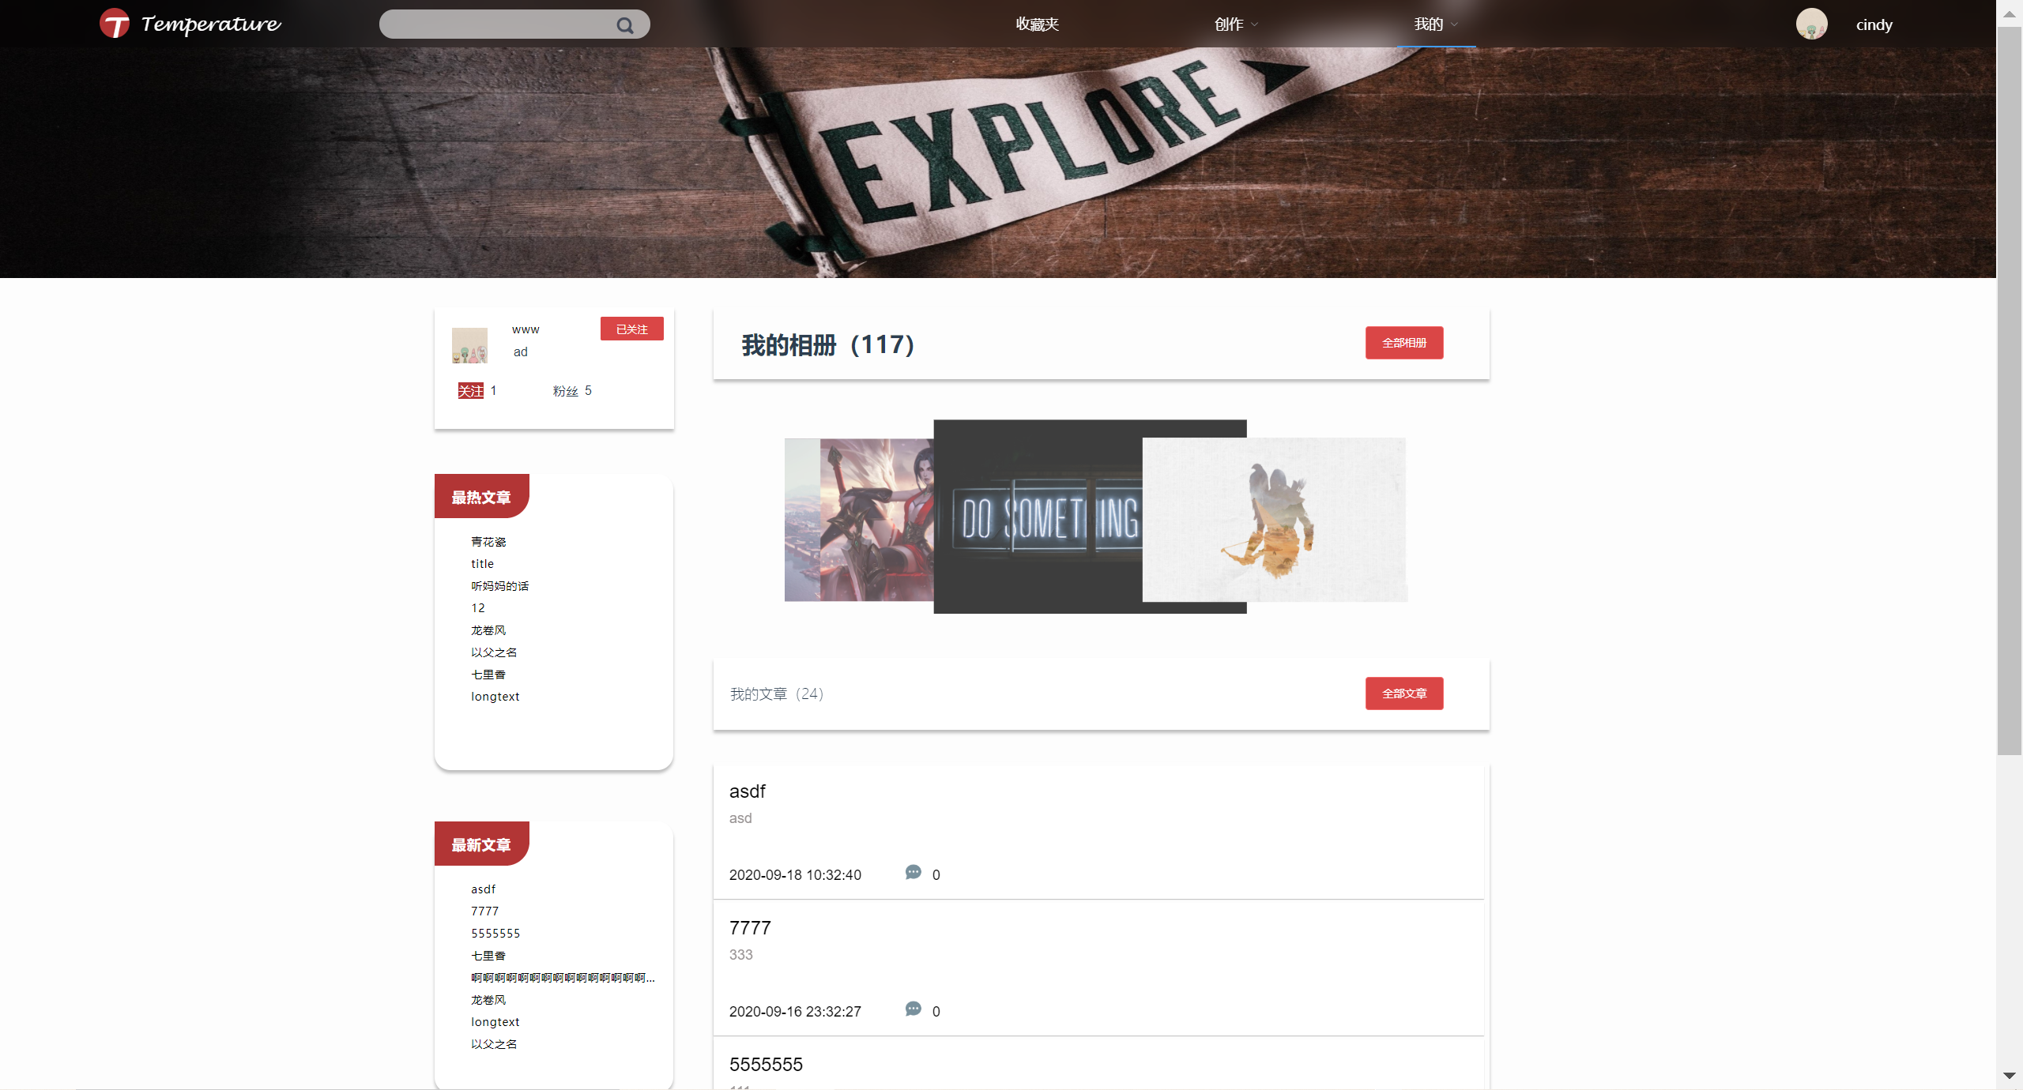

核心代码：

//返回头像

[HttpPost]

public IActionResult getAvatrResource(string nick_name)

{

int flag = 0;

var userid =

(from c in entity.User

where c.NickName == nick_name

select c.UserId).Distinct();

var id = userid.FirstOrDefault();

if (id == default)

{

flag = 2; //没有找到该用户

return Json(new { UploadFlag = flag });

}

var user = entity.User.Find(id); //在数据库中根据key找到相应记录

var name = user.Avatr;

flag = 1;

var errorImage = PicsRootPath + "\\default\\" + "defaultAvator.png";//没有找到图片

var imgPath = string.IsNullOrEmpty(name) ? errorImage : name;

//获取图片的返回类型

return Json(new { Flag = flag,Path = imgPath });

}

//获取用户公告内容

[HttpPost]

public JsonResult getAnnouncementByNickName(string nick_name)

{

var flag = 0;

var userid =

(from c in entity.User

where c.NickName == nick_name

select c.UserId).Distinct();

var id = userid.FirstOrDefault();

if (id == default)

{

flag = 2; //没有找到该用户

return Json(new { GetFlag = flag });

}

var announcementRecordID =

(from c in entity.Announcement

where c.UserId == id

select c.AnnouncementId).Distinct(); //根据userid找到记录(userid不是主码，不能直接find)

if (announcementRecordID == null)

{

flag = 3;//该用户没有创建的公告，无法返回

//return null;

return Json(new { GetFlag = flag });

}

flag = 1;

var announcement = entity.Announcement.Find(announcementRecordID.FirstOrDefault());

//Response.StatusCode = 200;//成功返回

return Json(new { GetFlag = flag, content = announcement });

}

//查询用户所有基本信息

[HttpPost]

public JsonResult getUserInfoByID(int user_id)

{

int flag = 0;

var user = entity.User.Find(user_id); //在数据库中根据key找到相应记录

var annoucement =

(from u in entity.Announcement

where u.UserId == user_id

select u.AnnouncementContent).Distinct().FirstOrDefault();

flag = 1;//找到该用户

return Json(new { uploadFlag = flag, userAnnouncement = annoucement ,userInfo = user });

}

//返回粉丝列表

[HttpPost]

public JsonResult getFansListByNickName(string nick_name)

{

int flag = 0;

var userid =

(from c in entity.User

where c.NickName == nick_name

select c.UserId).Distinct();

var id = userid.FirstOrDefault();

//var user = entity.User.Find(id); //在数据库中根据key找到相应记录

if (id == default)

{

flag = 2;//用户寻找失败

return Json(new { returnFlag = flag });

}

/*var fansID =

(from u in entity.UserFollow

where u.PassiveUserId == id

select u.ActiveUserId).Distinct();*/

var fansID =

(from u in entity.UserFollow

join right in entity.User

on u.ActiveUserId equals right.UserId

where u.PassiveUserId == id

select new { Name = right.NickName,Avator = right.Avatr}).Distinct();

if(fansID.FirstOrDefault() == default)

{

flag = 3;//该用户没有粉丝

return Json(new { returnFlag = flag });

}

flag = 1;

//Response.StatusCode = 200;

// return Json(new { returnFlag = flag, fansList = FansList, Thename = item.FanName, theA = item.FanAvator, ITEM = item });

return Json(new { returnFlag = flag, List = fansID });

}

//返回关注的博主列表

[HttpPost]

public JsonResult getFollowListByNickName(string nick_name)

{

int flag = 0;

var userid =

(from c in entity.User

where c.NickName == nick_name

select c.UserId).Distinct();

var id = userid.FirstOrDefault();

if (id == default)

{

flag = 2;//没有该用户

return Json(new { returnFlag = flag });

}

//var user = entity.User.Find(id); //在数据库中根据key找到相应记录

var followID =

(from u in entity.UserFollow

join right in entity.User

on u.PassiveUserId equals right.UserId

where u.ActiveUserId == id

select new { Name = right.NickName,Avator = right.Avatr}).Distinct();

if (followID.FirstOrDefault() == default)

{

flag = 3;//该用户关注的博主为空

return Json(new { returnFlag = flag });

}

flag = 1;//成功

//Response.StatusCode = 200; //成功

return Json(new { returnFlag = flag, FollowList = followID });

}

//返回用户文章数#1

[HttpPost]

public JsonResult getUserArticleNumByName(string nick_name)

{

int flag = 0;

string msg = "";

int cnt = -1;

try

{

var userid =

(from c in entity.User

where c.NickName == nick_name

select c.UserId).Distinct();

var id = userid.FirstOrDefault();

if (id == default)

{

flag = 2;//没有该用户

}

else

{

var ArticleCnt =

(from u in entity.Article

where u.UserId == id

select u).Distinct().Count();

cnt = ArticleCnt;

flag = 1;

}

}

catch (Exception e)

{

flag = 0;

msg = e.Message;

}

//var user = entity.User.Find(id); //在数据库中根据key找到相应记录

if (flag == 2)

{

return Json(new { returnFlag = flag });

}

return Json(new { returnFlag = flag, Count = cnt }); //flag =1

}

//返回用户文章数#2

[HttpPost]

public JsonResult getUserArticleNumByID(int id)

{

int flag = 0;

string msg = "";

int cnt = -1;

try

{

var user = entity.User.Find(id); //在数据库中根据key找到相应记录

if (user == default)

{

flag = 2;//没有该用户

}

else

{

var ArticleCnt =

(from u in entity.Article

where u.UserId == id

select u).Distinct().Count();

cnt = ArticleCnt;

flag = 1;

}

}

catch (Exception e)

{

flag = 0;

msg = e.Message;

}

if (flag == 2)

{

return Json(new { returnFlag = flag });

}

return Json(new { returnFlag = flag, Count = cnt }); //flag =1

}

//获取用户文章评论数

[HttpPost]

public JsonResult getUserArticleReplyNum(int id)

{

int flag = 0;

int cnt = 0;

string msg = "";

try

{

var user = entity.User.Find(id);

if (user == default)

{

flag = 2;//没有该用户

}

else

{

var result =

(from u in entity.ArticleCommentReply

join right in entity.Article

on u.ArticleId equals right.ArticleId

where right.UserId == id

select u.ArticleCrId).Distinct().Count();

cnt = result;

flag = 1;

}

}

catch(Exception e)

{

flag = 0;

msg = e.Message;

}

if(flag == 1)

{ return Json(new { Flag = flag, Count = cnt }); }

else

{

return Json(new { Flag = flag, errorMsg = msg });

}

}

// 获取用户总点赞数

[HttpPost]

public JsonResult getUserArticleLikesNum(int id)

{

int flag = 0;

int? cnt = 0;

string msg = "";

try

{

var user = entity.User.Find(id);

if (user == default)

{

flag = 2;//没有该用户

//return Json(new { returnFlag = flag });

}

else

{

var result =

(from u in entity.Article

where u.UserId == id

select u.ArticleLikes).Distinct().Sum();

cnt = result;

flag = 1;

}

}

catch (Exception e)

{

flag = 0;

msg = e.Message;

}

if (flag == 1)

{ return Json(new { Flag = flag, Count = cnt }); }

else

{

return Json(new { Flag = flag, errorMsg = msg });

}

}

// 返回用户的文章总数、评论数、点赞数

[HttpPost]

public JsonResult getUserLikesReplyArticleNum(int id)

{

int flag = 0;

int? LikesCnt = 0;

int? ReplyCnt = 0;

int? ArticleCnt = 0;

string msg = "";

try

{

var user = entity.User.Find(id);

if (user == default)

{

flag = 2;//没有该用户

}

else

{

//点赞数

LikesCnt =

(from u in entity.Article

where u.UserId == id

select u.ArticleLikes).Distinct().Sum();

//评论数

ReplyCnt =

(from u in entity.ArticleCommentReply

join right in entity.Article

on u.ArticleId equals right.ArticleId

where right.UserId == id

select u.ArticleCrId).Distinct().Count();

//文章数

ArticleCnt =

(from u in entity.Article

where u.UserId == id

select u).Distinct().Count();

flag = 1;

}

}

catch (Exception e)

{

flag = 0;

msg = e.Message;

}

if (flag == 1)

{ return Json(new { Flag = flag, likesCnt = LikesCnt,replyCnt = ReplyCnt,articleCnt = ArticleCnt }); }

else

{

return Json(new { Flag = flag, errorMsg = msg });

}

}

// 检查当前用户是否关注某用户

[HttpPost]

public JsonResult checkFollow(int idOfCurrentUser,int idOfCheckUser)

{

int flag = 0;

UserFollow result = new UserFollow();

string msg = "";

try

{

result = entity.UserFollow.Find(idOfCurrentUser, idOfCheckUser);

if (result == default)

{

flag = 2;//不存在该关系

}

else

{

flag = 1;

}

}

catch(Exception e)

{

flag = 0;

msg = e.Message;

}

if(flag == 1)

{

return Json(new { result = "True" });

}

else if (flag == 2)

{

return Json(new { result = "False" });

}

else

{

return Json(new { result = "error", errorMsg = msg });

}

}

## 2.3文章信息管理系统用例包设计

### 2.3.1个人文章信息管理用例实现

界面截图：

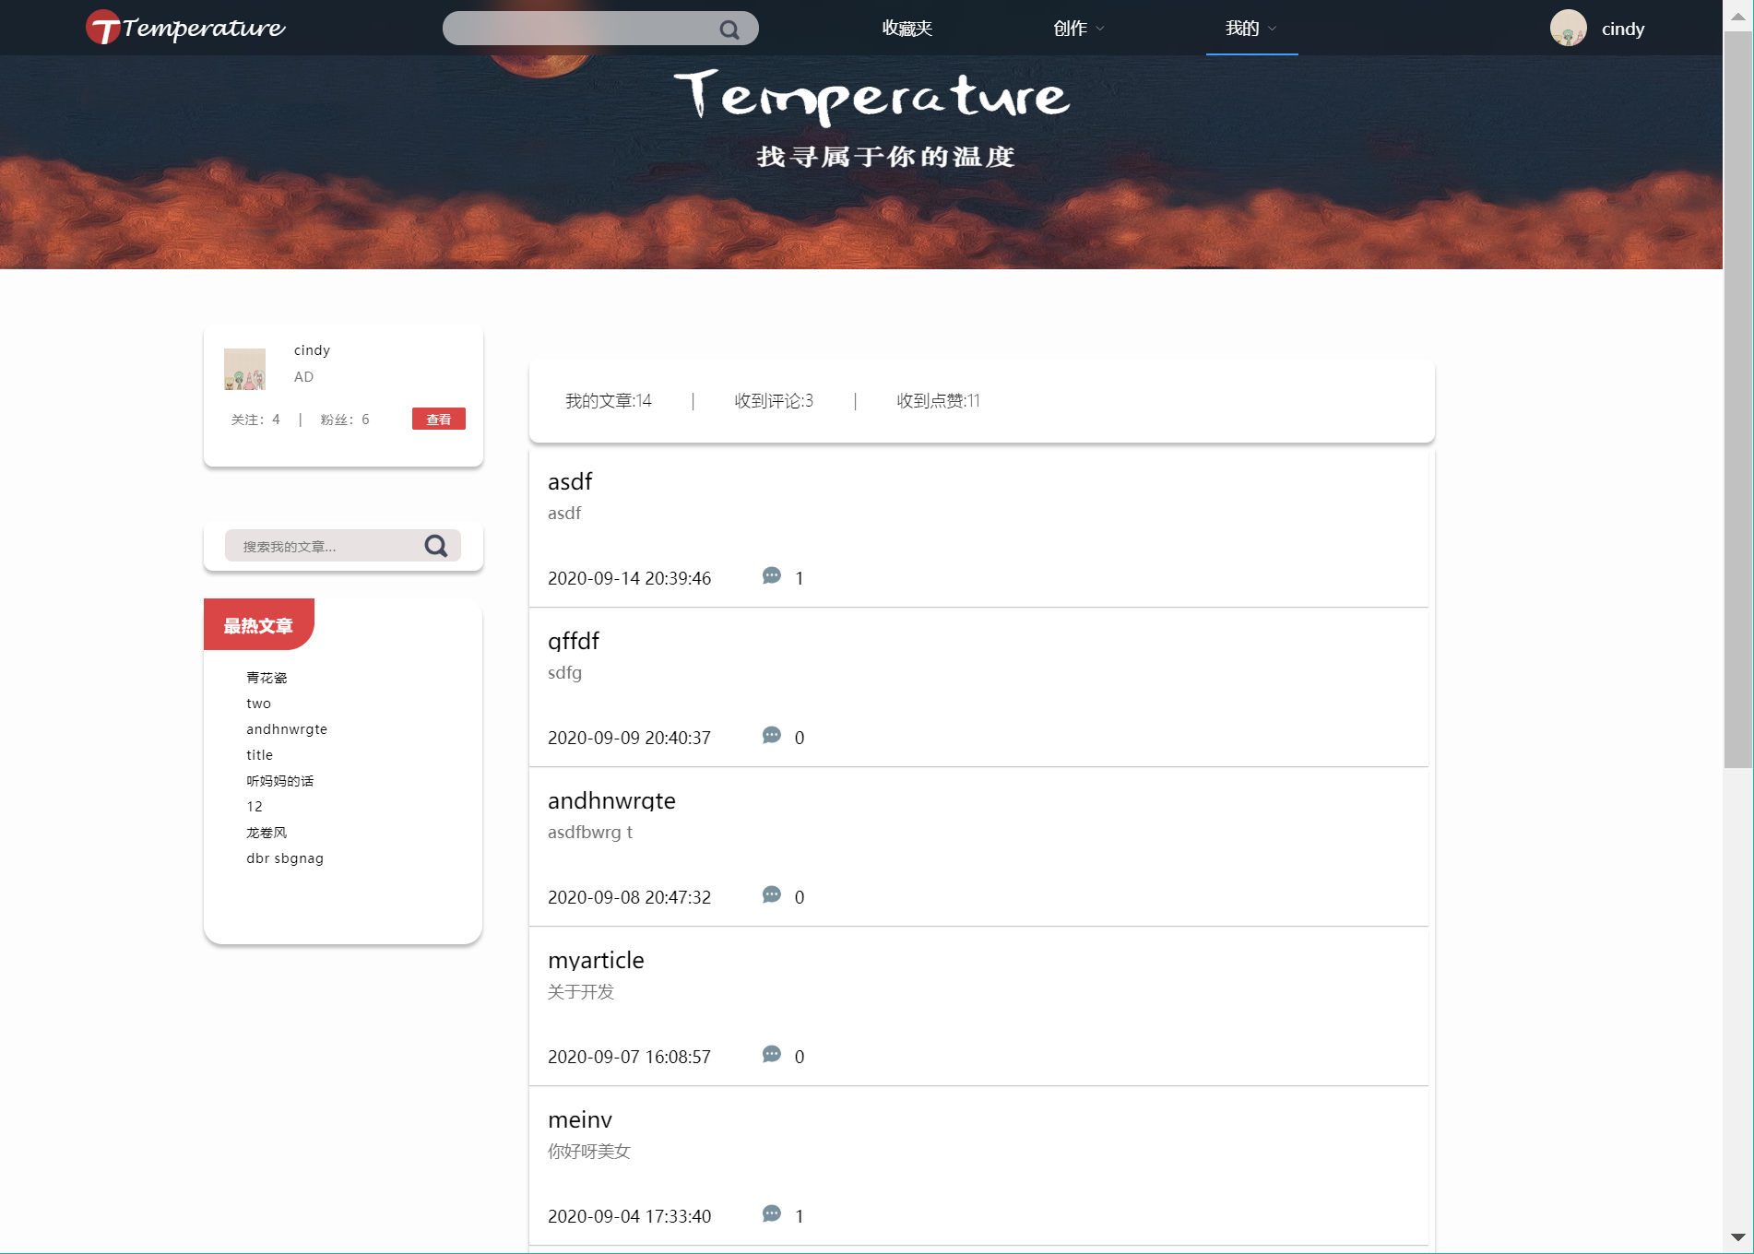

核心代码：

**创建文章**

[HttpPost]

public JsonResult createArticleByNickName()

{

var flag = 0;

string content = Request.Form["content"];

string title = Request.Form["title"];

string nick_name = Request.Form["nick_name"];

string zoneid = Request.Form["zoneid"];

var userid =

(from c in entity.User

where c.NickName == nick_name

select c.UserId).Distinct();

var id = userid.FirstOrDefault(); //在数据库中根据key找到相应记录

if (id == default)

{

flag = 2;//没有找到该用户

return Json(new { UserID = id, ReturnFlag = flag, result = "NOT FOUND" });

}

var checkArticle =

(from c in entity.Article

where (c.Title == title && c.UserId == id)

select c.ArticleId).Distinct();

var check = checkArticle.FirstOrDefault();

if (check != default)

{

flag = 3;//该用户已存在同名文章

return Json(new { ReturnFlag = flag, UserName = nick_name, Article_Name = title, result = "Already Exists!" });

}

//Zone里面更新文章数量

var zoneID = int.Parse(zoneid);

var zone = entity.Zone.Find(zoneID);

var num = zone.ZoneArticleNum;

if (num == default)

zone.ZoneArticleNum = 1;

else

zone.ZoneArticleNum = num + 1;

entity.Entry(zone).State = EntityState.Modified;

//Article里新增文章

var article = new Article();

article.Title = title;

article.UserId = id;

article.ReadNum = 0;

article.ZoneId=int.Parse(zoneid);

article.CollectNum = 0;

article.ArticleLikes = 0;

article.ArticleUploadTime = DateTime.Now;

article.ArticleContent = content;

entity.Article.Add(article);

entity.SaveChanges();

flag = 1;

return Json(new { ReturnFlag = flag, user = nick_name, article = title });

}

**删除文章**

[HttpPost]

public JsonResult deleteArticleByTitle(string nick_name, string title)

{

var flag = 0;

var userid =

(from c in entity.User

where c.NickName == nick_name

select c.UserId).Distinct();

var id = userid.FirstOrDefault();

if (id == default)

{

flag = 2;

return Json(new { ReturnFlag = flag, UserID = id, result = "NOT FOUND" });

}

//找到对应文章

var articleid =

(from c in entity.Article

where (c.Title == title && c.UserId == id)

select c.ArticleId).Distinct();

var A_id = articleid.FirstOrDefault();

if (A_id == default)

{

flag = 3;

return Json(new { ReturnFlag = flag, articleID = A_id, result = "NOT FOUND" });

}

//获得ArticleCommentReply表中记录

var A_CR_record =

(from c in entity.ArticleCommentReply

where c.ArticleId == A_id

select c).ToList();

foreach (var record in A_CR_record)

{

var crID = record.ArticleCrId;

entity.Entry(record).State = EntityState.Deleted;

entity.SaveChanges();

}

//获得ArticleRank表中记录

var A_Rank_record =

(from c in entity.ArticleRank

where c.ArticleId == A_id

select c).ToList();

foreach (var record in A_Rank_record)

{

var RID = record.ArticleRank1;

entity.Entry(record).State = EntityState.Deleted;

entity.SaveChanges();

}

//ArticleVisit删除

var A_V_record =

(from c in entity.ArticleVisit

where c.ArticleId == A_id

select c).ToList();

foreach (var record in A_V_record)

{

entity.Entry(record).State = EntityState.Deleted;

entity.SaveChanges();

}

//ARTICLE表删除

var info = entity.Article.Find(A_id);

entity.Entry(info).State = EntityState.Deleted;

entity.SaveChanges();

flag = 1;

return Json(new { ReturnFlag = flag, UserName = nick_name, ArticleName = title, result = "success!" });

}

**删除文章浏览记录**

[HttpPost]

public JsonResult DeleteArticleVisitByTitle(string nick_name, string title)

{

var flag = 0;

var userid =

(from c in entity.User

where c.NickName == nick_name

select c.UserId).Distinct();

var id = userid.FirstOrDefault();

if (id == default)

{

flag = 2;

return Json(new { ReturnFlag = flag, UserID = id, result = "NOT FOUND" });

}

//找到对应文章

var articleid =

(from c in entity.Article

where (c.Title == title)

select c.ArticleId).Distinct();

var A_id = articleid.FirstOrDefault();

if (A_id == default)

{

flag = 3;

return Json(new { ReturnFlag = flag, articleID = A_id, result = "NOT FOUND" });

}

//找到对应浏览记录

var visitid =

(from c in entity.ArticleVisit

where (c.ArticleId == A_id && c.UserId == id)

select c.ArticleId).Distinct();

var V_id = visitid.FirstOrDefault();

if (V_id == default)

{

flag = 4;

return Json(new { ReturnFlag = flag, VID = V_id, result = "NOT FOUND" });

}

var item = entity.ArticleVisit.Find(id, A_id);

//ARTICLEVISIT表中删除

entity.Entry(item).State = EntityState.Deleted;

entity.SaveChanges();

flag = 1;

return Json(new { ReturnFlag = flag, result = "successful deleted" });

}

**获取文章浏览记录**

[HttpPost]

public JsonResult getArticleVisitByTitle(string nick_name, string title)

{

var flag = 0;

var userid =

(from c in entity.User

where c.NickName == nick_name

select c.UserId).Distinct();

var id = userid.FirstOrDefault();

if (id == default)

{

flag = 2;

return Json(new { ReturnFlag = flag, UserID = id, result = "NOT FOUND" });

}

//找到文章

var articleid =

(from c in entity.Article

where (c.Title == title)

select c.ArticleId).Distinct();

var A_id = articleid.FirstOrDefault();

if (A_id == default)

{

flag = 3;

return Json(new { ReturnFlag = flag, articleID = A_id, result = "NOT FOUND" });

}

var item =

(from u in entity.ArticleVisit

where u.ArticleId == A_id

select u).OrderByDescending(u => u.ArticleVisitTime).Distinct();

flag = 1;

return Json(new { ReturnFlag = flag, Item = item });

}

**更新文章**

[HttpPost]

public JsonResult updateArticleByTtile(string nick_name, string title, string newName, string newContent)

{

var flag = 0;

var userid =

(from c in entity.User

where c.NickName == nick_name

select c.UserId).Distinct();

var id = userid.FirstOrDefault();

if (id == default)

{

flag = 2;

return Json(new { ReturnFlag = flag, UserID = id, result = "NOT FOUND" });

}

//找到文章

var articleid =

(from c in entity.Article

where (c.Title == title && c.UserId == id)

select c.ArticleId).Distinct();

var A_id = articleid.FirstOrDefault();

if (A_id == default)

{

flag = 3;

return Json(new { ReturnFlag = flag, articleID = A_id, result = "NOT FOUND" });

}

var info = entity.Article.Find(A_id);

info.Title = newName;

info.ArticleContent = newContent;

entity.Entry(info).State = EntityState.Modified;

entity.SaveChanges();

flag = 1;

return Json(new { ReturnFlag = flag, UserName = nick_name, OldName = title, NewName = newName, NewContent = newContent });

}

**分页获取用户自己的文章**

[HttpPost]

public JsonResult getpersonalArticlebypage(int pageNum, int pageSize, int userId)

{

int getFlag = 0;

Dictionary<string, string> returnJson = new Dictionary<string, string>();

returnJson.Add("Result", "");

try

{

var content = (from c in entity.Article

join right in entity.User on c.UserId equals right.UserId

where c.UserId == userId

orderby c.ArticleUploadTime descending

select new

{

User_name=right.NickName,

article_id = c.ArticleId,

title = c.Title,

userid = c.UserId,

articlcontent = c.ArticleContent,

articlelike = c.ArticleLikes,

collectnum = c.CollectNum,

readnum = c.ReadNum,

uploadtime = c.ArticleUploadTime,

zoneid = c.ZoneId,

commentnum = (from u in entity.ArticleCommentReply

where u.ArticleId == c.ArticleId

select u).Count() ,

}).Skip((pageNum - 1) * pageSize).Take(pageSize);

string contentJson = JsonConvert.SerializeObject(content); //序列化对象

returnJson["Result"] = contentJson;

getFlag = 1;

}

catch (Exception e)

{

getFlag = 0;

}

finally

{

returnJson.Add("getFlag", getFlag.ToString());

}

return Json(returnJson);

}

**分页获取别人的文章**

[HttpPost]

public JsonResult getotherArticlebypage(int pageNum, int pageSize, int userId, int authorid)

{

int getFlag = 0;

Dictionary<string, string> returnJson = new Dictionary<string, string>();

returnJson.Add("Result", "");

var user_name =

(from c in entity.User

where c.UserId == userId

select c.NickName).Distinct();

var username = user_name.FirstOrDefault();

try

{

var content = (from c in entity.Article

join right in entity.User on c.UserId equals right.UserId

where c.UserId == authorid

orderby c.ArticleUploadTime descending

select new

{

User_name = username,

authorname = right.NickName,

article_id = c.ArticleId,

title = c.Title,

userid = c.UserId,

articlcontent = c.ArticleContent,

articlelike = c.ArticleLikes,

collectnum = c.CollectNum,

readnum = c.ReadNum,

uploadtime = c.ArticleUploadTime,

zoneid = c.ZoneId,

commentnum = (from u in entity.ArticleCommentReply

where u.ArticleId == c.ArticleId

select u).Count(),//.Distinct().Count(),

}).Skip((pageNum - 1) * pageSize).Take(pageSize);

string contentJson = JsonConvert.SerializeObject(content); //序列化对象

returnJson["Result"] = contentJson;

getFlag = 1;

}

catch (Exception e)

{

getFlag = 0;

}

finally

{

returnJson.Add("getFlag", getFlag.ToString());

}

return Json(returnJson);

}

**得到一个用户的最热文章列表**

[HttpPost]

public JsonResult getPersonalhottestArticle(int userid,int getarticleNum)

{

int getArticleFlag = 0;

Dictionary<string, string> returnJson = new Dictionary<string, string>();

returnJson.Add("Result", "");

try

{

var content = (from c in entity.Article

join right in entity.User on c.UserId equals right.UserId

where c.UserId==userid

orderby (c.ReadNum + c.ArticleLikes) descending

select new

{

nickname = right.NickName,

article_id = c.ArticleId,

title = c.Title,

userid = c.UserId,

articlcontent = c.ArticleContent,

articlelike = c.ArticleLikes,

collectnum = c.CollectNum,

readnum = c.ReadNum,

uploadtime = c.ArticleUploadTime,

zoneid = c.ZoneId,

}

).Take(getarticleNum);

getArticleFlag = 1;

return Json(new { articleDetail = content, flag = getArticleFlag });

}

catch (Exception e)

{

getArticleFlag = 0;

}

finally

{

returnJson.Add("getArticleFlag", getArticleFlag.ToString());

}

return Json(returnJson);

}

**得到一个用户的最新文章列表**

[HttpPost]

public JsonResult getPersonalnewestArticle(int userid, int getarticleNum)

{

int getArticleFlag = 0;

Dictionary<string, string> returnJson = new Dictionary<string, string>();

returnJson.Add("Result", "");

try

{

var content = (from c in entity.Article

join right in entity.User on c.UserId equals right.UserId

where c.UserId == userid

orderby c.ArticleUploadTime descending

select new

{

nickname = right.NickName,

article_id = c.ArticleId,

title = c.Title,

userid = c.UserId,

articlcontent = c.ArticleContent,

articlelike = c.ArticleLikes,

collectnum = c.CollectNum,

readnum = c.ReadNum,

uploadtime = c.ArticleUploadTime,

zoneid = c.ZoneId,

}).Take(getarticleNum);

getArticleFlag = 1;

return Json(new { articleDetail = content, flag = getArticleFlag });

}

catch (Exception e)

{

getArticleFlag = 0;

}

finally

{

returnJson.Add("getArticleFlag", getArticleFlag.ToString());

}

return Json(returnJson);

}

**个人文章关键字搜索**

[HttpPost]

public JsonResult getSearchedpersonalArticle(string searchContent, int pageNum, int pageSize,int userid)

{

int flag = 0;

string tt = string.Format(@"({0})", searchContent);

try

{

var content = (from c in entity.Article

where c.UserId==userid

join d in entity.Zone on c.ZoneId equals d.ZoneId

where c.Title.Contains(searchContent)

select new

{

ArticleTitle = c.Title,

articleid = c.ArticleId,

articleContent = c.ArticleContent,

articlelike = c.ArticleLikes,

collectnum = c.CollectNum,

readnum = c.ReadNum,

userId = c.UserId,

articleUploadTime = c.ArticleUploadTime,

zoneId = c.ZoneId,

zoneName = d.ZoneName,

}).Skip((pageNum - 1) * pageSize).Take(pageSize);

flag = 1;

return Json(new { articleDetail = content, flag = flag });

}

catch (Exception e)

{

Console.WriteLine(e.Message);

flag = 0;

return Json(new { flag = flag });

}

}

}

### 2.3.2查看他人文章用例实现

界面截图：

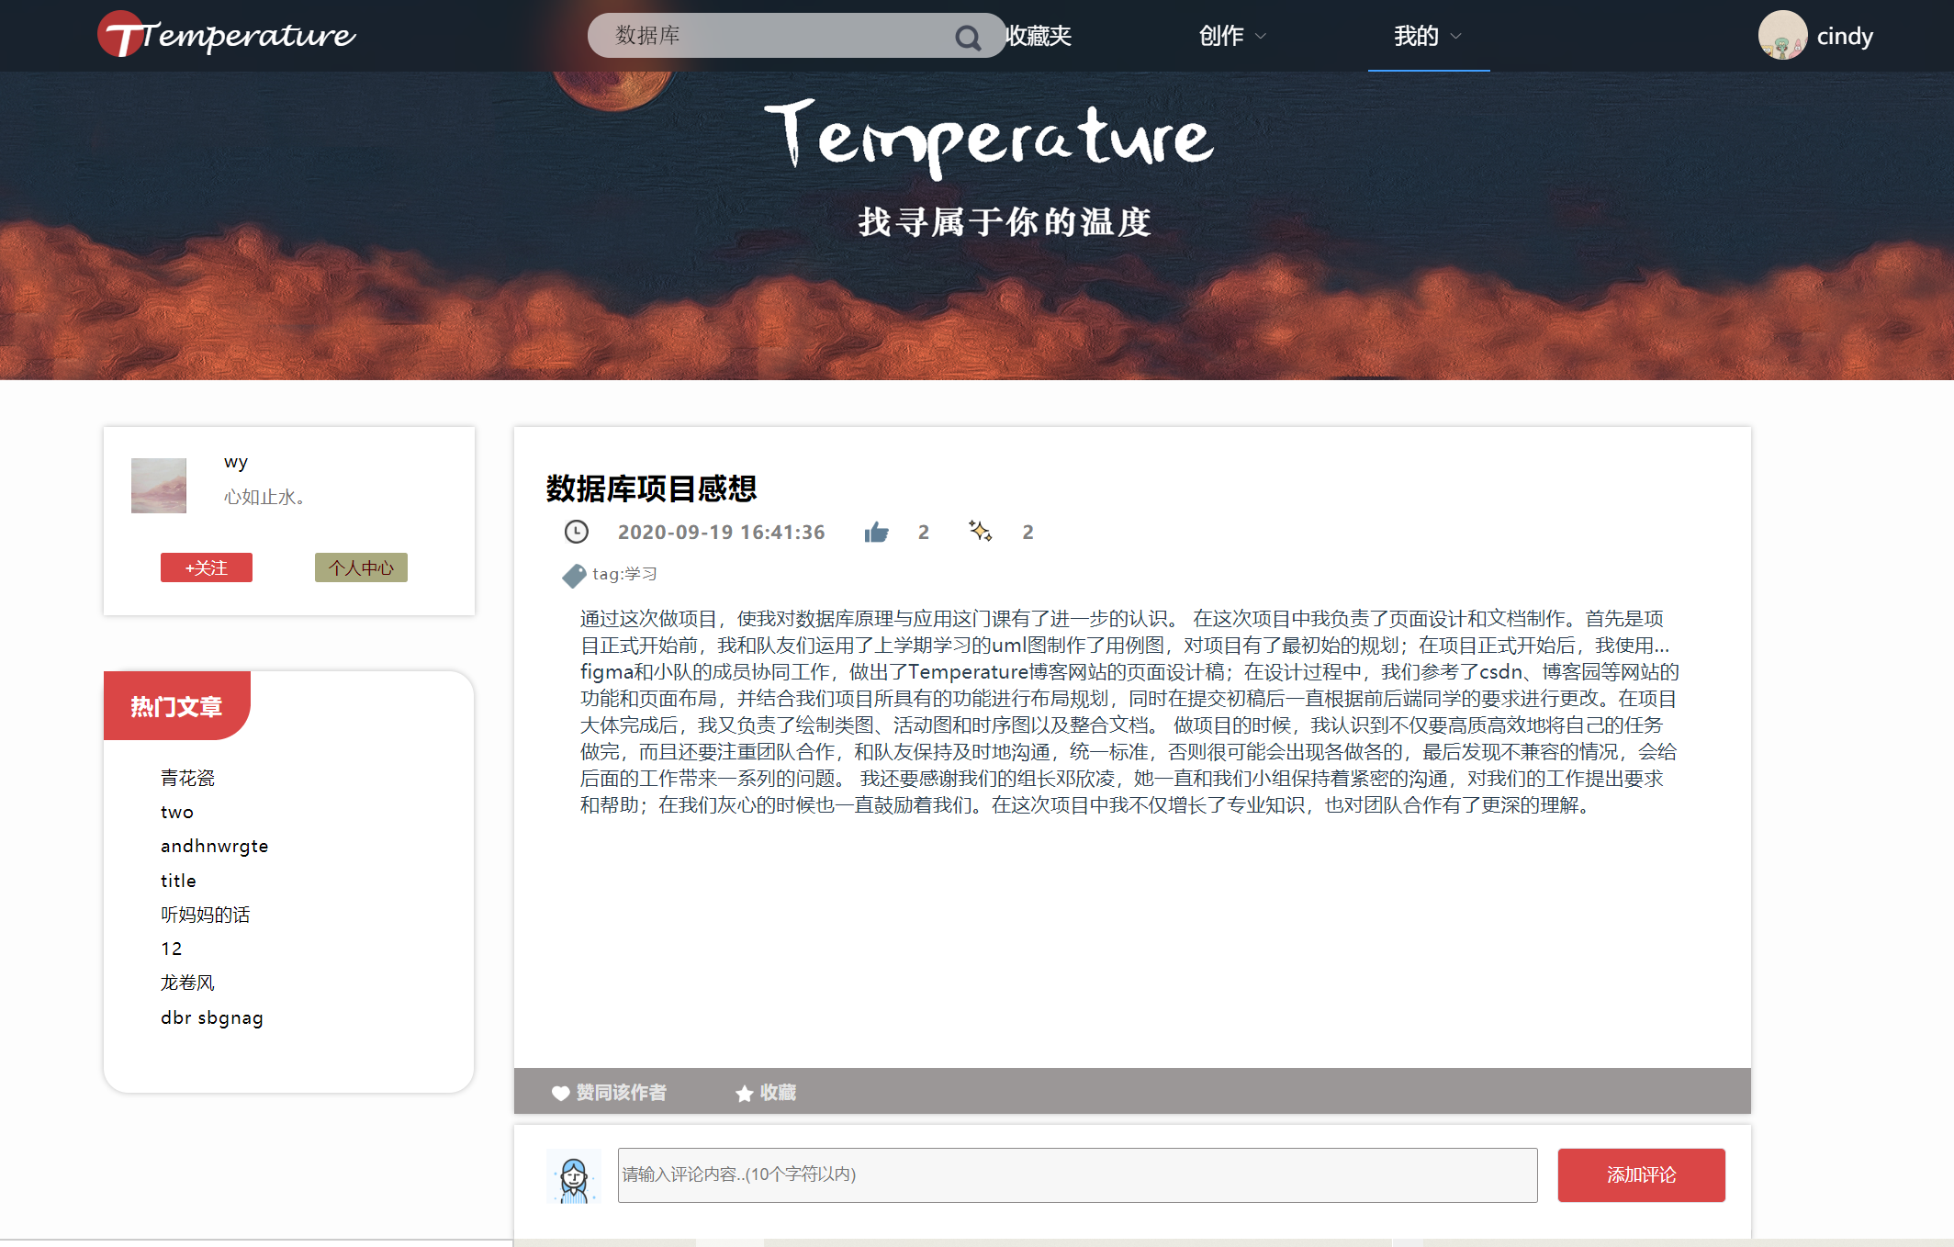

核心代码：

**查看文章**

[HttpPost]

public JsonResult getArticleInfoByTitle(string nick_name, string title)

{

var flag = 0;

var userid =

(from c in entity.User

where c.NickName == nick_name

select c.UserId).Distinct();

var id = userid.FirstOrDefault();

if (id == default)

{

flag = 2;

return Json(new { ReturnFlag = flag, UserID = id, result = "NOT FOUND" });

}

//根据文章名找到对应文章

var articleid =

(from c in entity.Article

where c.Title == title

select c.ArticleId).Distinct();

var A_id = articleid.FirstOrDefault();

if (A_id == default)

{

flag = 3;

return Json(new { ReturnFlag = flag, ArticleID = A_id, result = "NOT FOUND" });

}

//修改Article表

var article = entity.Article.Find(A_id);

article.ReadNum++;

entity.Entry(article).State = EntityState.Modified;

entity.SaveChanges();

//修改ArticleVisit表

var item = new ArticleVisit();

item.ArticleId = A_id;

item.ArticleVisitTime = DateTime.Now;

item.UserId = id;

entity.ArticleVisit.Add(item);

entity.SaveChanges();

var info = entity.Article.Find(A_id);

flag = 1;

return Json(new { ReturnFlag = flag,INFO = info });

}

### 2.3.3点赞他人文章用例实现

界面截图：

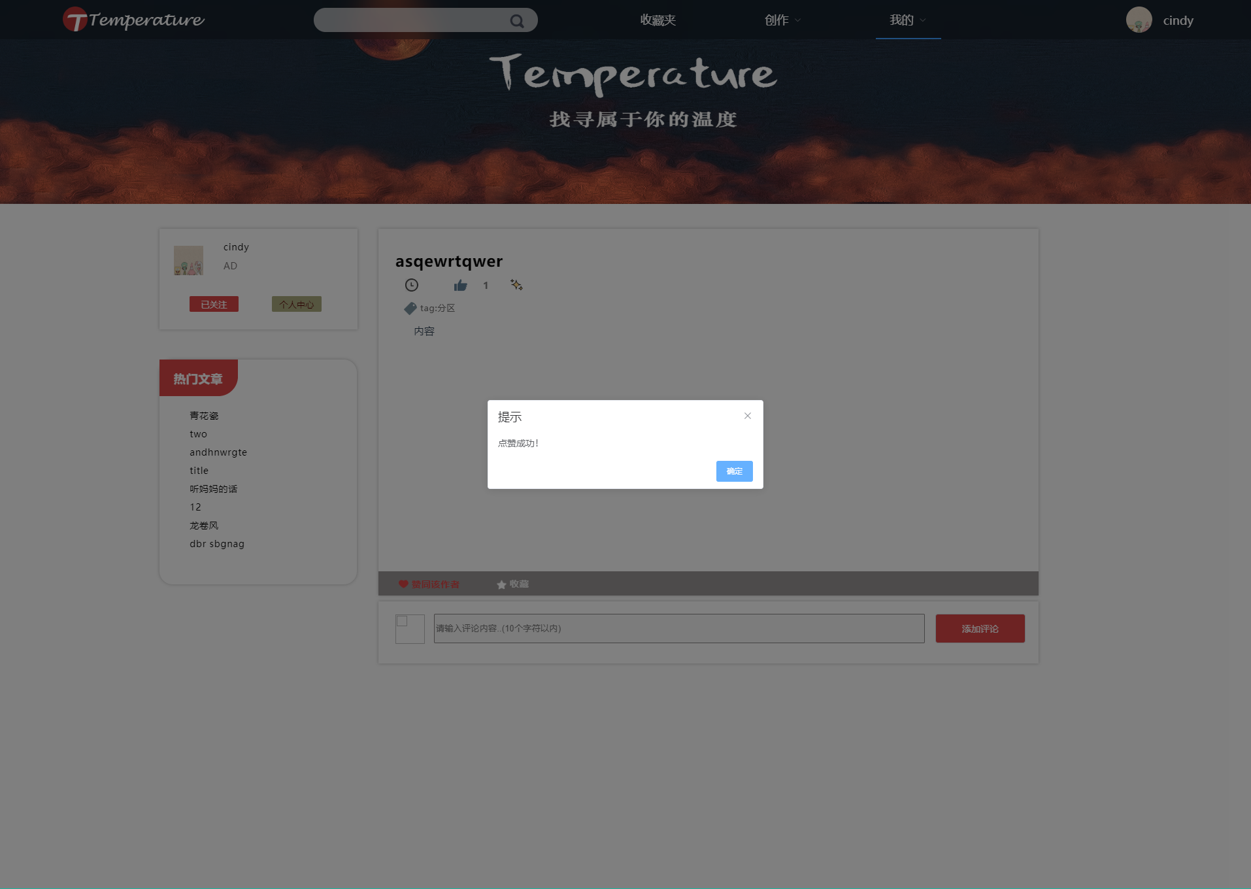

核心代码：

**点赞文章**

[HttpPost]

public JsonResult addArticleLikeByTitle(string nick_name, string title)

{

var flag = 0;

var userid =

(from c in entity.User

where c.NickName == nick_name

select c.UserId).Distinct();

var id = userid.FirstOrDefault();

if (id == default)

{

flag = 2;

return Json(new { ReturnFlag = flag, UserID = id, result = "NOT FOUND" });

}

//找到文章

var articleid =

(from c in entity.Article

where (c.Title == title)

select c.ArticleId).Distinct();

var A_id = articleid.FirstOrDefault();

if (A_id == default)

{

flag = 3;

return Json(new { ReturnFlag = flag, articleID = A_id, result = "NOT FOUND" });

}

string userID = id.ToString();

//检查之前是否点赞过

var checkItem = entity.ArticleRank.Find(userID, A_id);

if(checkItem == default) //没有点赞过,正常进行点赞

{

//修改文章表的articleLikes属性

var info = entity.Article.Find(A_id);

info.ArticleLikes++;

entity.Entry(info).State = EntityState.Modified;

entity.SaveChanges();

//修改点赞记录表(article_rank)

var record = new ArticleRank();

record.ArticleId = A_id;

record.ArticleRank1 = userID;

record.ArticleRankDate = DateTime.Now;

entity.ArticleRank.Add(record);

entity.SaveChanges();

flag = 1;

return Json(new { ReturnFlag = flag, result = "successful" });

}

else //已经被点赞

{

flag = 4;

return Json(new { ReturnFlag = flag, result = "already Liked" });

}

**收藏文章**

[HttpPost]

public JsonResult addArticleCollectByTitle(string nick_name, string title)

{

var flag = 0;

var userid =

(from c in entity.User

where c.NickName == nick_name

select c.UserId).Distinct();

var id = userid.FirstOrDefault();

if (id == default)

{

flag = 2;

return Json(new { ReturnFlag = flag, UserID = id, result = "NOT FOUND" });

}

//找到文章

var articleid =

(from c in entity.Article

where (c.Title == title)

select c.ArticleId).Distinct();

var A_id = articleid.FirstOrDefault();

if (A_id == default)

{

flag = 3;

return Json(new { ReturnFlag = flag, articleID = A_id, result = "NOT FOUND" });

}

var info = entity.Article.Find(A_id);

info.CollectNum++;

entity.Entry(info).State = EntityState.Modified;

entity.SaveChanges();

flag = 1;

return Json(new { ReturnFlag = flag, result = "successful" });

}

### 2.3.4评论他人文章用例实现

界面截图：

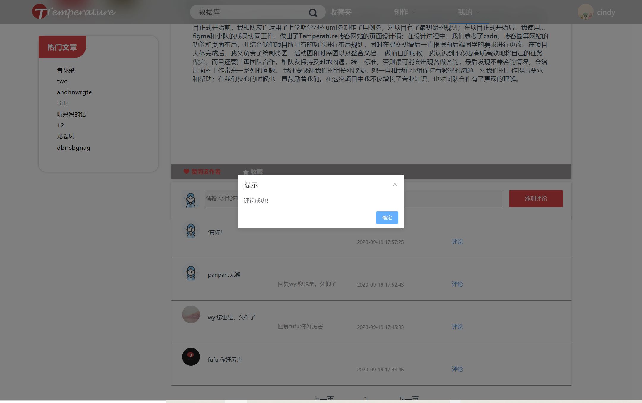

核心代码：

**新增文章评论**

[HttpPost]

public JsonResult createArticleCommentByNickName(string nick_name, string title, string content)

{

var flag = 0;

var userid =

(from c in entity.User

where c.NickName == nick_name

select c.UserId).Distinct();

var id = userid.FirstOrDefault();

if (id == default)

{

flag = 2;

return Json(new { ReturnFlag = flag, UserID = id, result = "NOT FOUND" });

}

var articleid =

(from c in entity.Article

where (c.Title == title)

select c.ArticleId).Distinct();

var A_id = articleid.FirstOrDefault();

if (A_id == default)

{

flag = 3; //没找到该文章

return Json(new { ReturnFlag = flag, article = title, result = "Article NOT FOUND" });

}

//加入ARTICLE_COMMENT_REPLY表

var item = new ArticleCommentReply();

item.ArticleId = A_id;

item.ArticleCrContent = content;

item.ArticleCrTime = DateTime.Now;

item.UserId = id;

entity.ArticleCommentReply.Add(item);

entity.SaveChanges();

flag = 1;

return Json(new { ReturnFlag = flag, articleID = A_id, articlecomment = content });

}

**删除评论**

[HttpPost]

public JsonResult deleteArticleCommentByID(string nick_name, int articlecommentID)

{

var flag = 0;

var userid =

(from c in entity.User

where c.NickName == nick_name

select c.UserId).Distinct();

var id = userid.FirstOrDefault();

if (id == default)

{

flag = 2;

return Json(new { ReturnFlag = flag, UserID = id, result = "NOT FOUND" });

}

//找到对应评论

var crid =

(from c in entity.ArticleCommentReply

where (c.ArticleCrId == articlecommentID && c.UserId == id)

select c.ArticleCrId).Distinct();

var A_id = crid.FirstOrDefault();

if (A_id == default)

{

flag = 3;

return Json(new { ReturnFlag = flag, crID = A_id, result = "NOT FOUND" });

}

var item = entity.ArticleCommentReply.Find(A_id);

//ARTICLE_COMMENT_REPLY表中更新

entity.Entry(item).State = EntityState.Deleted;

entity.SaveChanges();

flag = 1;

return Json(new { ReturnFlag = flag, result = "successful deleted" });

}

**分页查看文章评论**

[HttpPost]

public JsonResult getArticleCommentByTitle(string nick_name, string title,int pageNum,int pageSize)

{

var flag = 0;

var userid =

(from c in entity.User

where c.NickName == nick_name

select c.UserId).Distinct();

var id = userid.FirstOrDefault();

if (id == default)

{

flag = 2;

return Json(new { ReturnFlag = flag, UserID = id, result = "NOT FOUND" });

}

//找到文章

var articleid =

(from c in entity.Article

where (c.Title == title)

select c.ArticleId).Distinct();

var A_id = articleid.FirstOrDefault();

if (A_id == default)

{

flag = 3;

return Json(new { ReturnFlag = flag, articleID = A_id, result = "NOT FOUND" });

}

var item =

from u in entity.ArticleCommentReply

join right in entity.User on u.UserId equals right.UserId

join second in entity.ArticleCommentReply on u.ParentCrId equals second.ArticleCrId into resultOne //第一层

from x in resultOne.DefaultIfEmpty()

join three in entity.User on x.UserId equals three.UserId into resultTwo

from y in resultTwo.DefaultIfEmpty()

where u.ArticleId == A_id

orderby u.ArticleCrTime descending

select new { Article_cr_id = u.ArticleCrId,

Article_cr_content = u.ArticleCrContent,

Article_id = u.ArticleId,

Nick_name = right.NickName,

Article_cr_time = u.ArticleCrTime,

Parent_cr_id = u.ParentCrId,

Parent_cr_name =y.NickName,

Parent_cr_avatr=y.Avatr,

Parent_cr_content = x.ArticleCrContent,

Avatr =right.Avatr }).Skip((pageNum-1)*pageSize).Take(pageSize);

flag = 1;

return Json(new { ReturnFlag = flag, Item = item });

}

**返回父评论信息**

[HttpPost]

public JsonResult getparentCRByID(int articleCRid)

{

var flag = 0;

var parentid =

(from c in entity.ArticleCommentReply

where c.ArticleCrId == articleCRid

select c.ParentCrId).Distinct();

var id = parentid.FirstOrDefault();

var item =

(from u in entity.ArticleCommentReply

join right in entity.User on u.UserId equals right.UserId

where u.ArticleCrId == id

select new

{

parentid=id,

parent_name=right.NickName,

content=u.ArticleCrContent,

avatr=right.Avatr

}).Distinct();

flag = 1;

return Json(new { ReturnFlag = flag, Item = item });

}

**更新评论**

[HttpPost]

public JsonResult updateArticleCommentByID(string nick_name, int articlecrid, string newContent)

{

var flag = 0;

var userid =

(from c in entity.User

where c.NickName == nick_name

select c.UserId).Distinct();

var id = userid.FirstOrDefault();

if (id == default)

{

flag = 2;

return Json(new { ReturnFlag = flag, UserID = id, result = "NOT FOUND" });

}

//找到文章

var crid =

(from c in entity.ArticleCommentReply

where (c.ArticleCrId == articlecrid && c.UserId == id)

select c.ArticleCrId).Distinct();

var cr_id = crid.FirstOrDefault();

if (cr_id == default)

{

flag = 3;

return Json(new { ReturnFlag = flag, crID = cr_id, result = "NOT FOUND" });

}

var info = entity.ArticleCommentReply.Find(cr_id);

info.ArticleCrContent = newContent;

entity.Entry(info).State = EntityState.Modified;

entity.SaveChanges();

flag = 1;

return Json(new { ReturnFlag = flag, UserName = nick_name, crID = articlecrid, NewContent = newContent });

}

**评论其他评论**

[HttpPost]

public JsonResult createCommentCommentByID(string nick_name, int articlecommentID1, string content)

{

var flag = 0;

var userid =

(from c in entity.User

where c.NickName == nick_name

select c.UserId).Distinct();

var id = userid.FirstOrDefault();

if (id == default)

{

flag = 2;

return Json(new { ReturnFlag = flag, UserID = id, result = "NOT FOUND" });

}

var articleid =

(from c in entity.ArticleCommentReply

where (c.ArticleCrId == articlecommentID1)

select c.ArticleId).Distinct();

var A_id = articleid.FirstOrDefault();

var crid =

(from c in entity.ArticleCommentReply

where (c.ArticleCrId == articlecommentID1)

select c.ArticleCrId).Distinct();

var CR_id = crid.FirstOrDefault();

if (CR_id == default)

{

flag = 3;

return Json(new { ReturnFlag = flag, aclid = articlecommentID1, result = " NOT FOUND" });

}

//加入ARTICLE_COMMENT_REPLY表

var item = new ArticleCommentReply();

item.ArticleId = A_id;

item.ArticleCrContent = content;

item.ArticleCrTime = DateTime.Now;

item.UserId = id;

item.ParentCrId = articlecommentID1;

entity.ArticleCommentReply.Add(item);

entity.SaveChanges();

flag = 1;

return Json(new { ReturnFlag = flag, articleID = A_id, articlecomment = content });

}

**得到文章评论数**

[HttpPost]

public JsonResult getcommentNumbytitle(string title)

{

int getFlag = 0;

Dictionary<string, string> returnJson = new Dictionary<string, string>();

returnJson.Add("Result", "");

var articleid =

(from c in entity.Article

where c.Title == title

select c.ArticleId).Distinct();

var A_id = articleid.FirstOrDefault();

try

{

var commentnum = (from u in entity.ArticleCommentReply

where u.ArticleId == A_id

select u).Count();//.Distinct().Count(),

getFlag = 1;

return Json(new { commentNUM =commentnum, flag = getFlag });

}

catch (Exception e)

{

getFlag = 0;

}

finally

{

returnJson.Add("getFlag", getFlag.ToString());

}

return Json(returnJson);

}

**获取用户所有文章的最新评论**

[HttpPost]

public JsonResult getNewestComment(int takeCommentNum,string nick_name)

{

int flag = 0;

Dictionary<string, string> returnJson = new Dictionary<string, string>();

var userid =

(from c in entity.User

where c.NickName == nick_name

select c.UserId).Distinct();

var id = userid.FirstOrDefault();

if (id == default)

{

flag = 2;

return Json(new { ReturnFlag = flag, UserID = id, result = "NOT FOUND" });

}

try

{

var content =

(from c in entity.ArticleCommentReply

join right in entity.Article on c.ArticleId equals right.ArticleId

join left in entity.User on c.UserId equals left.UserId

where (right.UserId==id)

orderby c.ArticleCrTime descending

select new { Article_cr_id = c.ArticleCrId,

Article_cr_content = c.ArticleCrContent,

Article_id = c.ArticleId, Nick_name = left.NickName,

Article_cr_time = c.ArticleCrTime,

Parent_cr_id = c.ParentCrId }).Take(takeCommentNum);

returnJson.Add("comments", JsonConvert.SerializeObject(content));

flag = 1;

}

catch (Exception e)

{

Console.WriteLine(e.Message);

flag = 0;

}

returnJson.Add("flag", flag.ToString());

return Json(returnJson);

}

### 2.3.5所有文章操作用例实现

界面截图：

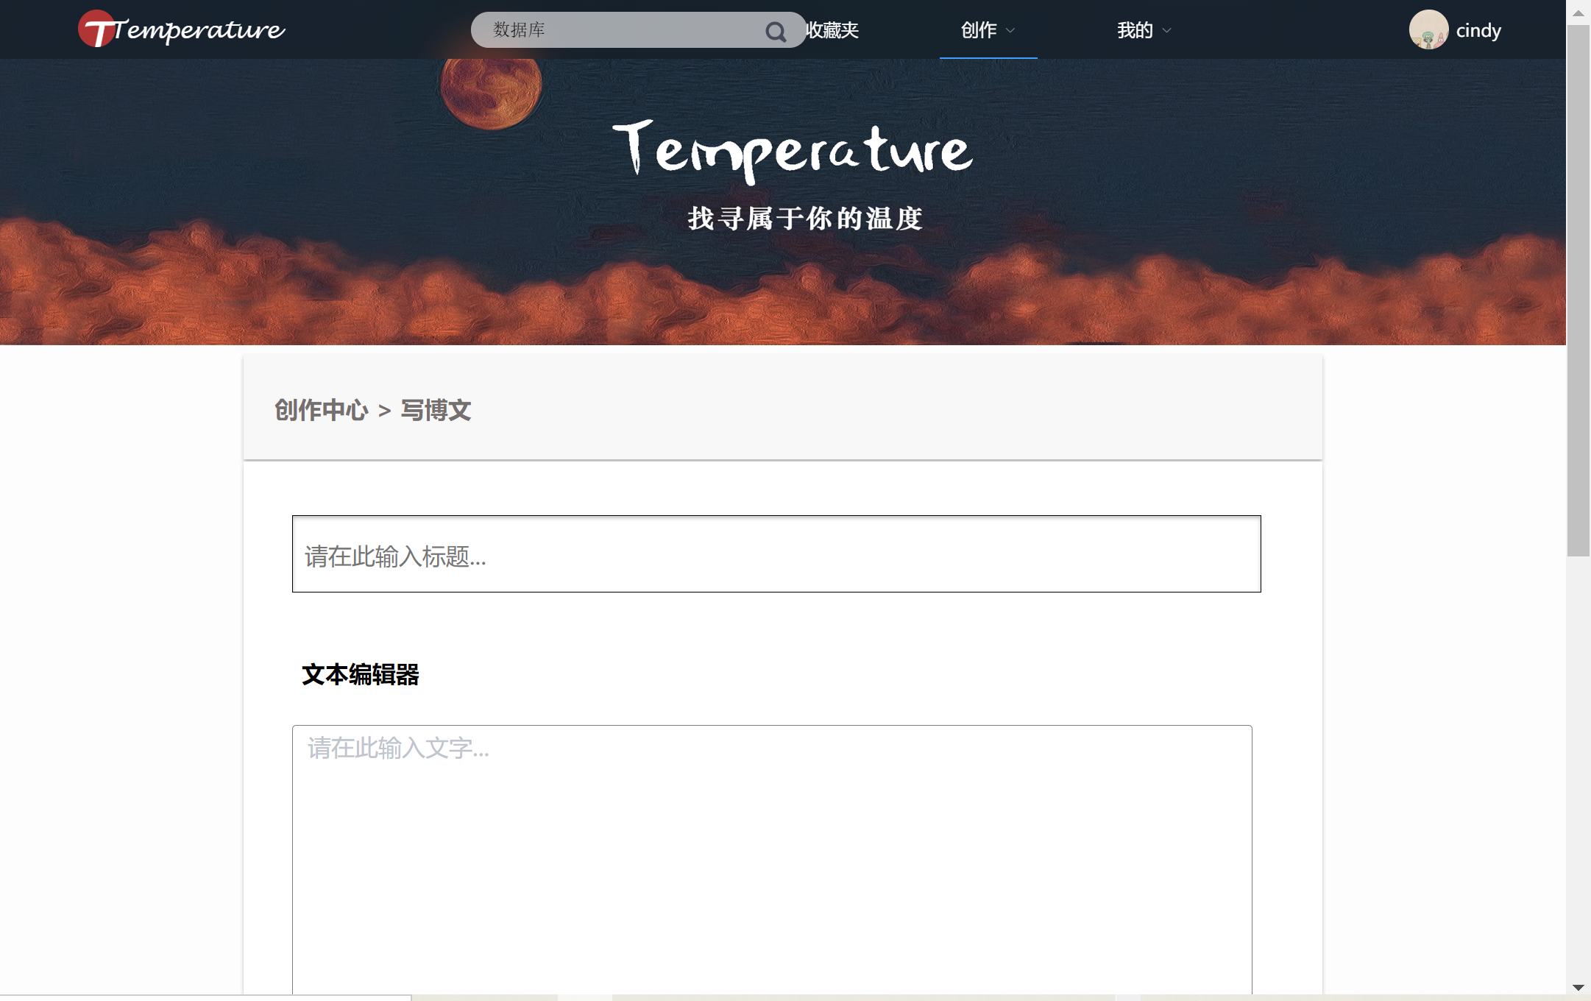

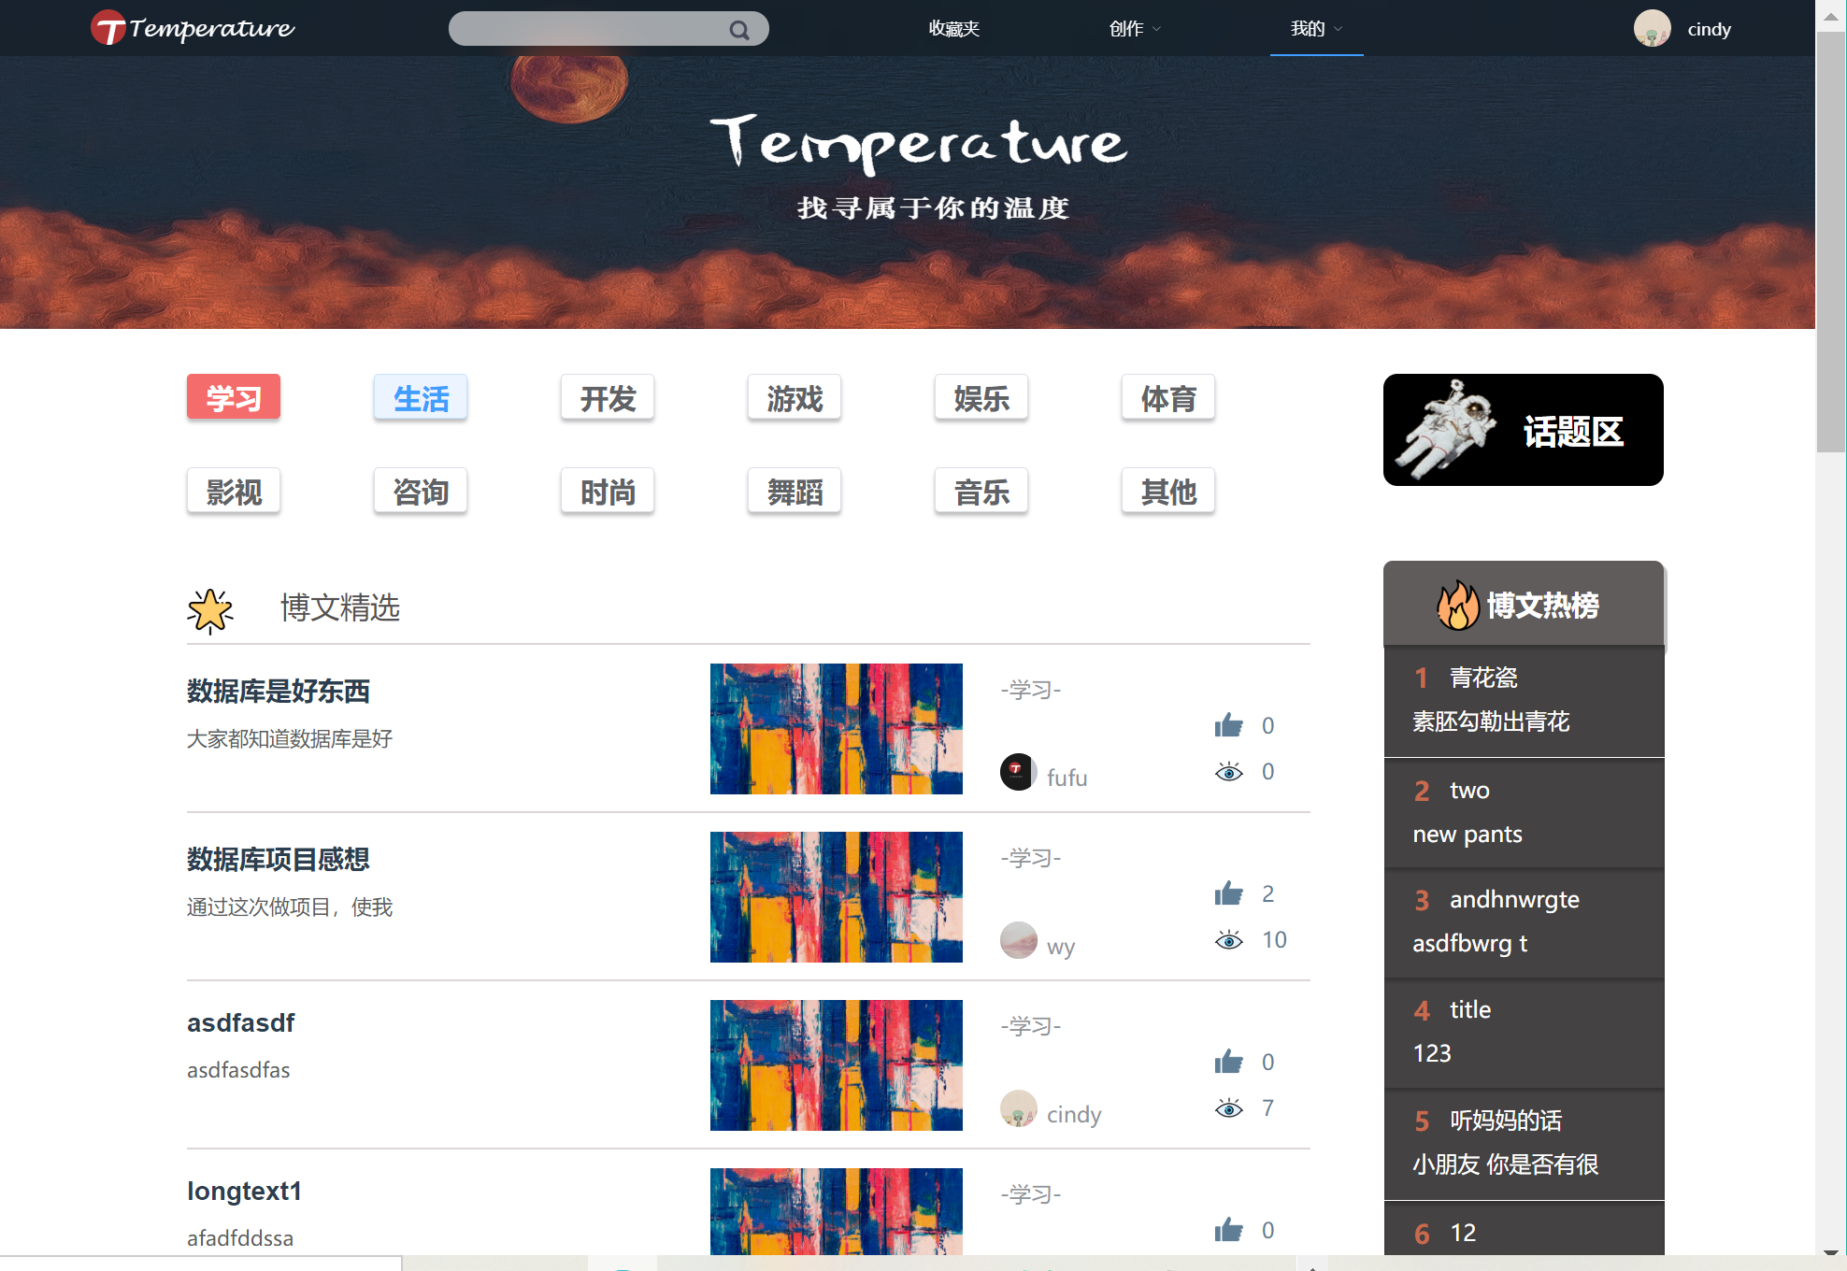

核心代码：

**获取文章浏览排行**

[HttpPost]

public JsonResult getArticleRankByTitle(string nick_name, string title)

{

var flag = 0;

var userid =

(from c in entity.User

where c.NickName == nick_name

select c.UserId).Distinct();

var id = userid.FirstOrDefault();

if (id == default)

{

flag = 2;

return Json(new { ReturnFlag = flag, UserID = id, result = "NOT FOUND" });

}

//找到文章

var articleid =

(from c in entity.Article

where (c.Title == title)

select c.ArticleId).Distinct();

var A_id = articleid.FirstOrDefault();

if (A_id == default)

{

flag = 3;

return Json(new { ReturnFlag = flag, articleID = A_id, result = "NOT FOUND" });

}

var item =

(from u in entity.ArticleRank

where u.ArticleId == A_id

select u).Distinct();

flag = 1;

return Json(new { ReturnFlag = flag, Itme = item });

}

**分页获取所有文章**

public JsonResult getArticleByPage(int pageNum, int pageSize, string zoneID)

{

int getArticleFlag = 0;

Dictionary<string, string> returnJson = new Dictionary<string, string>();

returnJson.Add("Result", "");

try

{

var content = (from c in entity.Article

join right in entity.User

on c.UserId equals right.UserId

where c.ZoneId == int.Parse(zoneID)

orderby c.ArticleUploadTime descending

select new

{

ArticleId = c.ArticleId,

Title = c.Title,

UserId = c.UserId,

Nick_name = right.NickName,

Avatr = right.Avatr,

ArticleContent = c.ArticleContent,

ArticleLikes = c.ArticleLikes,

CollectNum = c.CollectNum,

ReadNum = c.ReadNum,

ArticleUploadTime = c.ArticleUploadTime,

Zoneid = c.ZoneId,

commentnum = (from u in entity.ArticleCommentReply

where u.ArticleId == c.ArticleId

select u).Count()

}

).Skip((pageNum - 1) * pageSize).Take(pageSize);

getArticleFlag = 1;

return Json(new { articleDetail = content, flag = getArticleFlag });

}

catch (Exception e)

{

getArticleFlag = 0;

}

finally

{

returnJson.Add("getFlag", getArticleFlag.ToString());

}

return Json(returnJson);

}

**按阅读量获取文章列表**

[HttpPost]

public JsonResult getArticlebyreadnum(int takeArticleNum)

{

int flag = 0;

Dictionary<string, string> returnJson = new Dictionary<string, string>();

try

{

var content = (from c in entity.Article

join right in entity.User on c.UserId equals right.UserId

orderby c.ReadNum descending

select new

{

authorname = right.NickName,

article_id = c.ArticleId,

title = c.Title,

userid = c.UserId,

articlcontent = c.ArticleContent,

articlelike = c.ArticleLikes,

collectnum = c.CollectNum,

readnum = c.ReadNum,

uploadtime = c.ArticleUploadTime,

zoneid = c.ZoneId,

}).Take(takeArticleNum);

flag = 1;

return Json(new { articleDetail = content, flag = flag });

}

catch (Exception e)

{

Console.WriteLine(e.Message);

flag = 0;

}

returnJson.Add("flag", flag.ToString());

return Json(returnJson);

}

**分页按浏览量、点赞量排序返回所有文章**

[HttpPost]

public JsonResult getRecommandedArticle(int pageNum, int pageSize)

{

int getArticleFlag = 0;

Dictionary<string, string> returnJson = new Dictionary<string, string>();

returnJson.Add("Result", "");

try

{

var content = (from c in entity.Article

orderby (c.ReadNum + c.ArticleLikes) descending

select c).Skip((pageNum - 1) * pageSize).Take(pageSize);

string contentJson = JsonConvert.SerializeObject(content);

returnJson["Result"] = contentJson;

getArticleFlag = 1;

}

catch (Exception e)

{

getArticleFlag = 0;

}

finally

{

returnJson.Add("getArticleFlag", getArticleFlag.ToString());

}

return Json(returnJson);

}

**得到最新上传的文章列表**

[HttpPost]

public JsonResult getnewestArticle(int getarticleNum)

{

int getArticleFlag = 0;

Dictionary<string, string> returnJson = new Dictionary<string, string>();

returnJson.Add("Result", "");

try

{

var content = (from c in entity.Article

join d in entity.Zone on c.ZoneId equals d.ZoneId

join e in entity.User on c.UserId equals e.UserId

orderby c.ArticleUploadTime descending

select new

{

nickname = e.NickName,

avatr = e.Avatr,

ArticleTitle = c.Title,

articleid = c.ArticleId,

articleContent = c.ArticleContent,

articlelike = c.ArticleLikes,

collectnum = c.CollectNum,

readnum = c.ReadNum,

userId = c.UserId,

articleUploadTime = c.ArticleUploadTime,

zoneId = c.ZoneId,

zoneName = d.ZoneName,

}).Take(getarticleNum);

getArticleFlag = 1;

return Json(new { articleDetail = content, flag = getArticleFlag });

}

catch (Exception e)

{

getArticleFlag = 0;

}

finally

{

returnJson.Add("getArticleFlag", getArticleFlag.ToString());

}

return Json(returnJson);

}

**所有文章关键字检索**

[HttpPost]

public JsonResult getSearchedArticle(string searchContent,int pageNum,int pageSize)

{

int flag = 0;

string tt = string.Format(@"({0})", searchContent);

try

{

var content = (from c in entity.Article

join d in entity.Zone on c.ZoneId equals d.ZoneId

join right in entity.User on c.UserId equals right.UserId

where c.Title.Contains(searchContent)

select new

{

nickname=right.NickName,

ArticleTitle = c.Title,

articleid = c.ArticleId,

articleContent = c.ArticleContent,

articlelike=c.ArticleLikes,

collectnum=c.CollectNum,

readnum=c.ReadNum,

userId = c.UserId,

articleUploadTime = c.ArticleUploadTime,

zoneId = c.ZoneId,

zoneName = d.ZoneName,

}).Skip((pageNum - 1) * pageSize).Take(pageSize);

flag = 1;

return Json(new { articleDetail = content, flag = flag });

}

catch (Exception e)

{

Console.WriteLine(e.Message);

flag = 0;

return Json(new { flag = flag });

}

}

## 2.4收藏夹管理系统用例包设计

### 2.4.2收藏夹文章管理用例实现

界面截图：

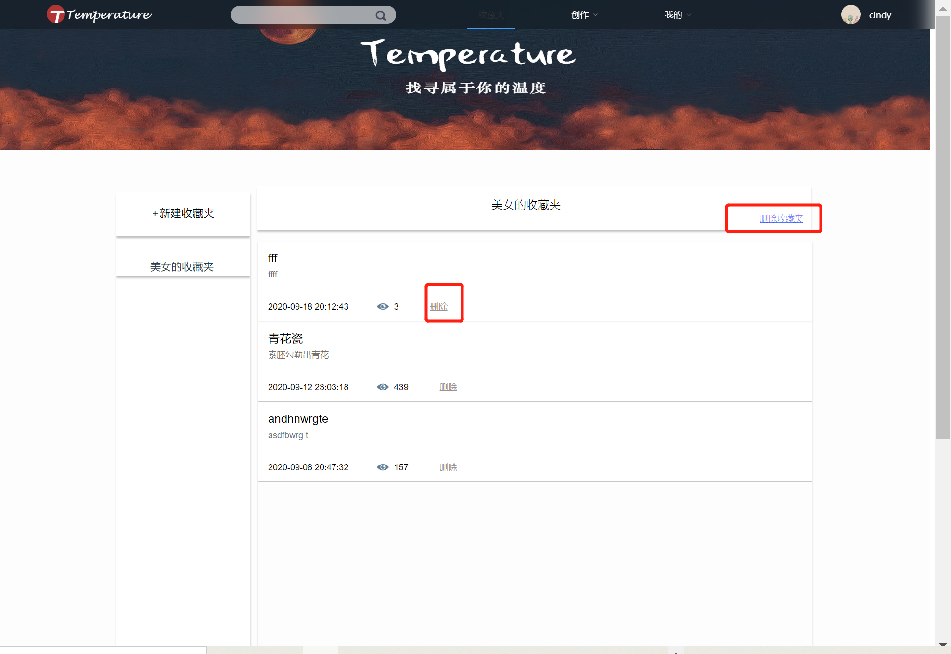

核心代码：

//分页返回收藏夹内文章的具体信息

[HttpPost]

public JsonResult getFolderArticleInfo(int folderID, int pageNum, int pageSize)

{

int flag = 0;

string msg = "";

try

{

var folder = entity.Favourite.Find(folderID);

if(folder == default)

{

flag = 2;

return Json(new { Flag = flag, errorMsg = "Folder Not Found" });

}

else

{

var result =

(from u in entity.FavouriteArticle

join mid in entity.Article on u.ArticleId equals mid.ArticleId

join right in entity.User on mid.UserId equals right.UserId //文章作者信息

where u.FavouriteId == folderID

select new { u.FavouriteId,

u.ArticleId,

u.FavouriteTime,

mid.Title,

right.UserId,

right.NickName,

mid.ArticleContent,

mid.ArticleLikes,

mid.CollectNum,

mid.ReadNum,

mid.ArticleUploadTime,

mid.ZoneId,

}).Distinct().OrderByDescending(right => right.ArticleUploadTime).Skip((pageNum - 1) * pageSize).Take(pageSize);

flag = 1;

return Json(new { Flag = flag, Result = result });

}

}

catch (Exception e)

{

msg = e.Message;

flag = 0;

}

return Json(new { Flag = flag, errorMsg = msg });

}

//查看收藏夹内文章

[HttpPost]

public JsonResult getArticleListByName(string nick_name, string folderName)

{

var flag = 0;

//根据用户名找到用户ID

var userid =

(from c in entity.User

where c.NickName == nick_name

select c.UserId).Distinct();

var id = userid.FirstOrDefault();

if (id == default)

{

flag = 2;

return Json(new { ReturnFlag = flag, UserName = nick_name, result = "NOT FOUND" });

}

//根据用户ID和收藏夹名找到对应收藏夹ID

var folderid =

(from c in entity.Favourite

where (c.FavouriteName == folderName && c.UserId == id)

select c.FavouriteId).Distinct();

var F_id = folderid.FirstOrDefault();

if (F_id == default)

{

flag = 3;

return Json(new { ReturnFlag = flag, FolderName = folderName, result = "NOT FOUND" });

}

var item =

(from u in entity.FavouriteArticle

join mid in entity.Article on u.ArticleId equals mid.ArticleId

join right in entity.User on mid.UserId equals right.UserId //文章作者信息

where u.FavouriteId == F_id

select new { u.FavouriteId,u.ArticleId,u.FavouriteTime,right.UserId,right.NickName,mid.Title}).Distinct();

flag = 1;

return Json(new { ReturnFlag = flag, Item = item });

}

//添加文章

[HttpPost]

public JsonResult addArticleByID(string nick_name,string folderName, int articleID)

{

var flag = 0;

//根据用户名找到用户ID

var userid =

(from c in entity.User

where c.NickName == nick_name

select c.UserId).Distinct();

var id = userid.FirstOrDefault();

string msg = "";

if (id == default)

{

flag = 2;

return Json(new { ReturnFlag = flag, UserID = id, result = "NOT FOUND" });

}

var folderid =

(from c in entity.Favourite

where (c.FavouriteName == folderName && c.UserId == id)

select c.FavouriteId).Distinct();

var F_id = folderid.FirstOrDefault();

if(F_id == default)

{

flag = 3;

return Json(new { ReturnFlag = flag, folderID = F_id, result = "NOT FOUND" });

}

try

{

//FAVOURITE里面更新收藏夹文章数量

var folder = entity.Favourite.Find(F_id);

var num = folder.ArticleNum;

if (num == default)

folder.ArticleNum = 1;

else

folder.ArticleNum = num + 1;

entity.Entry(folder).State = EntityState.Modified;

//ARTICLE表里面更新文章收藏量

var article = entity.Article.Find(articleID);

if (article == default)

{

flag = 4;

return Json(new { ReturnFlag = flag, ArticleID = articleID, result = "Article NOT FOUND!" });

}

var collectNum = article.CollectNum;

if (collectNum == default)

article.CollectNum = 1;

else

article.CollectNum = collectNum + 1;

entity.Entry(article).State = EntityState.Modified

//加入FAVOURITE_ARTICLE表

var item = new FavouriteArticle();

item.FavouriteId = F_id;

item.ArticleId = articleID;

item.FavouriteTime = DateTime.Now;

entity.FavouriteArticle.Add(item);

entity.SaveChanges();

flag = 1;

return Json(new { ReturnFlag = flag, folderID = F_id, articleId = articleID });

}

catch (Exception e)

{

flag = 0;

msg = e.Message;

}

return Json(new { Flag = flag, errorMsg = msg });

}

//删除文章

[HttpPost]

public JsonResult deleteArticleByID(string nick_name, string folderName, int articleID)

{

var flag = 0;

//根据用户名找到用户ID

var userid =

(from c in entity.User

where c.NickName == nick_name

select c.UserId).Distinct();

var id = userid.FirstOrDefault();

if (id == default)

{

flag = 2;

return Json(new { ReturnFlag = flag,UserName = nick_name, result = "NOT FOUND" });

}

//根据用户ID和收藏夹名找到对应收藏夹项

var folderid =

(from c in entity.Favourite

where (c.FavouriteName == folderName && c.UserId == id)

select c.FavouriteId).Distinct();

var F_id = folderid.FirstOrDefault();

if (F_id == default)

{

flag = 3;

return Json(new { ReturnFlag = flag, FolderName = folderName, result = "NOT FOUND" });

}

var folder = entity.Favourite.Find(F_id);

var item = entity.FavouriteArticle.Find(F_id, articleID);

if(item == default)

{

flag = 4;

return Json(new { ReturnFlag = flag, folderID = F_id, ArticleID = articleID, result = "NOT FOUND" });

}

//FAVORITE表中文章数量修改

var num = folder.ArticleNum;

if (num ==default)

{

flag = 5;

return Json(new { ReturnFlag = flag, result = "EMPTY FOLDER" });

}

folder.ArticleNum = num -1;

entity.Entry(folder).State = EntityState.Modified；

//ARTICLE中收藏数更新

var article = entity.Article.Find(articleID);

article.CollectNum--;

entity.Entry(article).State = EntityState.Modified;

//FAVORITE_ARTICLE表删除

entity.Entry(item).State = EntityState.Deleted;

entity.SaveChanges();

flag = 1;

return Json(new { ReturnFlag = flag, result = "successful deleted" });

}

## 2.5相册管理系统用例包设计

### 2.5.1相册管理用例实现

界面截图：

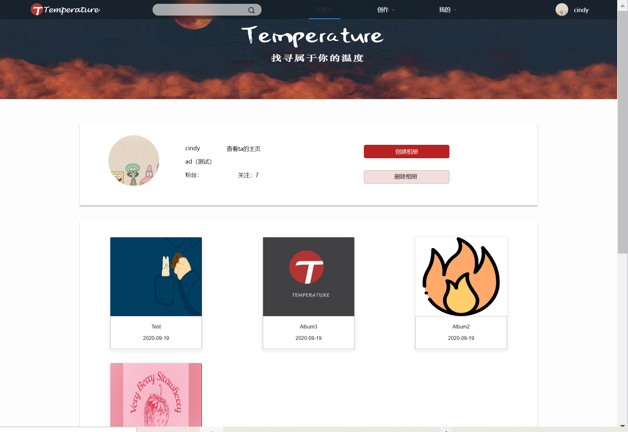

核心代码：

//查看相册

[HttpPost]

public ActionResult getAllAlbumByPage(string userID, int pageNum, int pageSize)

{

int getAllAlbumFlag = 0;

IEnumerable<object> albums = null;

List<string> firstPhoto = new List<string>();

try

{

albums = (from e in entity.Album

where e.UserId == int.Parse(userID)

orderby e.AlbumTime descending

select e).Skip((pageNum - 1) * pageSize).Take(pageSize); //最新的在前面

foreach (var album in albums.ToList())

{

var realAlbum = (Album)album;

int id = realAlbum.AlbumId;

var photo = (from f in entity.Photo

where f.AlbumId == id

select f.PhotoAddress).FirstOrDefault();

if (photo == null) firstPhoto.Add("BlogPics\\albums\\defaultAlbumPhoto.jpg");

else firstPhoto.Add(photo.ToString());

}

getAllAlbumFlag = 1;

}

catch (Exception e)

{

Console.WriteLine(e.Message);

getAllAlbumFlag = 0;

}

var returnJson = new

{

albums = JsonConvert.SerializeObject(albums),

firstPhoto = firstPhoto,

getAllAlbumFlag = getAllAlbumFlag,

};

return Json(returnJson);

}

//新建相册

[HttpPost]

public ActionResult createAlbumByID(string albumIntro, string albumName, string userID) {

DateTime dateTime = DateTime.Now; //创建当前时间

int createAlbumFlag = 0;

Album album = new Album();

album.AlbumIntroduction = albumIntro;

album.AlbumName = albumName;

album.UserId = int.Parse(userID);

album.AlbumTime = dateTime;

try {

entity.Album.Add(album);

entity.SaveChanges();

entity.Entry(album); //返回插入的记录并注入到album

createAlbumFlag = 1;

}

catch (Exception e) {

Console.WriteLine(e.Message);

}

if(createAlbumFlag == 1) {

string newPath = Path.Combine(albumRootPath, userID, album.AlbumId.ToString());

if(!Directory.Exists(newPath)) { //创建相簿文件目录

Directory.CreateDirectory(newPath);

}

}

return Json(new { createAlbumFlag = createAlbumFlag, albumID = album.AlbumId.ToString() });

}

//删除相册

[HttpPost]

public ActionResult deleteAlbumByID(string albumID, string userID) {

int deleteAlbumFlag = 0;

string deleteFilePath = "";

string msg = "";

try {

deleteFilePath = Path.Combine(albumRootPath, userID, albumID);

Directory.Delete(deleteFilePath, true); //删除本地文件夹 （删除文件不用写true）

Album album = entity.Album.Single(c => c.AlbumId == int.Parse(albumID)); //查找

entity.Album.Remove(album);

entity.SaveChanges(); //提交删除

deleteAlbumFlag = 1;

} catch(Exception e) {

Console.WriteLine(e.Message);

msg = e.Message;

deleteAlbumFlag = 0;

}

return Json(new {deleteAlbumFlag = deleteAlbumFlag ,Msg = msg});

}

### 2.5.2相册内照片管理用例实现

界面截图：

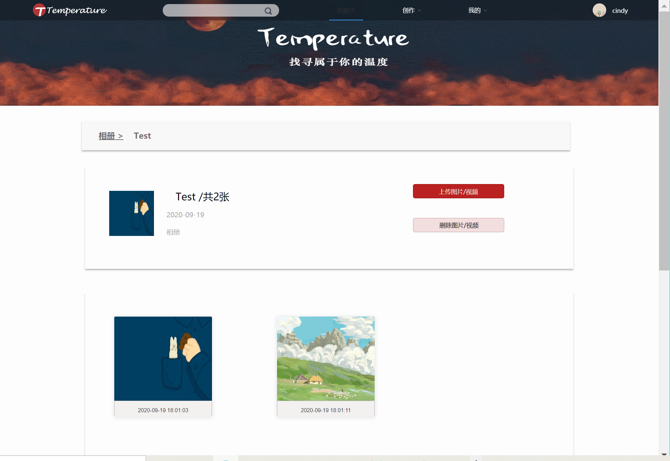

核心代码：

//查看相册内图片

[HttpPost]

public ActionResult getAllPhotoByPage(string albumID, string userID, int pageNum, int pageSize) {

DateTime dateTime = DateTime.Now;

int getAllPhotoFlag = 0;

IQueryable<Photo> photos = null;

try {

photos = (from c in entity.Photo

where c.AlbumId == int.Parse(albumID)

select c).OrderBy(c => c.PhotoUploadTime).Skip((pageNum - 1) * pageSize).Take(pageSize); //最新的在前面;

AlbumVisit albumVisit = new AlbumVisit();

albumVisit.AlbumId = int.Parse(albumID);

albumVisit.UserId = int.Parse(userID);

albumVisit.AlbumVisitTime = dateTime;

entity.AlbumVisit.Add(albumVisit);

entity.SaveChanges(); //更新访问记录

getAllPhotoFlag = 1;

} catch(Exception e) {

Console.WriteLine(e.Message);

getAllPhotoFlag = 0;

}

var returnJson = new {

photos = JsonConvert.SerializeObject(photos),

getAllPhotoFlag = getAllPhotoFlag,

};

return Json(returnJson);

}

//上传照片

[HttpPost]

public ActionResult createPhotoByID(IFormFileCollection uploadedPhoto, string albumID, string userID) {

DateTime dateTime = DateTime.Now;

int createPhotoFlag = 0;

string uploadsFolder = "";

string uniqueFileName = "";

string filePath = "";

string msg="";

List<string> allFilePath = new List<string>();

List<string> allPhotoID = new List<string>();

if (uploadedPhoto == null) return BadRequest();

for (int i = 0; i < uploadedPhoto.Count; i++) {

try {

uploadsFolder = Path.Combine(albumRootPath, userID, albumID); //计算存储路径

uniqueFileName = Guid.NewGuid().ToString() + "_" + uploadedPhoto[i].FileName;

filePath = Path.Combine(uploadsFolder, uniqueFileName);

if (!Directory.Exists(uploadsFolder))

Directory.CreateDirectory(uploadsFolder);

Photo photo = new Photo();

photo.AlbumId = int.Parse(albumID);

photo.PhotoLikes = 0;

photo.VisitNum = 0;

photo.PhotoAddress = filePath;

photo.PhotoUploadTime = dateTime;

photo.UserId = int.Parse(userID);

entity.Photo.Add(photo); //将图片信息添加到数据库中

entity.SaveChanges();

entity.Entry(photo); //获取新插入的photo的photoID

uploadedPhoto[i].CopyTo(new FileStream(filePath, FileMode.Create)); //存储图片到本地 持久化

allFilePath.Add(filePath);

allPhotoID.Add(photo.PhotoId.ToString());

createPhotoFlag = 1;

}

catch (Exception e) {

createPhotoFlag = 0;

msg = e.Message;

Console.WriteLine(e.Message);

}

}

var resultJson = new {

uploadPaths = JsonConvert.SerializeObject(allFilePath),

coorespondingPhotoIDs = JsonConvert.SerializeObject(allPhotoID),

Msg = msg,

createPhotoFlag = createPhotoFlag,

};

return Json(resultJson);

}

//删除相册内图片

[HttpPost]

public ActionResult deletePhotoByID(string photoID) {

int deletePhotoFlag = 0;

string filePath = "";

string msg = "";

try {

Photo photo = entity.Photo.Single(c => c.PhotoId == int.Parse(photoID));

filePath = photo.PhotoAddress;

entity.Photo.Remove(photo);

entity.SaveChanges();

System.IO.File.Delete(filePath); //删除单个文件

deletePhotoFlag = 1;

} catch(Exception e) {

Console.WriteLine(e.Message);

msg = e.Message;

deletePhotoFlag = 0;

}

return Json(new { deletePhotoFlag = deletePhotoFlag,Msg = msg }) ;

}

### 2.5.3相册信息管理用例实现

界面截图：

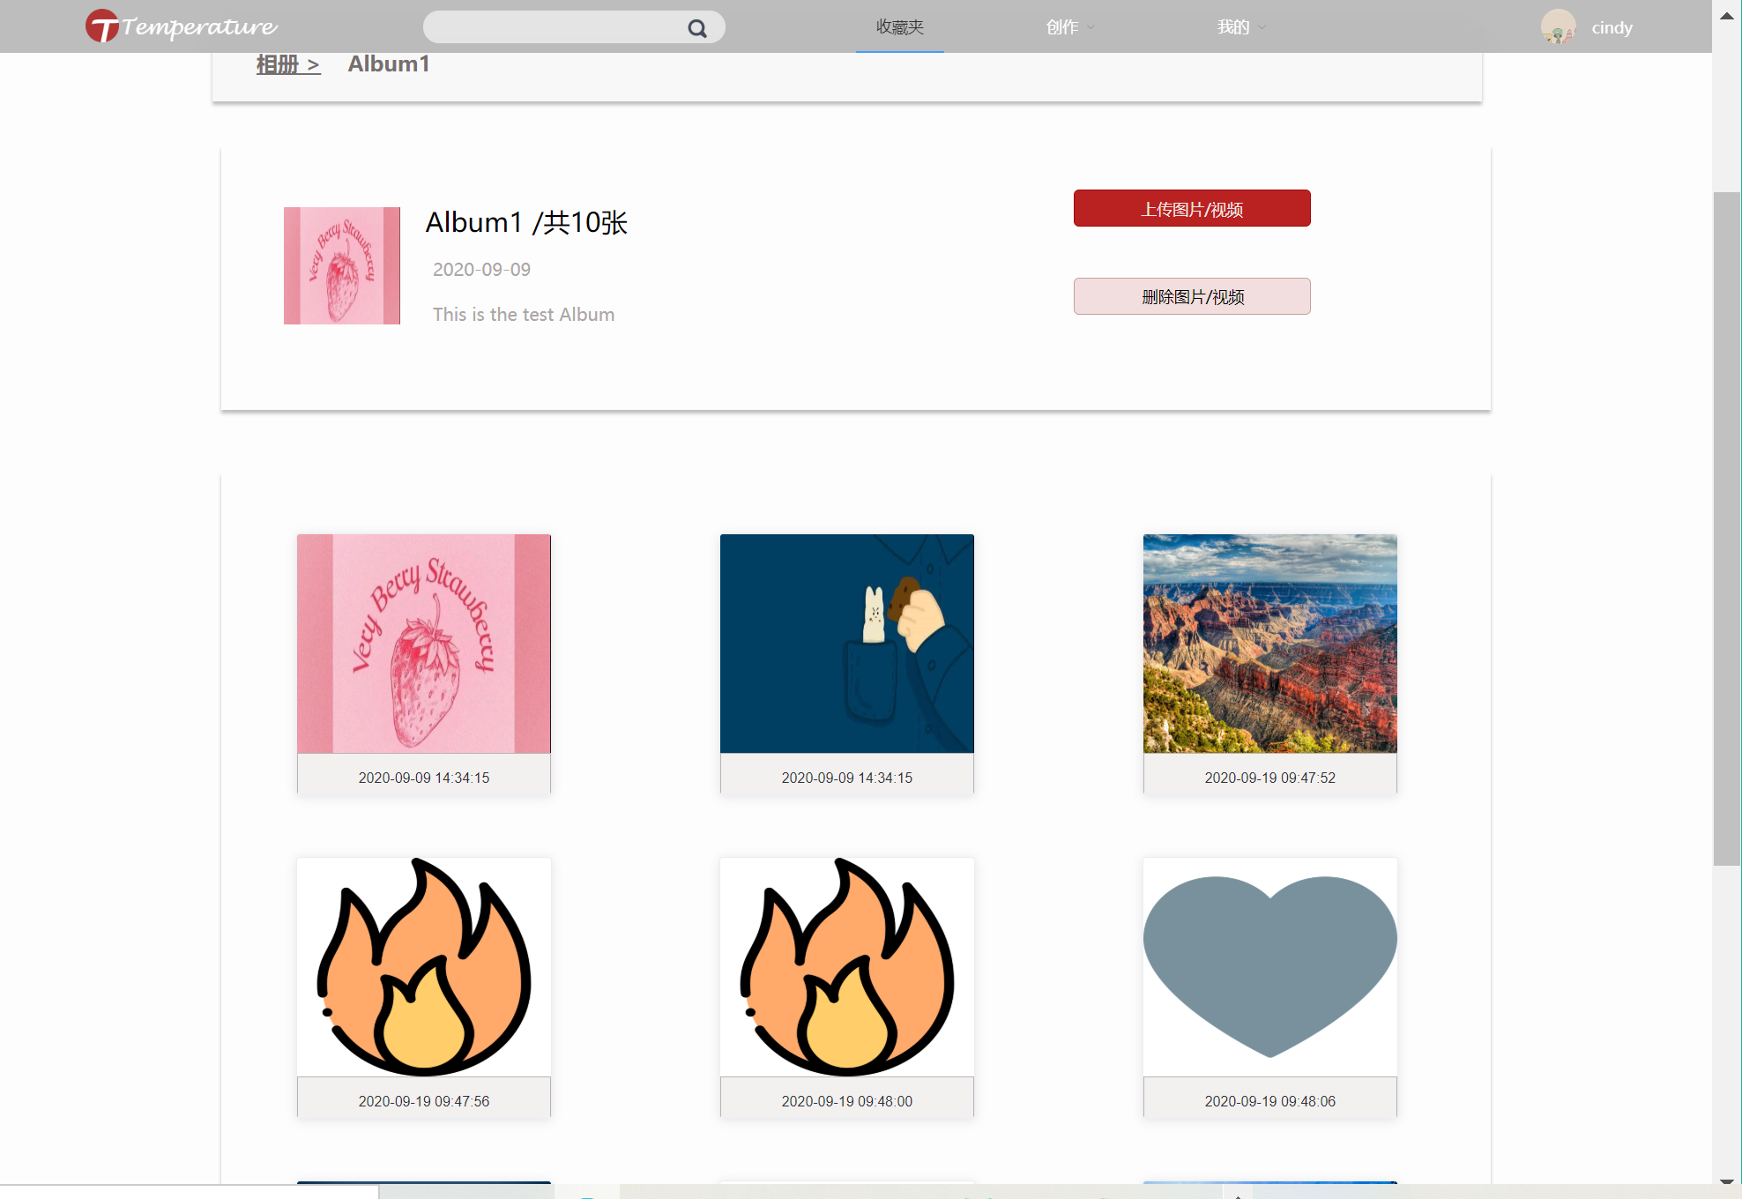

核心代码：

//点赞量更新

[HttpGet]

public ActionResult setPhotoLike(string photoID, string userID)

{

int setPhotoLikeFlag = 0;

int likes = 0;

try

{

var hasSetLike = (from c in entity.MessageLibrary

where c.MessageId == int.Parse(photoID)

select c).FirstOrDefault();

if (hasSetLike != null && hasSetLike.MessageType == userID)

return Json(new { setPhotoLikeFlag = 1, hasSetLike = 1 });

//新建点赞记录

var record = new MessageLibrary();

record.MessageId = int.Parse(photoID);

record.MessageType = userID;

entity.MessageLibrary.Add(record);

entity.SaveChanges();

var photo = entity.Photo.Single(c => c.PhotoId == int.Parse(photoID));

photo.PhotoLikes += 1;

likes = (int)photo.PhotoLikes;

entity.Photo.Update(photo);

entity.SaveChanges();

setPhotoLikeFlag = 1;

}

catch (Exception e)

{

Console.WriteLine(e.Message);

setPhotoLikeFlag = 0;

}

var returnJson = new

{

photoID = photoID,

photoLikes = likes,

setPhotoLikeFlag = setPhotoLikeFlag,

};

return Json(returnJson);

}

// 返回用户是否点赞

[HttpGet]

public ActionResult checkPhotoLike(string photoID, string userID)

{

int flag = 0;

try

{

var hasSetLike = entity.MessageLibrary.Single(c => c.MessageId == int.Parse(photoID));

if (hasSetLike.MessageType == userID)

{

flag = 1;

return Json(new { flag = flag, hasSetLike = 1 });

}

else

{

flag = 0;

return Json(new { flag = flag, hasSetLike = 0 });

}

}

catch (Exception e)

{

Console.WriteLine(e.Message);

flag = 0;

return Json(new { flag = flag });

}

}

//评论图片

[HttpPost]

public ActionResult createPhotoCommentByID(string content, string photoID, string userID) {

DateTime dateTime = DateTime.Now;

int createPhotoCommentFlag = 0;

PhotoComment photoComment = new PhotoComment();

photoComment.PhotoCommentContent = content;

photoComment.PhotoId = int.Parse(photoID);

photoComment.UserId = int.Parse(userID);

photoComment.PhotoCommentTime = dateTime;

try {

entity.PhotoComment.Add(photoComment);

entity.SaveChanges();

entity.Entry(photoComment);

createPhotoCommentFlag = 1;

} catch(Exception e) {

Console.WriteLine(e.Message);

createPhotoCommentFlag = 0;

}

var returnJson = new {

PhotoCommentByID = photoComment.PhotoCommentId.ToString(),

createPhotoCommentFlag = createPhotoCommentFlag,

};

return Json(returnJson);

}

//获取用户评论

[HttpPost]

public ActionResult getPhotoCommentByID(string photoID) {

int getPhotoCommentFlag = 0;

IQueryable<Object> photoComments = null;

try {

photoComments = (from c in entity.PhotoComment

join d in entity.User on c.UserId equals d.UserId

where c.PhotoId == int.Parse(photoID)

select new {

photoCommentID = c.PhotoCommentId,

photoCommentContent = c.PhotoCommentContent,

photoId = c.PhotoId,

userId = c.UserId,

photoCommentTime = c.PhotoCommentTime,

userName = d.NickName,

avatar = d.Avatr

});

getPhotoCommentFlag = 1;

}

catch (Exception e) {

Console.WriteLine(e.Message);

getPhotoCommentFlag = 0;

}

var returnJson = new {

photoComments = JsonConvert.SerializeObject(photoComments),

getPhotoCommentFlag = getPhotoCommentFlag,

};

return Json(returnJson);

}

//删除评论

[HttpPost]

public ActionResult deletePhotoCommentByID(string commentID) {

int deletePhotoCommentFlag = 0;

try {

PhotoComment photoComment = entity.PhotoComment.Single(c => c.PhotoCommentId == int.Parse(commentID));

entity.PhotoComment.Remove(photoComment);

entity.SaveChanges();

deletePhotoCommentFlag = 1;

} catch(Exception e) {

Console.WriteLine(e.Message);

deletePhotoCommentFlag = 0;

}

return Json(new { deletePhotoCommentFlag = deletePhotoCommentFlag });

}

## 2.6话题管理系统用例包设计

### 2.6.1查看话题及回答

界面截图：

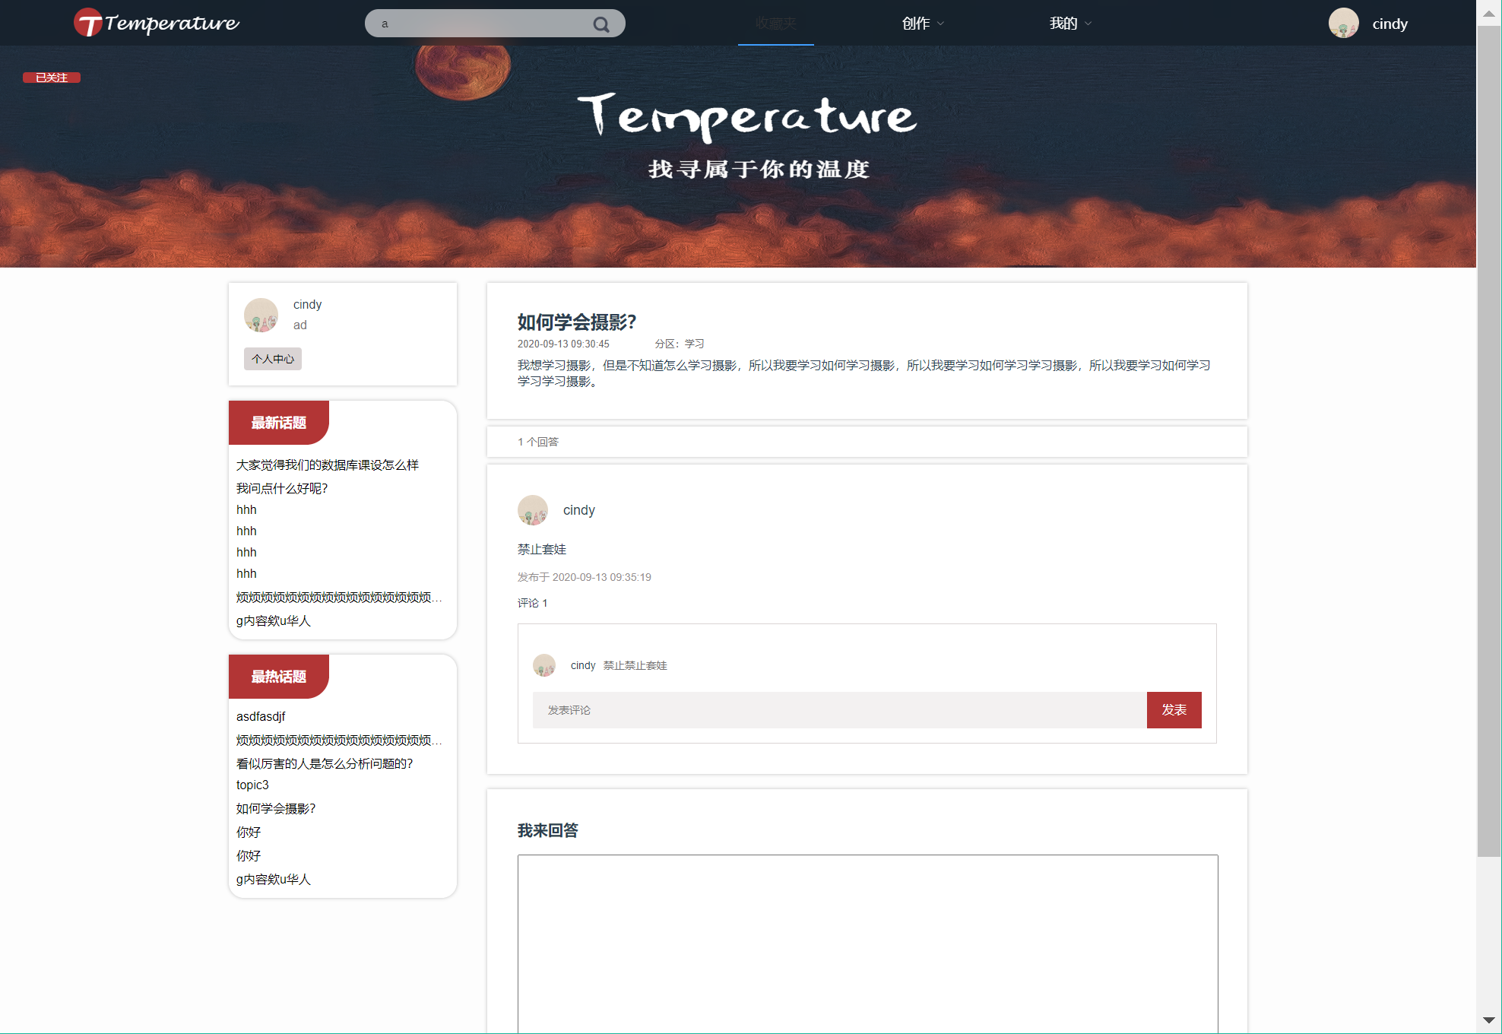

核心代码：

//分页获取话题

[SwaggerResponse(200, "文档注释", typeof(Topic))]

[HttpPost]

public JsonResult getTopicByPage(int pageNum, int pageSize, string zoneID) {

int getTopicFlag = 0;

Dictionary<string, string> returnJson = new Dictionary<string, string>();

returnJson.Add("Result", "");

try {

var content = (from c in entity.Topic

where c.ZoneId == int.Parse(zoneID)

select c).OrderByDescending(c => c.TopicUploadTime).Skip((pageNum - 1) * pageSize).Take(pageSize);

string contentJson = JsonConvert.SerializeObject(content); //序列化对象

returnJson["Result"] = contentJson;

getTopicFlag = 1;

} catch(Exception e) {

getTopicFlag = 0;

} finally {

returnJson.Add("getTopicFlag", getTopicFlag.ToString());

}

return Json(returnJson);

}

[HttpPost]

public JsonResult getMyTopicByPage(string userID, int pageNum, int pageSize) {

int flag = 0;

Dictionary<string, string> returnJson = new Dictionary<string, string>();

returnJson.Add("Result", "");

try {

var content = (from c in entity.Topic

where c.UserId == int.Parse(userID)

select c).OrderByDescending(c => c.TopicUploadTime).Skip((pageNum - 1) * pageSize).Take(pageSize); //最新的在前面

string contentJson = JsonConvert.SerializeObject(content); //序列化对象

returnJson["Result"] = contentJson;

flag = 1;

} catch (Exception e) {

flag = 0;

} finally {

returnJson.Add("getTopicFlag", flag.ToString());

}

return Json(returnJson);

}

//查看话题内容

[HttpPost]

public JsonResult getTopicDetailByID(string topicID) {

int flag = 0;

List<string> answerUserList = new List<string>();

try {

Topic topic = entity.Topic.Single(c => c.TopicId == int.Parse(topicID));

//选取此topic的所有一级评论

var topicAnswer = (from c in entity.TopicAnswerReply

join d in entity.User on c.UserId equals d.UserId

where c.TopicId == topic.TopicId && c.ParentAnswerId == -1

select new {

TopicAnswerID = c.TopicAnswerId,

TopicID = c.TopicId,

AnswerLikes = c.AnswerLikes,

Content = c.AnswerContent,

UserID = c.UserId,

UserNickName = d.NickName,

UserAvatr = d.Avatr,

UploadTime = c.AnswerUploadTime,

ParentAnswerID = c.ParentAnswerId

});

//每个一级评论中

foreach(var t in topicAnswer.ToList()) {

var a = new { firstLevelComment = JsonConvert.SerializeObject(t),

userComments = new List<string>()};

var allSecondLevelAnswer = (from c in entity.TopicAnswerReply

join d in entity.User on c.UserId equals d.UserId

where c.ParentAnswerId == t.TopicAnswerID

select new {

TopicAnswerID = c.TopicAnswerId,

TopicID = c.TopicId,

AnswerLikes = c.AnswerLikes,

Content = c.AnswerContent,

UserID = c.UserId,

UserNickName = d.NickName,

UserAvatr = d.Avatr,

UploadTime = c.AnswerUploadTime,

ParentAnswerID = c.ParentAnswerId

});

foreach (var tt in allSecondLevelAnswer.ToList()) {

a.userComments.Add(JsonConvert.SerializeObject(tt) );

}

answerUserList.Add(JsonConvert.SerializeObject(a) );

}

flag = 1;

} catch(Exception e) {

Console.WriteLine(e.Message);

flag = 0;

}

var returnJson = new { answerUserList = answerUserList,

flag = flag};

return Json(returnJson);

}

//返回话题详情

[HttpPost]

public JsonResult getSingleTopicDetail(string topicID) {

int flag = 0;

try {

var content = (from c in entity.Topic

join d in entity.Zone on c.ZoneId equals d.ZoneId

where c.TopicId == int.Parse(topicID)

select new {

topicTitle = c.TopicTitle,

topicId = c.TopicId,

topicContent = c.TopicContent,

answerNum = c.AnswerNum,

userId = c.UserId,

topicUploadTime = c.TopicUploadTime,

zoneId = c.ZoneId,

zoneName = d.ZoneName,

}).FirstOrDefault();

flag = 1;

return Json(new { topicDetail = content, flag = flag });

} catch(Exception e) {

Console.WriteLine(e.Message);

flag = 0;

return Json(new { flag = flag });

}

}

### 2.6.2回答话题

界面截图：

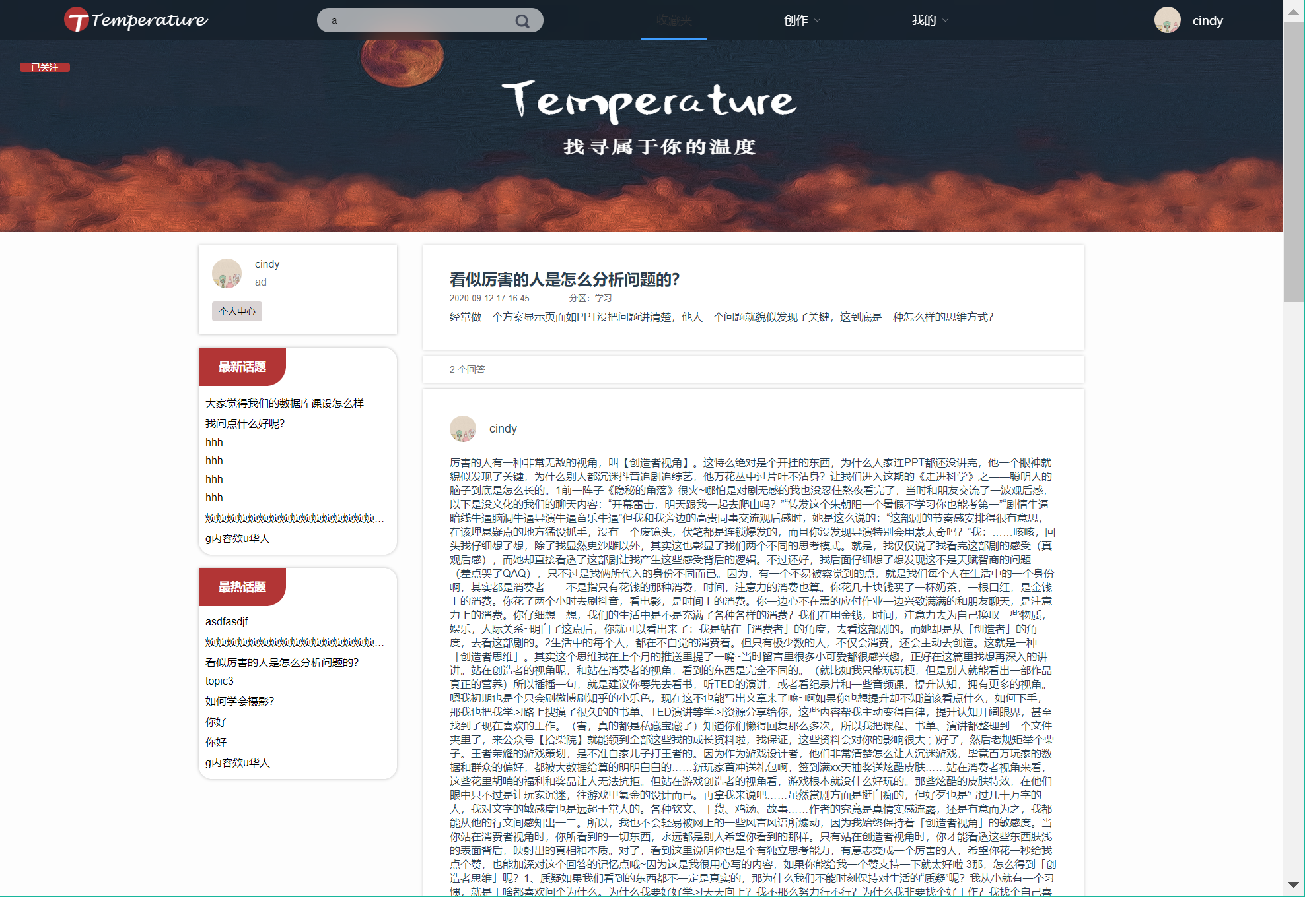

核心代码：

//创建话题回答

[HttpPost]

public ActionResult createTopicAnswerByID() {

DateTime dateTime = DateTime.Now; //获取当前时间

int cerateTopicAnswerFlag = 0;

try {

//获取参数

string content = Request.Form["content"];

string topicID = Request.Form["topicID"];

string userID = Request.Form["userID"];

string parentID = Request.Form["parentID"];

//新建answer

TopicAnswerReply topicAnswerReply = new TopicAnswerReply {

TopicId = int.Parse(topicID),

AnswerLikes = 0,

AnswerContent = content,

UserId = int.Parse(userID),

AnswerUploadTime = dateTime,

ParentAnswerId = int.Parse(parentID),

};

entity.TopicAnswerReply.Add(topicAnswerReply);

int nums = entity.SaveChanges();

//更新相应topic answer数量

Topic topic = entity.Topic.Single(c => c.TopicId == int.Parse(topicID));

topic.AnswerNum += 1;

entity.Topic.Update(topic);

entity.SaveChanges();

cerateTopicAnswerFlag = 1;

} catch (Exception e) {

cerateTopicAnswerFlag = 0;

Console.WriteLine(e.Message);

}

return Json(new { cerateTopicAnswerFlag = cerateTopicAnswerFlag });

}

### 2.6.3用户话题管理用例实现

界面截图：

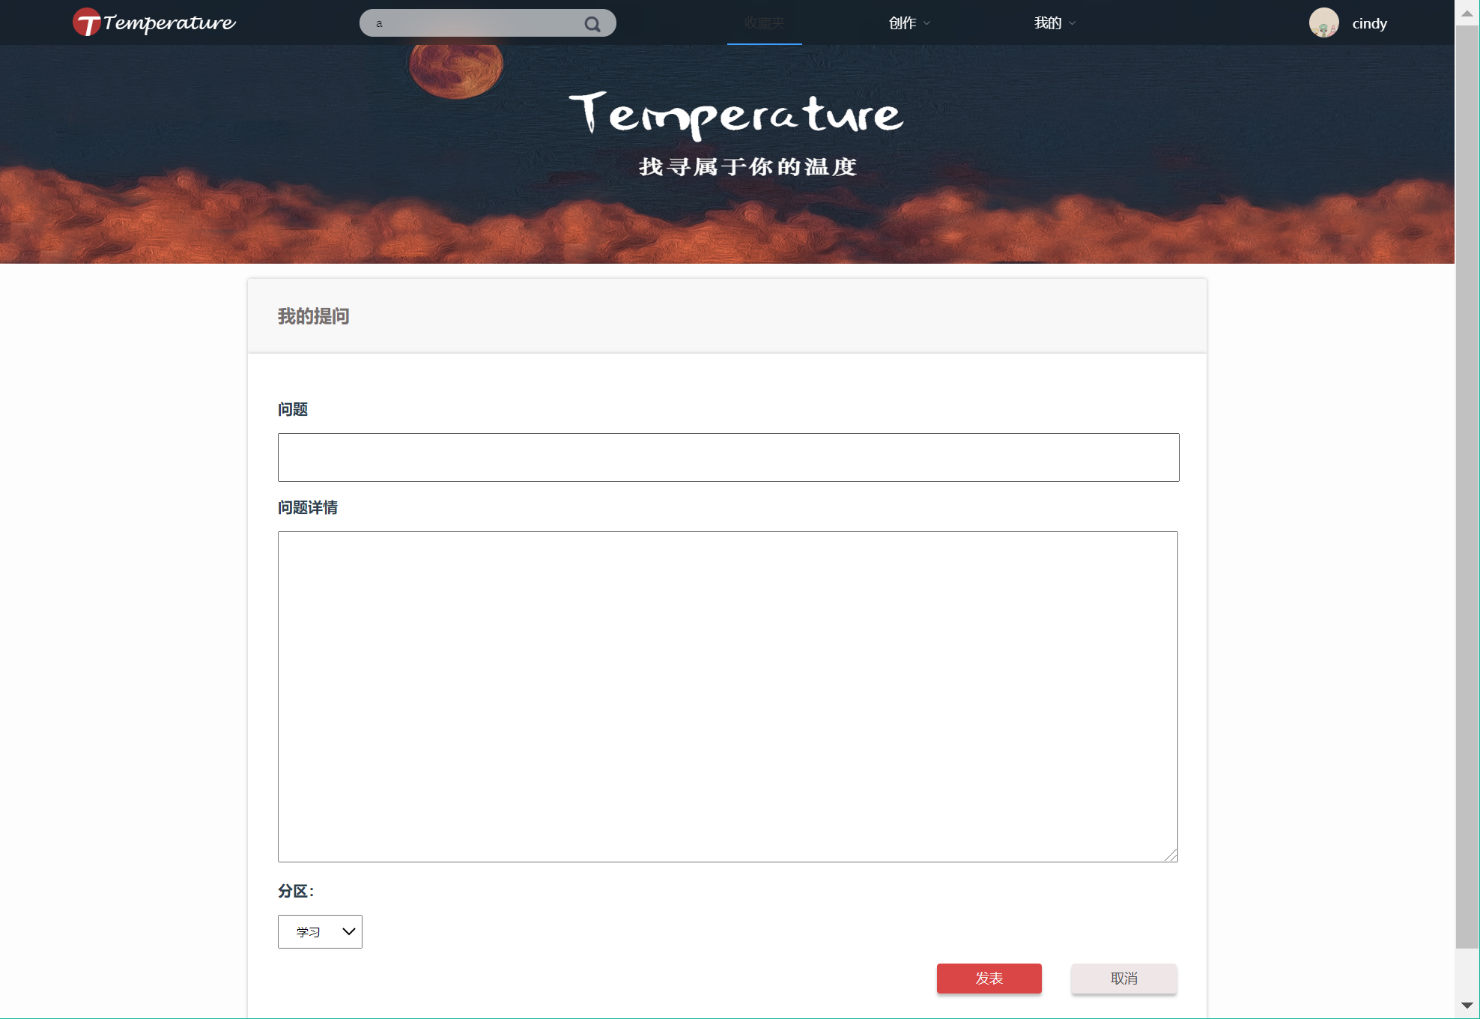

核心代码：

//创建话题

[HttpPost]

public ActionResult createTopicByID() {

DateTime dateTime = DateTime.Now; //获取当前时间

Topic topic = new Topic(); //新建topic条目项

int createTopicFlag = 0;

try {

//获取参数

string content = Request.Form["content"];

string title = Request.Form["title"];

string userID = Request.Form["userID"];

string zoneID = Request.Form["zoneID"];

//向条目中插入数据

topic.TopicContent = content;

topic.TopicTitle = title;

topic.AnswerNum = 0;

topic.UserId = int.Parse(userID);

topic.TopicUploadTime = dateTime;

topic.ZoneId = int.Parse(zoneID);

var zoneContent = (from c in entity.Zone

where c.ZoneId == int.Parse(zoneID)

select c).FirstOrDefault();

zoneContent.ZoneTopicNum += 1;

entity.Zone.Update(zoneContent);

entity.SaveChanges();

entity.Add(topic);

createTopicFlag = entity.SaveChanges(); //存入数据库 返回值为1表示成功

entity.Entry(topic);

createTopicFlag = 1;

return Json(new { topicDetail = topic, createTopicFlag = createTopicFlag });

}

catch (Exception e) {

Console.WriteLine(e.Message);

createTopicFlag = 0;

return Json(new { createTopicFlag = createTopicFlag });

}

}

//删除话题

[HttpPost]

public JsonResult deleteTopicByID(string topicID) {

int deleteTopicFlag = 0;

Dictionary<string, string> returnJson = new Dictionary<string, string>();

try {

Topic topic = entity.Topic.Single(c => c.TopicId == int.Parse(topicID));

entity.Topic.Remove(topic);

entity.SaveChanges();

//更新分区topic数量

var zone = entity.Zone.Single(c => c.ZoneId == topic.ZoneId);

zone.ZoneTopicNum -= 1;

entity.Zone.Update(zone);

entity.SaveChanges();

returnJson.Add("deleteTopic", topic.TopicId.ToString());

} catch (Exception e) {

deleteTopicFlag = 0; //失败

} finally {

returnJson.Add("deleteTopicAnswerFlag", deleteTopicFlag.ToString());

}

return Json(returnJson);

}

//获取话题评论

[HttpPost]

public JsonResult getTopicCommentByID(string topicID) {

int getTopicCommentFlag = 0;

Dictionary<string, string> returnJson = new Dictionary<string, string>();

returnJson.Add("Result", "");

try {

var content = (from c in entity.TopicAnswerReply

where c.TopicId == int.Parse(topicID)

select c);

string contentJson = JsonConvert.SerializeObject(content);

returnJson["Result"] = contentJson;

} catch(Exception e) {

getTopicCommentFlag = 0;

} finally {

returnJson.Add("getTopicCommentFlag", getTopicCommentFlag.ToString());

}

return Json(returnJson);

}

### 2.6.4话题管理用例实现

界面截图：

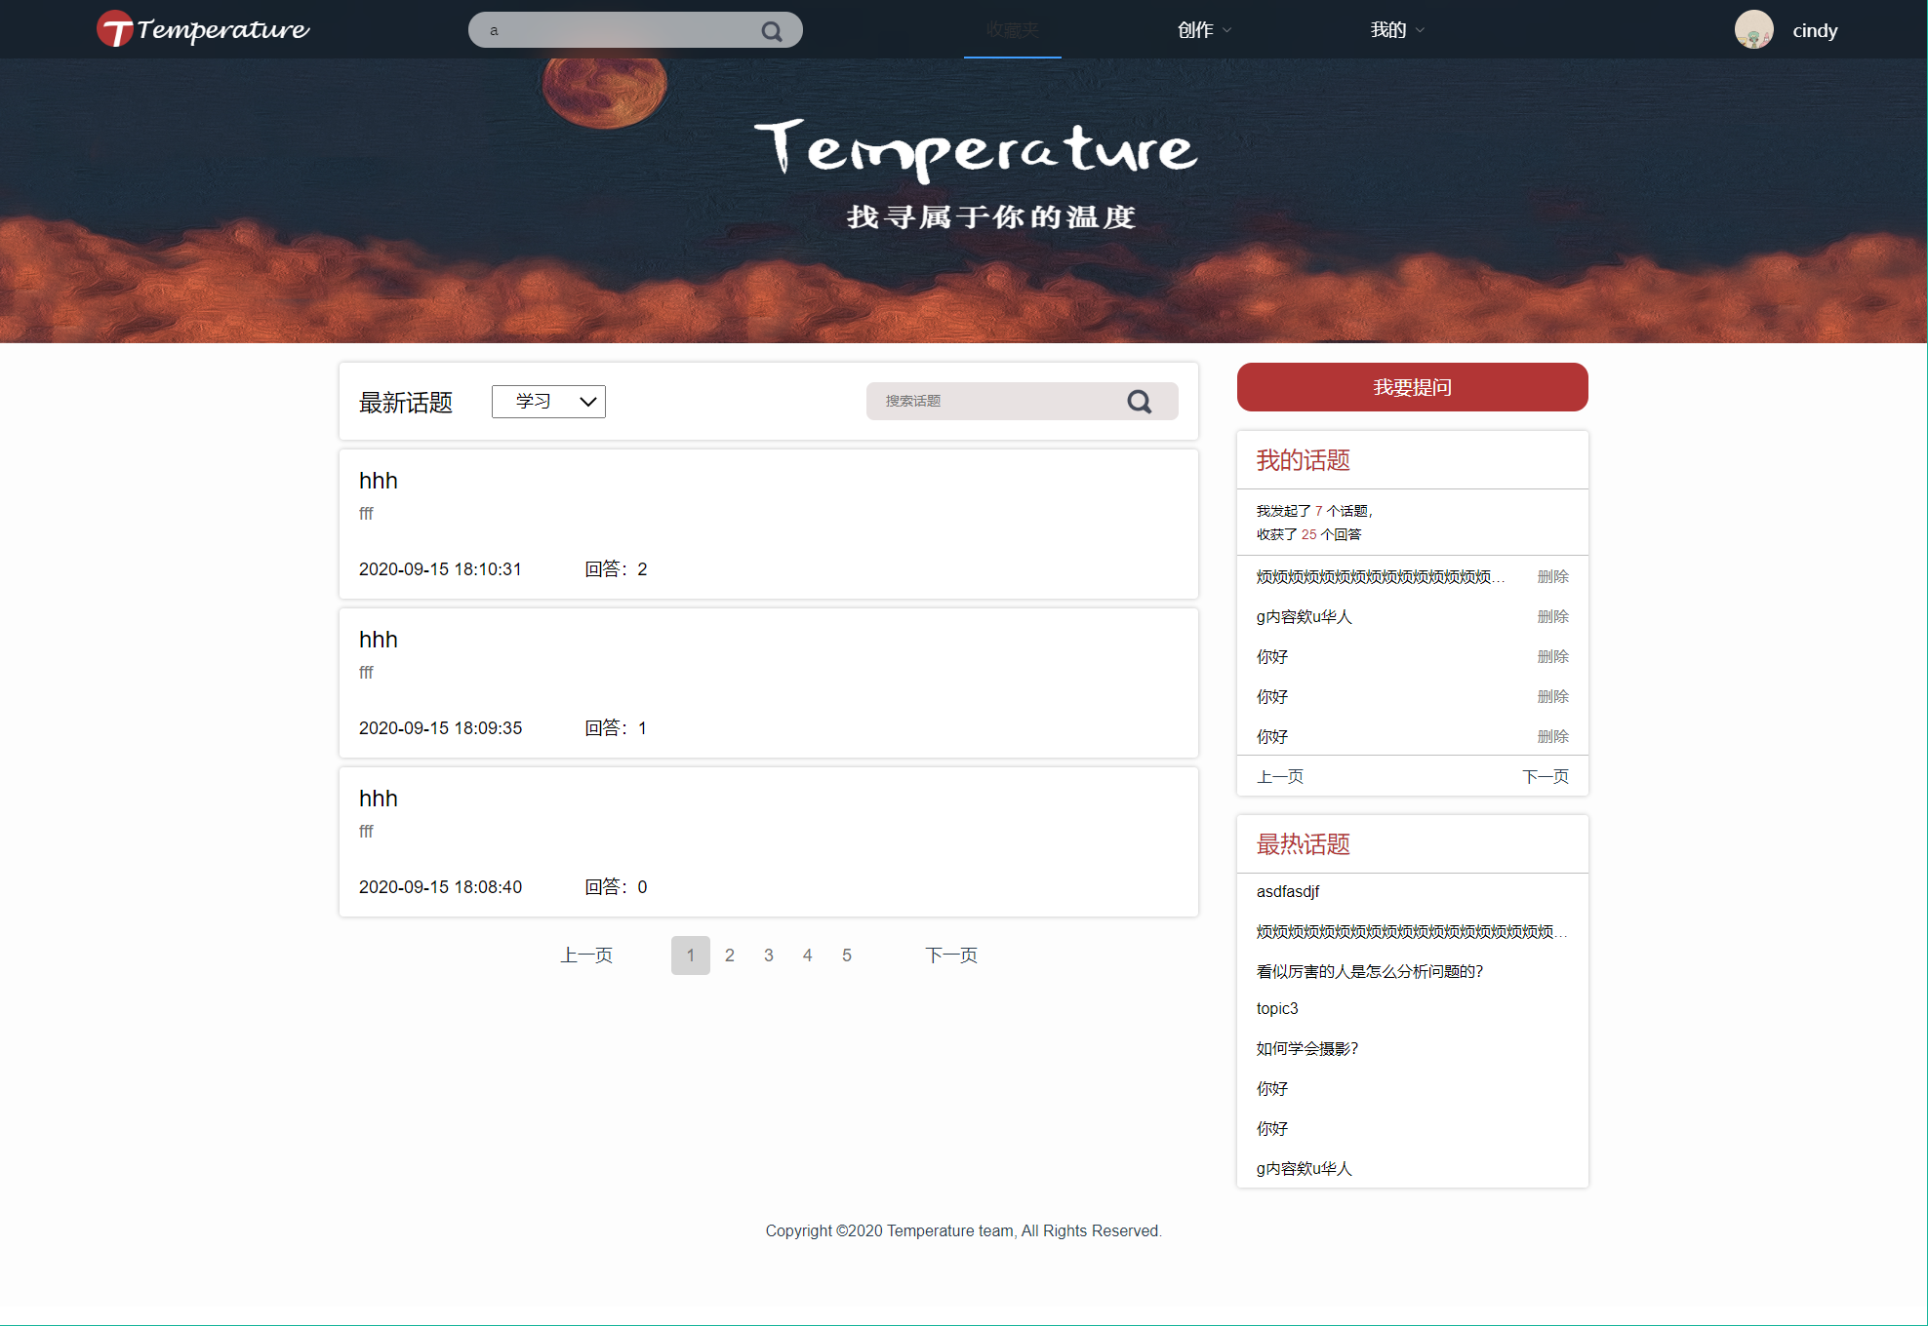

核心代码：

//搜索话题

[HttpPost]

public JsonResult getSearchedTopic(string searchContent, int pageNum, int pageSize)

{

int flag = 0;

string tt = string.Format(@"({0})", searchContent);

try

{

var content = (from c in entity.Topic

join d in entity.Zone on c.ZoneId equals d.ZoneId

where c.TopicTitle.Contains(searchContent)

select new

{

topicTitle = c.TopicTitle,

topicId = c.TopicId,

topicContent = c.TopicContent,

answerNum = c.AnswerNum,

userId = c.UserId,

topicUploadTime = c.TopicUploadTime,

zoneId = c.ZoneId,

zoneName = d.ZoneName,

}).Skip((pageNum - 1) * pageSize).Take(pageSize);

flag = 1;

return Json(new { topicDetail = content, flag = flag });

}

catch (Exception e)

{

Console.WriteLine(e.Message);

flag = 0;

return Json(new { flag = flag });

}

}

## 2.7 数据统计功能

使用Echart，利用数据库中的数据进行数据统计并展示

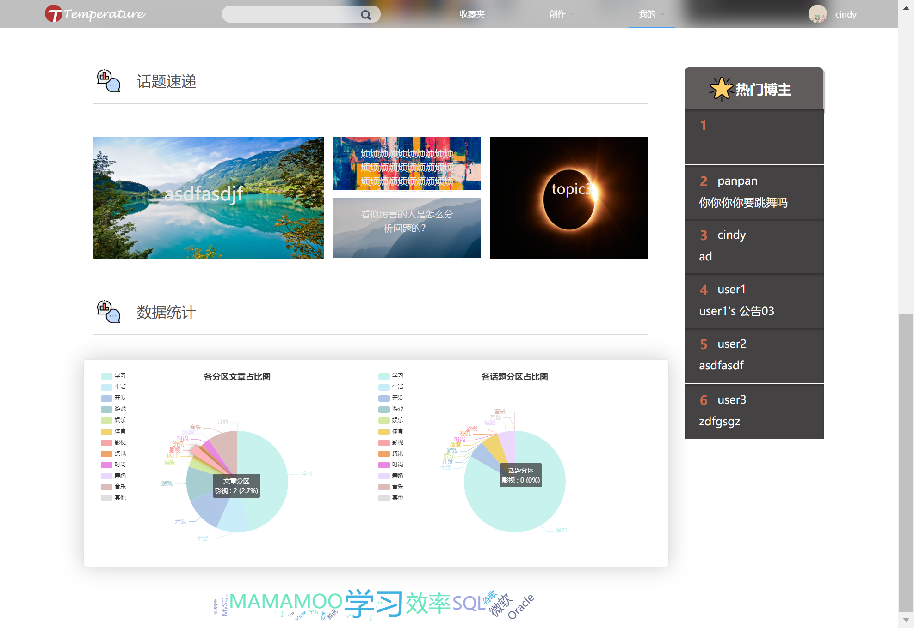

1. 图表索引

图1.2- 1 注册登录--活动图 7

图1.2- 2 注册登录--类图 8

图1.2- 3 注册登录--时序图 8

图1.2- 4 个人账户信息管理--活动图 9

图1.2- 5 个人账户信息管理--类图 10

图1.2- 6 个人账户信息管理--时序图 10

图1.2- 7 查看他人账户信息--活动图 11

图1.2- 8 查看他人账户信息--类图 12

图1.2- 9 查看他人账户信息--时序图 12

图1.2- 10 个人文章信息管理--活动图 12

图1.2- 11 个人文章信息管理--类图 13

图1.2- 12 个人文章信息管理--时序图 14

图1.2- 13 查看、点赞、评论他人文章--活动图 14

图1.2- 14 查看、点赞、评论他人文章--类图 15

图1.2- 15 查看、点赞、评论他人文章--时序图 15

图1.2- 16 收藏夹管理用例--活动图 16

图1.2- 17 收藏夹管理用例--类图 17

图1.2- 18 收藏夹管理用例--时序图 17

图1.2- 19 收藏夹文章管理用例--活动图 18

图1.2- 20 收藏夹文章管理用例--类图 18

图1.2- 21 收藏夹文章管理用例--时序图 19

图1.2- 22 相册管理用例--活动图 20

图1.2- 23 相册管理用例--类图 21

图1.2- 24 相册管理用例--时序图 22

图1.2- 25 相册内照片管理用例--活动图 23

图1.2- 26 相册内照片管理用例--类图 23

图1.2- 27 相册内照片管理用例--时序图 24

图1.2- 28 照片信息管理用例--活动图 25

图1.2- 29 照片信息管理用例--类图 26

图1.2- 30 照片信息管理用例--时序图 26

图1.2- 31 查看话题及回答用例--活动图 28

图1.2- 32 查看话题及回答用例--类图 29

图1.2- 33 查看话题及回答用例--时序图 29

图1.2- 34 回答话题用例--活动图 30

图1.2- 35 回答话题用例--类图 31

图1.2- 36 回答话题用例--时序图 31

图1.2- 37 用户话题管理用例--活动图 33

图1.2- 38 用户话题管理用例--类图 34

图1.2- 39 用户话题管理用例--时序图 34

图1.2- 40 话题搜索用例--活动图 35

图1.2- 41 话题搜索用例--类图 36

图1.2- 42 话题搜索用例--时序图 36